Year 1/2 Spring 1 Curriculum Overview

**English**

**Text:** The Man on the Moon: A Day in the Life of Bob.

**Skills:**

* Expanded noun phrases
* Co-ordinating conjunctions e.g. and, but, or
* Time adverbials
* Using the past tense

**Mathematics**

**Focus:** Shape, Addition and Subtraction

**Objectives include:**

* Compares and sorts common 2- D and 3-D shapes and everyday objects using knowledge of their properties
* Identify and describe the properties of 2D shapes including the number of sides, line of symmetry
* Identify and describe the properties of 3D shapes including number of edges, vertices and faces
* Add and subtract within and across a 10.
* Add and subtract two 2-digit numbers.

**PSHE**

**Unit:** Dreams and Goals

**Overview:**

* Perseverance
* Personal Strengths
* Teamwork
* Setting goals

**Religious Education**

**Unit:** Passover

**Key Question:** How important is it to Jewish people to do what God is asking?

page1image23063488

**Author for this half term;** Roald Dahl

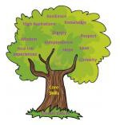

**PE**

Send and Receive

Develop basic movements as well

as balance, agility and

co-ordination.

Dance

Develop dances using simple

Movement patterns.

Unit: Computing Systems and Networks

* Word processing software
* Important buttons to use on a computer keyboard

**Computing**

**Art/Design Technology**

Unit: Mechanisms: Making a moving monster.

What am I scared of?

* Making linkages using card for levers and split pins for pivots
* Experimenting with linkages adjusting the widths, lengths and thicknesses of card used

**Music**

**Unit:** Call and Response (animals)

Use dynamics when creating sound.

Copy and create a sound pattern.

Demonstrate both call and response.

**Humanities**

Unit: Great Explorers

**Key Question:**

How have explorers changed the world?

Is it okay to try and give up?

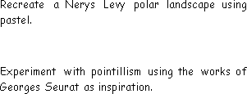

**Science**

**Unit:** Plants

**Key questions/ experiments:**

Do plants grow healthier in the light or dark?

**Unit:** Living Things and their Habitats

**Key questions/ experiments:**

What different habitats are there on planet Earth and what lives in each habitat?