St Giles’ and St George’s C of E Academy

Aspire Believe Achieve

Wednesday 8th January

|  |  |
| --- | --- |
| **Diary Dates** | |
| w/b 13th January | Library Visits |
| Tuesday 14th January | Year 1 seatbelt safety |
| Wednesday 15th January | Y4 LF GLOW |
| Friday 17th January | Pastoral Coffee and Catch up at 2pm |
| Tuesday 11th February | Year 3 Stepping out |
| Wednesday 12th February | Year 4 AT GLOW |
| Friday 14th February | Finish for half term |
| Monday 24th February | INSET Day |
| Tuesday 25th February | Return to school |
| Thursday 27th February | Young Voices |
| Tuesday 11th March | Stoke’s Gotta Sing |
| Wednesday 12th March | Year 3 EP GLOW |
| Wednesday 19th March | Recorder Festival |
| Friday 28th March and Monday 31st March | INSET days |
| Tuesday 8th April | Pre-nursery stay and play |
| Wednesday 9th April | Year 3 NB GLOW |
| Thursday 10th April | Easter Bonnets and egg scenes |
| Friday 11th April | Finish for Easter |
| Monday 28th April | Return to school    After school clubs for the children will start next week and a letter will be sent home later this week. These clubs are a fantastic opportunitiy for the children to develop new skills or improve on skills they already have. Please encourage your children to stay for them if they can. |



**Arbor**

As you are aware, we have launched the new pupil information portal which you should have been able to log on to. If you have any issues, please speak to the office.

Moving forward this system will allow you to keep contact details up to date and pay for/book your child in for trips and clubs. Additionally, you will be able to keep track of you child’s attendance.



**Reminders**

Just a reminder that children need to bring a water bottle into school each day along with their reading book and diary.

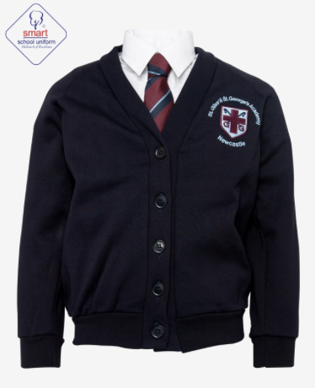

Also, please ensure that children are wearing the correct uniform including school shoes rather than trainers each day and only wearing a PE kit and their school hoodie on days their class has PE.

Many thanks.

**Food and Clothes bank**

Just a reminder that we have a food bank and clothes bank available to anyone who needs it in the front entrance of school.



We have a range of food items, toiletries, uniform, other children’s clothing and coats; please come into school and help yourself to whatever you need.

**Library Visits**

Over the next few weeks, children in Years 1-6 will be visiting Newcastle library.

As part of the visit, children will be able to take outa book of their choice but they will need a library card to do this. If your child is already registered with the library, they can bring their card along on the day of their visit. For those who aren't currently registered, library application forms will be coming home this week. If you would like to be registered, please complete the form and bring it back to school and we will send them off to be completed ready for the class visits.  
  
The dates of the visits are:  
Year 1- Tuesday 14th January  
Year 2- Tuesday 14th January  
Year 3- Thursday 16th January  
Year 4- Thursday 16th January  
Year 5- Tuesday 21st January  
Year 6- Tuesday 28th January



