



Writing Curriculum

Writing Intent, Implementation and Impact

**Inspired by our Christian faith, we guide children on a personalised journey towards achievement. As a learning community, we are committed to ensuring that children are equipped with, skills and aspirations to reach their full potential in mind, body, heart and spirit.**

**INTENT**

As a Church of England school, our English curriculum is underpinned by our gospel values. These values are used and applied throughout the English curriculum. Our children are learned and wise in the way that they practise and apply English skills in a variety of different contexts and use these skills to write for a real purpose. They show curiosity, attentiveness and active learning through their independence within lessons, following their own learning journey, taking charge of their own learning by using a variety of resources, including their working wall and continuously acting on their ‘pink pen’ feedback through active marking within each lesson. Our gospel values create a solid moral background for our children and encourage them to become better members of society.

At the heart of our English curriculum is our core skills. These skills are progressive and are built on year after year from EYFS all the way through to Year 6. This ensures that children are given opportunities to practise and apply English skills, for instance composition, grammar, spelling and comprehension in different contexts and make good progress in all areas. These learning journeys enable our pupils to be ready to access the next stages in their education, culminating in them being well-equipped in their English education for secondary school.

Our children come from a wide range of backgrounds and many are not equipped with the English skills and experiences they need to become the best readers and writers that they can be. We have worked together to create our main outcomes that we want for our children. In English, we want to instil curiosity and a love of learning through immersion in high quality texts. Real-life experiences provide children with purposeful contexts for their writing. Our class/lesson set-up and marking policy promotes independence, resilience and high aspirations through our bronze, silver and gold learning journeys.

Our gospel values, core skills and key outcomes will raise aspirations and ensure that our children are more than ready for the next stages in their English journey.

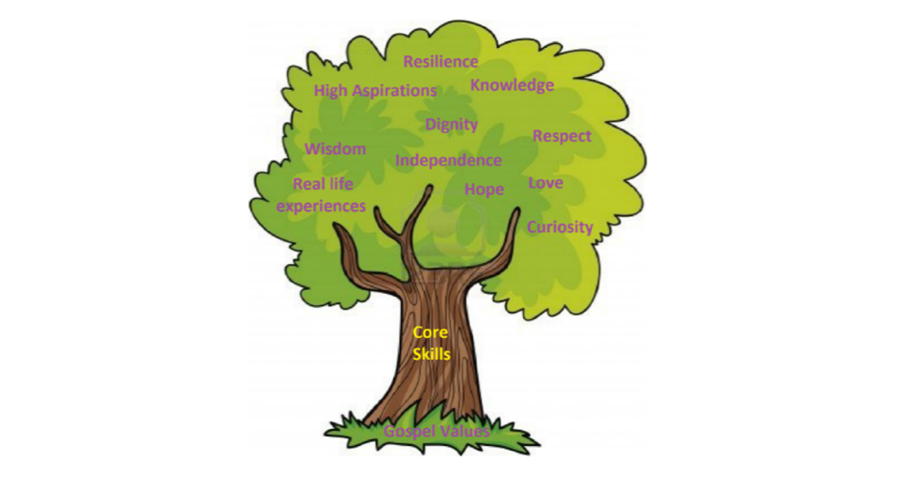

**IMPLEMENTATION**

St Giles’ and St George’s Writing Learning Journey focuses on a spiral curriculum model where previous skills and knowledge are revisited and built upon.  Writing is taught for 45minutes a day in KS1 and an hour a day in KS2. Writing skills are taught through a ‘Teach, Practise, Apply’ sequence and then the children complete ‘short writes’ or ‘hot writes’ during which they are expected to apply the skills they have been taught. These writes are linked to the text for the term. The children also have opportunities for ‘free writing’. Within each lesson a starter activity is used to recap previous learning or focus on developing grammar/spelling knowledge. An AfL task is used to assess the children’s level of understanding and this information is used to allocate the children to the appropriate activity for the lesson.

In Writing, work is recorded in an exercise book and marked in line with the marking policy.

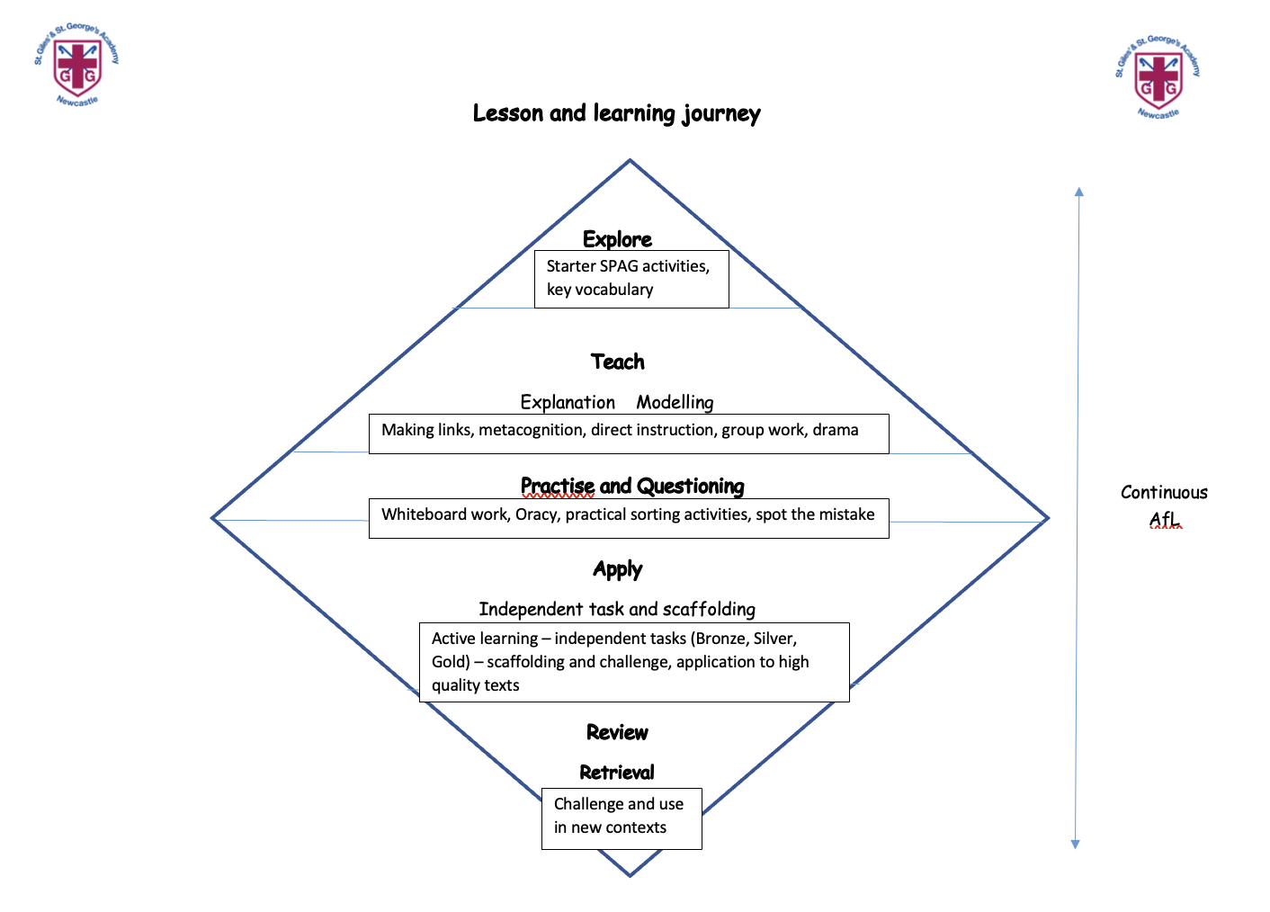

**EYFS**

As part of Development Matters (2021), Writing is taught in relation to the strand ‘Literacy’, sub-strand ‘Writing’. Children in EYFS are taught ‘PenPals’ handwriting, starting with copying patterns. They are then linked to the letter patterns and letter families. Children in EYFS are taught to write CVC words and are encouraged then to hear and write more phonemes/graphemes in words. Children in reception have adult led book activities where the teacher will support them with the next step in their writing journey. Continuous provision activities are a variety of scaffolded and ‘free’ writing opportunities to allow children to ‘practise’ what has been taught and ‘apply’ it independently. When ready, children will then be taught along their journey to writing sentences.

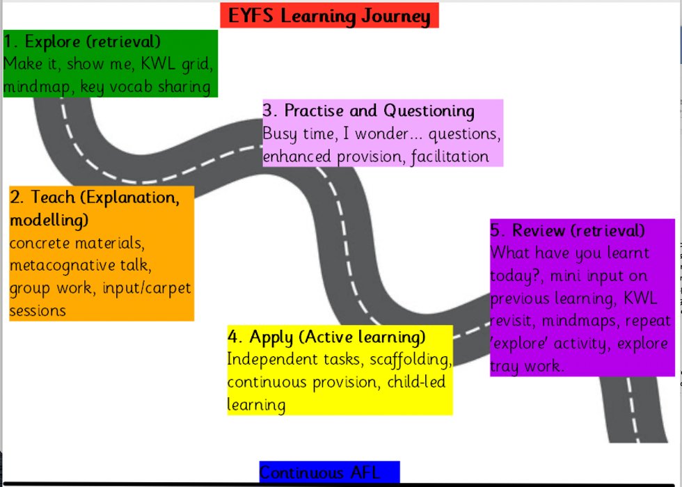

EYFS also take part in daily dough disco exercises which promote finger strength. Pre-Nursery take part in ‘Wiggle Me Into a Squiggle’ sessions three times per week for 10 minutes. Nursery take part in ‘Squiggle Whilst You Wiggle’ sessions for 10 minutes three times per week. For Reception, this is used as a targeted intervention for children who need extra support with their core and arm strength as a pre-requisite to writing.

**IMPACT**

In addition to the outcomes shown on our curriculum tree the specific impact of the St Giles’ and St George’s Writing Learning Journey is that children will (as stated in the national curriculum):

* acquire a wide vocabulary, an understanding of grammar and knowledge of linguistic conventions for reading, writing and spoken language
* appreciate our rich and varied literary heritage
* write clearly, accurately and coherently, adapting their language and style in and for a range of contexts, purposes and audiences
* use discussion in order to learn; they should be able to elaborate and explain clearly their understanding and ideas
* are competent in the arts of speaking and listening, making formal presentations, demonstrating to others and participating in debate

Handwriting

We aim for our children to leave in Year 6 with the ability to write using their own style of fast, fluent, legible and sustainable handwriting, as well as other styles of writing for specific purposes. In addition to teaching handwriting during our regular handwriting lessons, we have high expectations that what is taught and practiced in handwriting lessons will be used in all writing activities, across all subject areas. We believe that handwriting is integral to a child’s personal development and know that children’s engagement and self-esteem can be improved by their satisfaction and pride in good quality presentation.

Handwriting is a taught skill that develops at different rates for different children. All of the teachers in our school put a priority on teaching handwriting and have high expectations for handwriting across the curriculum. Our school uses *Penpals for Handwriting* to ensure that:

* The importance of handwriting is recognised and given appropriate time.
* The progression of handwriting is consistent across the school.
* Handwriting is acknowledged to be a whole body activity and emphasis is placed on correct posture and pencil grip for handwriting.
* Expectations of left-handed children are equal to those of right-handed children, and appropriate advice and resources are available to ensure that they learn to write with a comfortable, straight wrist.
* Handwriting is linked into grammar, punctuation and spelling in order to practice and contextualise all of the transcriptional and stylistic skills for writing.
* Children learn to self-assess their own writing and develop understanding and responsibility for improving it.
* Children learn to write in different styles for different purposes such as print for labelling a diagram, illustrated capitals letters for creating a poster, swift jottings for writing notes, making a ‘best copy’ for presentation and fast, fluent and legible writing across the curriculum.

Throughout their time at St Giles’ and St George’s Academy, children use a range of tools for different purposes and styles of handwriting including:

* A wide range of tools and media for mark-making in the EYFS.
* Whiteboard pens throughout the school.
* Fingers when writing on the interactive whiteboard.
* Art supplies including coloured pens and pencils for posters, displays and artwork.
* Sharp pencils for most writing until a pen licence is awarded.
* A handwriting pen for when they sustain a good level of presentation.

All of our children have equal access to handwriting lessons and to the resources available. We recognise that some children take longer to develop the necessary skills and we cater for those children by providing additional opportunities for skills development. Children who need specific gross/fine motor or handwriting interventions are identified early and the impact of interventions is carefully monitored. Children with a physical disability are catered for, and progress is monitored, according to their additional support plans.

Spelling

At our school, we aim for our children to be taught spelling rules to enable them to write fluently and consistently. Spelling and word knowledge are key components in the process of learning to read and write. At St Giles’ and St George’s, we teach spelling through the use of Supersonic Phonic Friends (in EYFS and KS1) and Spelling Shed (in KS2), in addition to a teach, practise, apply cycle of lessons.

During the regular spelling lessons, children will get the chance to be ‘taught’ a spelling rule and ‘practise’ through a range of opportunities. The children are then encouraged to apply their spelling knowledge to their writing lessons. This is done through the encouragement to use their spelling log as a resource during the lesson, spelling word banks and dictionaries being readily available.

We encourage children to find spelling practise fun. Through our use of games, quizzes, activity sheets and our school spelling leader board, we intend for our children to have a passion to practise and engage with the spelling curriculum. Our use of spelling logs ensures that those pupils who cannot access the Spelling Shed program at home or those pupils who prefer a traditional method of practise, can still engage in spelling practise at home.

Throughout the child’s time in EYFS and KS1, they work their way through the different phases of the Supersonic Phonic Friends scheme from Firm Foundations, through Basics 2, 3 and 4 and then onto the Choose to Use and Switch it Spelling rules before moving on to Suze’s Spelling Rules.

Throughout the child’s time in KS2 St Giles’ and St George’s Academy, they will work their way through the coloured log stages. To ensure the child is accessing the spelling curriculum at a suitable level for them, we administer a diagnostic spelling test. This allows teachers to assign a log that is at an appropriate level for the child allowing them to progress at their pace.

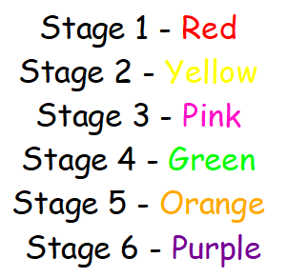

Within each colour stage, there are word lists. The children get a weekly test on these word lists. This ensures teachers can monitor the children’s progress and identify gaps in spelling knowledge promptly.

Dictation

We use dictation to enable the children to practise their handwriting, spelling and skills. It is used as a step between modelling and independence, and a bridge to editing and proofreading independently. The practice helps children to over-learn and embed new learning. Dictation is used three times a week and encompasses spelling patterns from the year group. The expectation for the final dictated text is that all words are spelt correctly, punctuated correctly and joined correctly, where appropriate.

There is progression of dictation through the year. Autumn term focuses on fundamentals and securing the previous year’s learning. Spring term sees the children taking more of a role within their own dictation passages and dictating to each other. Summer term expects children to be proofreading independently and using all features covered in the dictation.

Decoding skills, which involve correlating written language with its spoken form, are essential for acquiring language skills, particularly for enhancing listening and reading fluency and dictation can help with that.

This is where dictation has a lot of advantages, for example:

* Development of all four language skills
* Reinforcement of spelling and sound correlations
* Attentive listening and sound discrimination
* Improvement in listening skills
* Error identification ad language awareness
* Focus on accuracy and meaning
* Developing inference skills

SEND Adjustments

To ensure all pupils can access our Writing curriculum and lessons, we make the following adjustments where necessary:

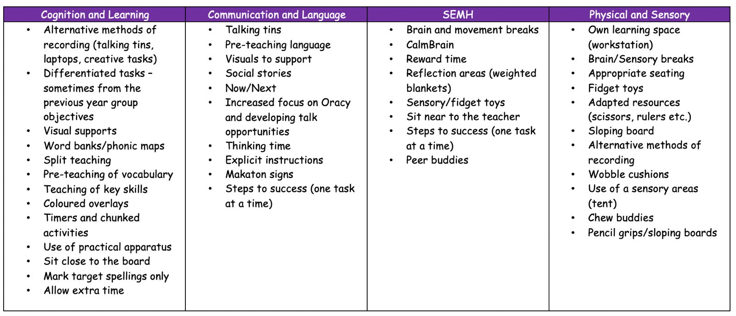

Lowest 20% offer

Text Box

|  |  |
| --- | --- |
| **EYFS**  **Loving and Compassionate**  How does Beegu show love and kindness?  **Grateful and Generous**  Why should we be thankful for the things that make us who we are?  **Curious and Active**  Why is it fun to explore new things, like Handa does on her walk?  **Attentive and discerning**  How can we be good listeners and pay attention to what's around us, just like Mr. Bear does when he's trying to sleep?  **Learned and Wise**  How do the skeletons learn new things as they go on their adventures at night?  **Faith-filled and Hopeful**  Why is it important to believe in yourself and know that you are special?  **Intentional and Prophetic**  How do the girls try to take care of the Bog Baby after they find him in the pond? | **KS1**  **Loving and Compassionate**  How does Princess Pearl show love and compassion by helping Zog and the other animals?  **Grateful and Generous**  How does Bella show generosity when she helps Dave get Dogger back?  **Curious and Active**  How does Vlad’s curiosity help him learn about the Great Fire of London?  **Attentive and Discerning**  How does Mr. Grinling pay close attention to make sure the lighthouse works and that the ships stay safe?  **Learned and Wise**  What does Sunny the meerkat learn when he travels to different places?  **Faith-filled and Hopeful**  How can having faith and hope help us turn something small into something beautiful, just like the tin forest?  **Intentional and Prophetic**  How can we be brave and stand up for others, like Traction Man, even when it's hard? |
| **LKS2**  **Loving and Compassionate**  How does Barney show love and compassion to Stig, even though they are very different?  **Grateful and Generous**  Why should we be grateful for the simple things in life and be generous in taking care of nature, like Brigg does?  **Curious and Active**  How does Alfred’s curiosity and bravery lead him to discover the truth about his kingdom?  **Attentive and Discerning**  How do the children and their community stay attentive to the needs of the rainforest and their way of life?  **Learned and Wise**  How can we be wise in handling difficult situations, like Rhodopis, and learn from our experiences?  **Faith-filled and Hopeful**  How does Phileas Fogg stay hopeful and full of faith in his plan, even when things go wrong on his journey?  **Intentional and prophetic**  How do Tranio and Livia act intentionally and show courage in trying to escape the danger of Pompeii? | **UKS2**  **Loving and Compassionate**  How does Michael show love and compassion toward Skellig, even when he doesn’t fully understand him?  **Grateful and Generous**  How does Hugo show gratitude and generosity through his relationships?  **Curious and Active**  How does Perilus’s curiosity help him discover new things and take action?  **Attentive and Discerning**  Why is it important to pay attention to the people around us and make thoughtful choices during difficult times, like George does?  **Learned and Wise**  How does Michael gain wisdom from Kensuke during their time together on the island?  **Faith-filled and Hopeful**  How does Daniel keep his hope alive, even when he’s faced with the mysteries of the Nowhere Emporium?  **Intentional and Prophetic**  How can we be intentional and brave in standing up for what is right, just like Beowulf does? |

|  |  |  |  |
| --- | --- | --- | --- |
|  | **EYFS** | **Year 1** | **Year 2** |
| **Autumn 1** | Exploring writing through a range of different genres and tasks.  Text examples:   | A book cover of a child holding a dog  Description automatically generated with medium confidence  Personal writing through continuous provision. For example, labels, captions, etc. | Writing to inform: Shape, arrow  Description automatically generatedInvitation  Writing to inform: Information leaflet |
| **Autumn 2** | A picture containing text, cemetery, grave, font  Description automatically generatedPersonal writing through continuous provision. For example, labels, captions, etc.  **Poem Focus**  Alphabet poems - Michael Rosen | Writing to inform: Postcard  Writing to entertain: Alternative ending narrative  **Poem focus**  Acrostic poem (Fireworks or Christmas) Gervais Phinn |
| **Spring 1** | A picture containing text, cartoon, animated cartoon, fiction  Description automatically generatedWriting to inform: Diary entry  Writing to entertain: Character description | Writing to inform: A picture containing text, cartoon, book  Description automatically generatedDiary entry  Writing to entertain: Setting description |
| **Spring 2** | Writing to entertain: A book cover with a cartoon face  Description automatically generated with low confidenceNarrative ending  Writing to entertain: Setting description  **Poem focus**  Simple shape poems: What can you do with a football? James Carter | Writing to inform: The Lighthouse Keeper's Lunch: Amazon.co.uk: Armitage, Ronda, Armitage,  David: BooksInstructions  Writing to entertain: Alternative narrative  **Poem focus**  Diamante – various examples |
| **Summer 1** | Writing to persuade: A picture containing text, poster, cartoon, crest  Description automatically generatedPersuasive advert  Writing to inform: Informal letter | Writing to inform: A picture containing text, book cover, poster, novel  Description automatically generatedDiary entry  Writing to entertain: Setting description |
| **Summer 2** | Writing to inform: Usborne - Look Inside A Castle - books4childrenInstructions  Writing to inform: Recount of a trip  **Poem focus**  Riddles: ww.poetry4kids.com | A screenshot of a computer  Description automatically generatedWriting to inform: Non-chronological report  **Poem focus**  Onomatopoeia and alliteration: The Sound Collector – Roger  McGough |

Whole School Yearly Overview

|  |  |  |  |  |
| --- | --- | --- | --- | --- |
|  | **Year 3** | **Year 4** | **Year 5** | **Year 6** |
| **Autumn 1** | A cover of a book  Description automatically generated with low confidenceWriting to entertain: Setting description  Writing to entertain: Playscript  Writing to entertain: Retell  Writing to inform: Non-Chronological report  **Poem focus**  Kennings: Bird Dresser – Tony Mitton | The Beast of Buckingham Palace: The epic new children's book from  multi-million bestselling author David Walliams : Walliams, David,  Walliams, David, Lumley, Joanna, Shaw, Fiona, Serkis, Andy, Waterworth,  Lizzie, Goode, James, Ganatra,Writing to entertain: Setting description  Writing to inform: Biography  Writing to entertain: Character description.  Writing to entertain: Narrative -hidden scene or new character  **Poem focus**  Personification: Snow and Snow – Ted Hughes | Writing to inform: See the source imageReport to emperor  Writing to entertain: Narrative - next chapter or what happens between | A book cover with a silhouette of a person walking in front of a building  Description automatically generated with low confidenceWriting to inform: Biography  Writing to entertain: Retell |
| **Autumn 2** | A book cover with a cartoon character  Description automatically generated with low confidenceWriting to inform: Non-chronological report using humour  Writing to inform: Diary entry    **Poem focus**  Metaphors: Winter Morning - Ogden Nash | A picture containing text, cartoon, fiction, poster  Description automatically generatedWriting to inform: Diary entry x 2  Writing to entertain: Setting description  **Poem focus**  Sonnet:: Any Shakespeare with iambic pentameter |
| **Spring 1** | See the source image  Writing to entertain: 1st person narrative  Writing to inform: Fact file | The Vanishing Rainforest : Platt, Richard, van Wyk, Rupert: Amazon.co.uk:  BooksWriting to entertain: Opening narrative  Writing to persuade: Leaflet | A book cover with butterflies and birds  Description automatically generatedWriting to inform: formal letter  Writing to entertain: narrative – retell (dialogue switch between informal and formal) | A book cover with a boat on the waves  Description automatically generatedWriting to inform: Non-chronological report (Guide to survival on an island)  Writing to entertain: Narrative (Scene between Michael and Kensuke – from Stella’s perspective) |
| **Spring 2** | Around The World In 80 DaysWriting to inform: Interview with PF  Writing to entertain: Setting description of a fictional country  **Poem focus**  Similes: Blue Bottle – Judith Nichols | A picture containing text, book cover, novel, book  Description automatically generatedWriting to entertain: Setting description before  Writing to entertain: Setting description after  **Poem focus**  Limericks: Loopy Limericks - John Foster | A picture containing text  Description automatically generatedWriting to inform: Informal – email or blog  Writing to entertain: tension narrative  **Poem focus**  Tankas: Various – John Foster | Diagram  Description automatically generatedWriting to inform: Informal – email or blog  Writing to entertain: tension narrative  **Poem focus**  Narrative: The Highwayman – Alfred Noyes |
| **Summer 1** | A book cover of a person wearing a blue headdress  Description automatically generated with low confidenceWriting to entertain: Character description  Writing to inform: Diary entry | A picture containing text, cartoon, poster  Description automatically generatedWriting to entertain: Myth  Writing to inform: Diary entry | https://images-na.ssl-images-amazon.com/images/I/51DB2QtnDCL._SX325_BO1,204,203,200_.jpgWriting to entertain: setting description  Writing to inform: Non chronological report – fictional creature  Writing to entertain: Suspense narrative of choice  Writing to entertain: Narrative based on  Alma  **Poem focus**  Cinquains: Various – John Foster | The Invention of Hugo Cabret by [Brian Selznick] Writing to entertain: Setting description  Writing to inform: Non-chronological report – Paris  Writing to entertain: Suspense narrative of choice  Writing to entertain: Narrative based on  Rock, Paper, Scissors short film.  **Poem focus**  Rhyming couplets/nonsense: Any nonsense poem – Edward Lear and any from Please Mrs Butler - Allan Ahlberg |
| **Summer 2** | A picture containing text, cartoon, book, human face  Description automatically generated Writing to inform: Non-chronological report  Writing to entertain: Narrative  **Poem focus**  Question: Registration – Allan Ahlberg | Visitor's Guide to Ancient Greece (Visitor Guides): Amazon.co.uk: Sims,  Lesley, Various: 9781409566168: Books Writing to inform: Non-chronological report  Writing to persuade: Leaflet  **Poem focus**  Haikus: Seaview Haiku and Windy Day – John Foster |

Progression of skills and knowledge

(taken from National Curriculum statements)

|  |  |  |  |  |  |  |
| --- | --- | --- | --- | --- | --- | --- |
| **Transcription: Handwriting** | | | | | | |
| **EYFS** | **Year 1** | **Year 2** | **Year 3** | **Year 4** | **Year 5** | **Year 6** |
| Children handle equipment and tools effectively, including pencils for writing.  Children write in print.  Write letters using the correct sequence of movement.  Develop the tripod grip of a pen/pencil. | Sit correctly at the table, holding pencil comfortably and correctly.  Form lower-case letters in the correct direction, starting and finishing in the right place.  Form capital letters correctly.  Understand which letters belong to which handwriting ‘families’ and practise these.  Continue to develop the tripod grip of a pen/pencil.  Form digits 0- 9 correctly. | Form lower-case letters of the correct size relative to one another.  Start using some of the diagonal and horizontal strokes needed to join letters.  Understand which letters, when adjacent to one another, are best left unjoined.  Write capitals of the correct size, orientation and relationship to one another and to lower case letters.  Use spacing between words that reflects the size of the letters.  Master the tripod grip of a pen/pencil.  Write digits of the correct size and orientation. | Use the diagonal and horizontal strokes needed to join letters.  Understand which letters, when adjacent to one another, are best left unjoined.  Increase the legibility, consistency and quality of handwriting, e.g., by ensuring that down strokes of letters are parallel and equidistant; that lines of writing are spaced sufficiently so that the ascenders and descenders of letters do not touch. | Use the diagonal and horizontal strokes needed to join letters.  Understand which letters, when adjacent to one another, are best left unjoined.  Increase the legibility, consistency and quality of handwriting, e.g., by ensuring that down strokes of letters are parallel and equidistant; that lines of writing are spaced sufficiently so that the ascenders and descenders of letters do not touch. | Write legibly, fluently, with increasing speed by:  Choosing which shape of letter to use when given choices and deciding whether or not to join specific letters.  Choosing the writing implement that is best suited for the task. | Write legibly, fluently, with increasing speed by:  Choosing which shape of letter to use when given choices and deciding whether or not to join specific letters.  Choosing the writing implement that is best suited for the task.  Choose the standard of handwriting appropriate to the task, e.g., quick notes or final presented version. |

|  |  |  |  |  |  |  |
| --- | --- | --- | --- | --- | --- | --- |
| **Transcription: Spelling (Phonic and whole word)** | | | | | | |
| **EYFS** | **Year 1** | **Year 2** | **Year 3** | **Year 4** | **Year 5** | **Year 6** |
|  | Spell words containing each of the 40+ phonemes taught  Spell common exception words  Spell the days of the week  Name the letters of the alphabet in order  Use letter names to distinguish between alternative spellings of the same sound  Spell words with simple phoneme/grapheme correspondence accurately e.g. cat, dog, red  Make phonetically plausible attempts at writing longer words using dominant phonemes and common grapheme representations | Segment spoken words into phonemes and represent these by graphemes, spelling many correctly  Learn new ways of spelling phonemes for which 1 or more spellings are already known, and learn some words with each spelling, including a few common homophones  Learn to spell common exception words  Distinguish between homophones and near- homophones | Spell further homophones  Spell words that are often misspelt | Spell further homophones  Spell words that are often misspelt | Spell some words with ‘silent’ letters  Continue to distinguish between homophones and other words which are often confused  Use knowledge of morphology and etymology in spelling and understand that the spelling of some words needs to be learnt specifically | Spell some words with ‘silent’ letters  Continue to distinguish between homophones and other words which are often confused  Use knowledge of morphology and etymology in spelling and understand that the spelling of some words |

|  |  |  |  |  |  |  |
| --- | --- | --- | --- | --- | --- | --- |
| **Transcription: Spelling (Other word building)** | | | | | | |
| **EYFS** | **Year 1** | **Year 2** | **Year 3** | **Year 4** | **Year 5** | **Year 6** |
|  | Use the spelling rule for adding –s or –es as the plural marker for nouns and the third person singular marker for verbs  Use the prefix un–  Use –ing, –ed, –er and –est where no change is needed in the spelling of root words  Apply simple spelling rules | Learning the possessive apostrophe (singular)  Learn to spell more words with contracted forms  Add suffixes to spell longer words, including –ment, –ness, –ful, – less, –ly  Show awareness of silent letters in spelling e.g. knight, write  Use –le ending as the most common spelling for this sound at the end of words | Use further prefixes and suffixes and understand how to add them  Place the possessive apostrophe accurately in words with regular plurals and in words with irregular plurals  Use the first 2 or 3 letters of a word to check its spelling in a dictionary | Use further prefixes and suffixes and understand how to add them  Place the possessive apostrophe accurately in words with regular plurals and in words with irregular plurals  Use the first 2 or 3 letters of a word to check its spelling in a dictionary | Use further prefixes and suffixes and understand the guidance for adding them  Use dictionaries to check the spelling and meaning of words  Use the first 3 or 4 letters of a word to check spelling, meaning or both of these in a dictionary | Use further prefixes and suffixes and understand the guidance for adding them  Use dictionaries to check the spelling and meaning of words  Use the first 3 or 4 letters of a word to check spelling, meaning or both of these in a dictionary |

|  |  |  |  |  |  |  |
| --- | --- | --- | --- | --- | --- | --- |
| **Composition: Planning** | | | | | | |
| **EYFS** | **Year 1** | **Year 2** | **Year 3** | **Year 4** | **Year 5** | **Year 6** |
| Compose a caption orally before writing. | Compose a sentence orally before writing. | Pan what they are going to write about, including writing down ideas and/or key words and new vocabulary eg: mind-maps. | Use ideas from their own reading and modelled examples to plan their writing.  Discuss and record ideas about writing similar to which they are planning to write in order to understand and learn from its structure, vocabulary and grammar | Discuss and record ideas about writing similar to which they are planning to write in order to understand and learn from its structure, vocabulary and grammar | Plan their writing by identifying the audience for and purpose of the writing, selecting the appropriate form and using other similar writing as models for their own. | Note down and develop initial ideas, drawing on reading and research where necessary. |

|  |  |  |  |  |  |  |
| --- | --- | --- | --- | --- | --- | --- |
| **Composition: drafting and writing** | | | | | | |
| **EYFS** | **Year 1** | **Year 2** | **Year 3** | **Year 4** | **Year 5** | **Year 6** |
| Say a caption out loud to sequence words | Encapsulate what they want to say sentence by sentence. | Say a sentence out loud before writing it – oral rehearsal.  Squence sentences to form short narratives. | Compose and rehearse sentences orally (including dialogue) progressively building a varied and rich vocabulary and increasing range of sentence structures  Organise paragraphs around a theme (e.g. beginning, middle and end) | Compose and rehearse sentences orally (including dialogue) progressively building a varied and rich vocabulary and increasing range of sentence structures  Organise paragraphs around a theme to add cohesion and aid the reader | Select appropriate grammar and vocab, understanding how such choices can change and enhance meaning  Use a wide range of devices to build cohesion within and across paragraphs.  Use appropriate organisational and presentational devices to structure text and to guide the reader (e.g. headings, bullet points, underlining). | Select appropriate grammar and vocab, understanding how such choices can change and enhance meaning  Use a wide range of devices to build cohesion within and across paragraphs.  Use appropriate organisational and presentational devices to structure text and to guide the reader (e.g. headings, bullet points, underlining). |

|  |  |  |  |  |  |  |
| --- | --- | --- | --- | --- | --- | --- |
| **Composition: editing and evaluating** | | | | | | |
| **EYFS** | **Year 1** | **Year 2** | **Year 3** | **Year 4** | **Year 5** | **Year 6** |
| Discuss what they have written with the teacher | Read their writing to check that it makes sense to themselves and to an adult.  Discuss what they have written with the teacher or other pupils.  Begin to independently make a change to their writing so that they make their writing better.  Read aloud their writing clearly enough to be heard by their peers and teacher. | Make simple additions, revisions and corrections to their own writing by evaluating their writing with the teacher and other pupils.    Read to check that their writing makes sense and that the correct tense is used throughout with the help of an adult where necessary.  Check for errors in spelling, grammar and punctuation with the help of an adult where necessary.  Read aloud their writing with appropriate intonation to make the meaning clear. | Assess the effectiveness of their own and others’ writing and suggesting improvements  Propose changes to vocabulary to improve consistency including accurate use of pronouns.  Proofread for spelling and punctuation errors  Read aloud their writing to a group or whole class, using appropriate intonation and controlling the tone and volume so that the meaning is clear. | Assess the effectiveness of their own and others’ writing and suggesting improvements  Propose changes to vocabulary to improve consistency including accurate use of pronouns.  Proofread for spelling and punctuation errors  Read aloud their writing to a group or whole class, using appropriate intonation and controlling the tone and volume so that the meaning is clear. | Make changes to vocabulary, grammar and punctuation to enhance effects and clarify meaning.  Assess the effectiveness of their own and others’ writing and suggesting improvements  Proofread for spelling and punctuation errors  Perform their own compositions, using appropriate intonation, volume and movement so that meaning is clear. | Recognise how words are related by meaning as synonyms and antonyms and to use this knowledge to make improvements to their writing  Make changes to vocabulary, grammar and punctuation to enhance effects and clarify meaning.  Assess the effectiveness of their own and others’ writing and suggesting improvements  Proofread for spelling and punctuation errors  Perform their own compositions, using appropriate intonation, volume and movement so that meaning is clear. |

|  |  |  |  |  |  |  |
| --- | --- | --- | --- | --- | --- | --- |
| **Composition: Punctuation and grammar** | | | | | | |
| **Text structure** | | | | | | |
| **EYFS** | **Year 1** | **Year 2** | **Year 3** | **Year 4** | **Year 5** | **Year 6** |
| Sequencing words to make captions. | Sequencing sentences to form short narratives. | Correct choice and consistent use of the present tense and past tense throughout writing.  Use of the progressive form of verbs in the present and past tense to mark actions in progress | Introduction to paragraphs as a way to group related material.  Headings and subheadings to aid presentations.  Use of the present perfect form of verbs instead of the simple past. (e.g. He has gone out to play contrasted with He went out to play) | Use paragraphs to organise ideas around a theme.  Appropriate choice of pronoun and noun within and across sentences to aid cohesion and avoid repetition. | Devices to build cohesion within a paragraph (e.g. then, after that, this, firstly).  Linking ideas across paragraphs using adverbials of time (e.g. later), place (e.g. nearby), number (e.g. secondly) and tense choice (e.g. he had seen her before). | Linking ideas across paragraphs using a wider range of cohesive devices: repetition of word or phrase, grammatical connections (e.g. the use of adverbials such as on the other hand, in contrast) and ellipsis.  Layout devices, such as headings, sub headings, columns, bullets, tables, to structure text. |

**The following progression should be used to inform the TPA cycles for each year group**

|  |  |  |  |  |  |  |
| --- | --- | --- | --- | --- | --- | --- |
| **Composition: Punctuation and grammar** | | | | | | |
| **Sentence structure** | | | | | | |
| **EYFS** | **Year 1** | **Year 2** | **Year 3** | **Year 4** | **Year 5** | **Year 6** |
| A word is made up of phonemes and graphemes.  How words can be separated with spaces.  Write captions that can be read by themselves and others. | How words can combine to make sentences. Joining words and joining sentences using and  Write from memory simple sentences dictated by the teacher. | Subordination (using when, if, that, because) and coordination (using or, and, or, but).  Expanded noun phrases for description sand specification (e.g. the blue butterfly).  How the grammatical patterns in a sentence indicate its function as a statement, question, exclamation or command. | Expressing the time, place and cause using conjunctions (e.g. when, so, before, after, while, because), adverbs (e.g. then, next, soon, therefore), or prepositions (e.g. before, after, during, in, because) use ‘a’ or ‘an’ correctly throughout a piece of writing.  Use subordinate clauses, extending the range of sentences with more than one clause by using a wider range of conjunctions, including when, if, because, and although. | Noun phrases expanded by the addition of modifying adjectives, nouns and preposition phrases (e.g. the teacher expanded to: the strict maths teacher with curly hair).  Fronted adverbials (e.g. Later that day, I heard bad news). | Relative clauses beginning with who, which, where, why, whose, that *** an omitted pronoun.  Indicating degrees of possibility using adverbs (e.g perhaps, surely) or modal verbs (e.g. might, should, will, must). | Use the passive voice to affect the presentation of information in a sentence.  Know how words are related by meaning as synonyms and antonyms e.g. big, large, little and use these in their writing.  The difference between structures typical of informal speech and structures appropriate for formal speech and writing (such as the use of question tags, e.g. He’s your friend, isn’t he? Or the use of subjunctive forms such as ‘I were’ or ‘Were they to come ‘ in some very formal writing and speech) |

|  |  |  |  |  |  |  |
| --- | --- | --- | --- | --- | --- | --- |
| **Composition: Punctuation and grammar** | | | | | | |
| **Sentence types (see resource document for examples and link to National Curriculum)** | | | | | | |
| **EYFS** | **Year 1** | **Year 2** | **Year 3** | **Year 4** | **Year 5** | **Year 6** |
| N/A | Short  Simple sentences  Sound! Cause.  All the W’s | 2A sentences  List sentences  BOYs sentences  Similes | Alliteration  Ad, same ad  _ing, _ ed  Double ly ending | Personification  Emotion word, (comma)  Verb, person  If, if, if, then | 3 _ed  Noun, which/where/who  The more, the more  3 bad – (dash) question?  Metaphors | De:de  Some; others  Irony  Outside. (Inside.)  Imagine 3  Figurative language |

|  |  |  |  |  |  |  |
| --- | --- | --- | --- | --- | --- | --- |
| **Composition: Punctuation and grammar** | | | | | | |
| **Punctuation** | | | | | | |
| **EYFS** | **Year 1** | **Year 2** | **Year 3** | **Year 4** | **Year 5** | **Year 6** |
| Introduce capital letters and full stops. | Separation of words with finger spaces.  Begin to use capital letters, full stops, question marks and exclamation marks to demarcate sentences.  Capital letters for names and the personal pronoun I, places and days of the week. | Use of capital letters, full stops, question marks and exclamation marks to demarcate sentences.  Commas to separate items in a list.  Apostrophes to mark where letters are missing in spelling (omission) and to mark singular possession in nouns. | Introduction to inverted commas to punctuate direct speech. | Use of inverted commas and other punctuation to indicate direct speech.  Apostrophes to mark plural possession.  Use of commas after fronted adverbials. | Brackets, dashes or commas to indicate parenthesis. Use of commas to clarify meaning or avoid ambiguity | Use of semi-colon, colon and dash to mark the boundary between independent clauses.  Use of the colon to introduce a list and use of the semi- colon within lists. Punctuation of bullet points to list information.  How hyphens can be used to avoid ambiguity. |
| **Terminology used** | | | | | | |
| Letter  Capital letter  Full stop  Finger space  Phoneme  Grapheme  Word  Caption | Letter, capital letter Word  Singular  Plural  Sentence Punctuation mark  Full stop  Question mark  Exclamation mark | Noun  Noun phrase Statement  Question  Exclamation  Command Compound  Suffix Adjective  Verb  Adverb  Tense (past, present)  Apostrophe  Comma | Preposition  Conjunction Word family  Prefix Cause  Subordinate clause  Direct speech Consonant  Vowel  Inverted commas (or speech marks) | Determiner  Pronoun  Possessive pronoun  Adverbial | Modal verb  Relative pronoun  Relative clause  Parenthesis  Bracket  Dash Cohesion  Ambiguity | Subject  Object Active  Passive Synonym  Antonym Ellipsis  Hyphen  Colon  Semi-colon  Bullet points |

Year 1 Assessment

Year 2 Assessment

Year 3 Assessment

Year 4 Assessment

Year 5 Assessment

Year 6 Assessment