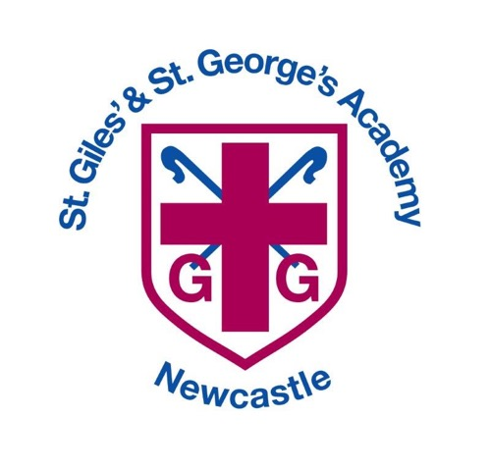

Reading Curriculum

Intent, Implementation and Impact

**Inspired by our Christian faith, we guide children on a personalised journey towards achievement. As a learning community, we are committed to ensuring that children are equipped with, skills and aspirations to reach their full potential in mind, body, heart and spirit.**

**Intent**

As a Church of England school, our English curriculum is underpinned by our gospel values. These values are used and applied throughout the English curriculum. Our children are learned and wise in the way that they practise and apply English skills in a variety of different contexts and use these skills to read for a real purpose. They show curiosity, attentiveness and active learning through their independence within lessons, following their own learning journey, taking charge of their own learning by using a variety of resources, including their working wall and continuously acting on their ‘pink pen’ feedback through active marking within each lesson. Our gospel values create a solid moral background for our children and encourage them to become better members of society.

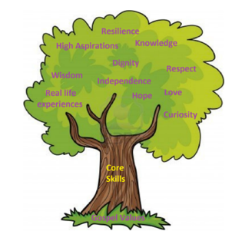At the heart of our English curriculum is our core skills, evident in our termly learning journeys. These skills are progressive and are built on year after year from EYFS all the way through to Year 6. These learning journeys enable our pupils to be ready to access the next stages in their education, culminating in them being well-equipped in their English education for secondary school. Our children come from a wide range of backgrounds and many are not equipped with the English skills and experiences they need to become the best readers that they can be. We have worked together to create our main outcomes that we want for our children. In English, we want to instil curiosity and a love of learning through immersion in high quality texts. Real-life experiences provide children with purposeful contexts for their reading. Our class/lesson set-up and marking policy promotes independence, resilience and high aspirations through our bronze, silver and gold learning journeys.

Our gospel values, core skills and key outcomes will raise aspirations and ensure that our children are more than ready for the next stages in their English journey.

**Implementation**

St Giles’ and St George’s Reading Learning Journey focuses on a spiral curriculum model where previous skills and knowledge are revisited and built upon.

EYFS

As part of Development Matters (2021), Reading is taught in relation to the strand ‘Literacy’, with some sessions linking to the ‘Communication and Language’ strand. Children in EYFS are taught the mechanics of reading and have whole class reading sessions in addition to being read with. The children in EYFS are exposed to a class text each week and will answer questions in this during their adult-led input and activity. These questions link to the ‘Comprehension’ sub-strand of the ‘Literacy’ strand. Children are taught to recognise graphemes, segmenting and blending through phonics sessions as well as their mechanics of reading session linking to the sub-strand ‘Word Reading’. Children in EYFS also have stories read to them each day to promote a passion for reading.

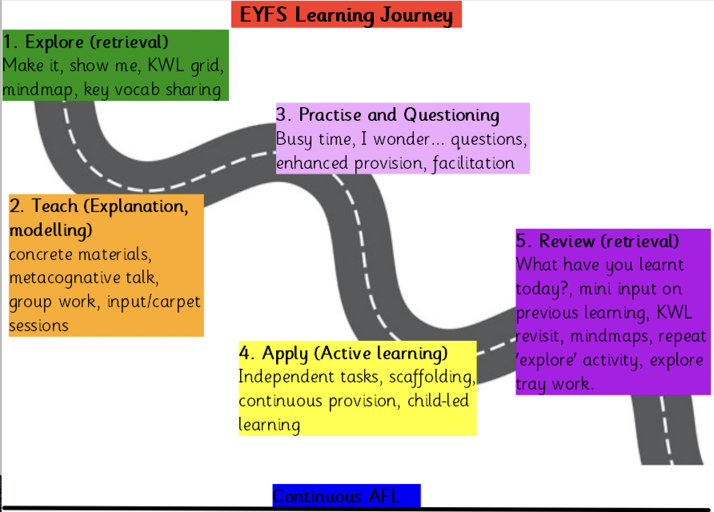

Phonics

We have chosen to follow Supersonic Phonic Friends as our phonic scheme; it was chosen because it had strong links to rhyme and alliteration, was interactive for our children and would ensure consistency in approach to teaching phonics across school. Staff follow the Supersonic Phonic Friends planning and Powerpoint presentations online. Staff are expected to plan their own revisit and review sessions which will be based on previous assessments of learning. Staff have the autonomy to and are expected to make alterations to planning to suit the needs of the children, for instance how long to spend on the learning of a GPC (Grapheme Phoneme Correspondence).

Each new piece of learning should include the following sections:

* Revisit and review (every lesson)
* Listen with Len
* Segment with Seb and blend with Ben
* See it with Sam
* Segment with Seb and build with Bill
* Read with Rex
* Write with Ron

Nursery lessons last for 5-10 minutes. Reception lessons start at 10 minutes, with daily additional oral blending – increasing to 20 minutes when ready, like Key Stage 1. Timely interventions take place for the lowest 20% and children who have been identified as needing more support from lesson assessments. These take the form of post-teach and microphonic bursts of no more than 10 minutes. This is also the case for Year 2 and Key Stage 2 children who need extra support with phonics.

Reading

Whilst some reading strategies are used more often to teach emergent reading (such as phonics), the academy recognises that learners may require a blend of different strategies in order for children to progress.

1. Phonics (see previous sections on phonics)

2. Individual Reading and Group Modelled Reading

• At the learning to read stage, teachers and support staff may listen to children read individually or as part of a group of similar ability children, if the child requires more focused support in applying their phonics.

• Texts are chosen from the school’s phonics book bands and are at the instructional level for each child

Individual and group modelled reading will be used to:

• Provide a context for the teacher to teach common exception words, decoding skills, use of picture clues and use of context to support prediction;

• Provide an opportunity for child to consolidate his/her early decoding skills;

• Monitor the application of reading skills of the child.

Focus on developing fluency in reading

Enable teachers to model the skills and strategies used by effective readers.

Ensure that the mechanics of reading are being taught explicitly to the children (A combination of phonemic awareness, word analysis, phonics and sight words are key principles that make the reading process both meaningful and manageable for young children.)

3. Whole Class Reading

• Shared reading takes place in various forms across all ages:

EYFS – Reading is a whole-class learning experience based on a shared text. These texts provide the theme for continuous provision and the adult-led activities. Through these experiences children develop their understanding of language, characters, settings and simple story structures, which may include repetition.

KS1 and KS2– Reading takes place within the Whole Class Reading session, using their focus text for that half term. Children access the text through copies and the use of the interactive whiteboard. The children’s reading has a purpose, such as exploring characters, plot, making simple predictions and developing vocabulary further. The texts used in shared reading are linked to writing activities.

WCR across all stages will be used to:

• Demonstrate how to read a wide variety of different genres and text types.

• Demonstrate that reading is a pleasurable experience;

• Give access to challenging texts for all pupils;

• Focus on developing the comprehension skills of the children

• Focus on language development through oracy

4. Independent Reading (Read and Relax)

As pupils reach the ‘reading to learn’ stage and are confidently decoding and answering simple comprehension questions, then they will also be encouraged to read independently. In KS2, this reading takes place in the form of Accelerated Reader.

Independent reading will be used to:

* Promote enjoyment of reading;
* Promote the development of independent learning strategies;
* Provide a context for the application of skills and knowledge about reading.

In WCR, work is recorded in an exercise book and marked in line with the marking policy.

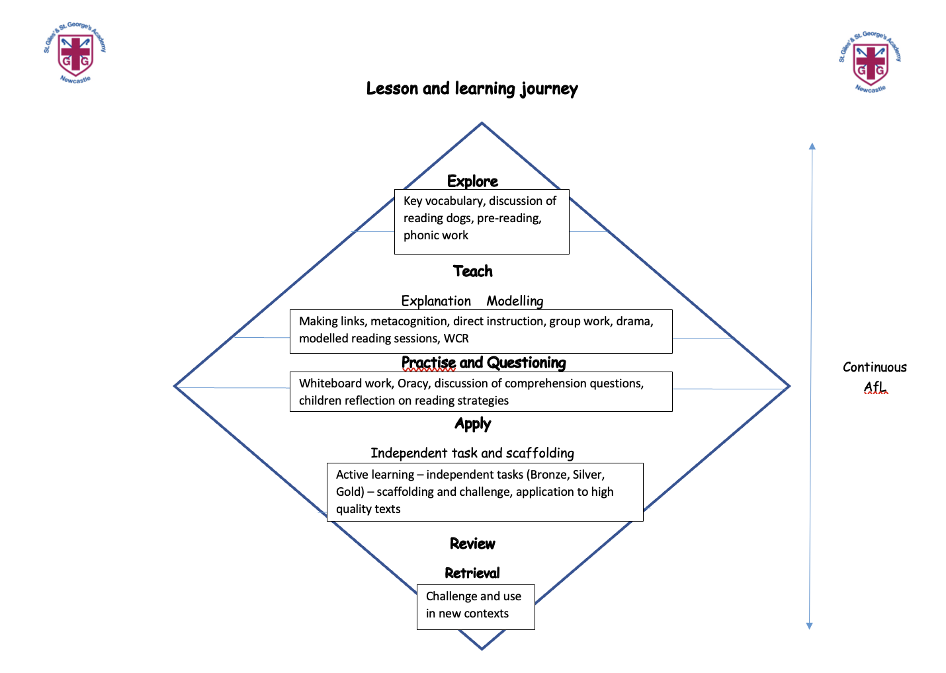

**Impact**

In addition to the outcomes shown on our curriculum tree the specific impact of the St Giles’ and St George’s Writing Learning Journey is that children will (as stated in the national curriculum):

* read easily, fluently and with good understanding
* develop the habit of reading widely and often, for both pleasure and information
* acquire a wide vocabulary, an understanding of grammar and knowledge of linguistic conventions for reading, writing and spoken language
* appreciate our rich and varied literary heritage
* use discussion in order to learn; they should be able to elaborate and explain clearly their understanding and ideas
* are competent in the arts of speaking and listening, making formal presentations, demonstrating to others and participating in debate

SEND Adjustments

To ensure all pupils can access our Writing curriculum and lessons, we make the following adjustments where necessary:

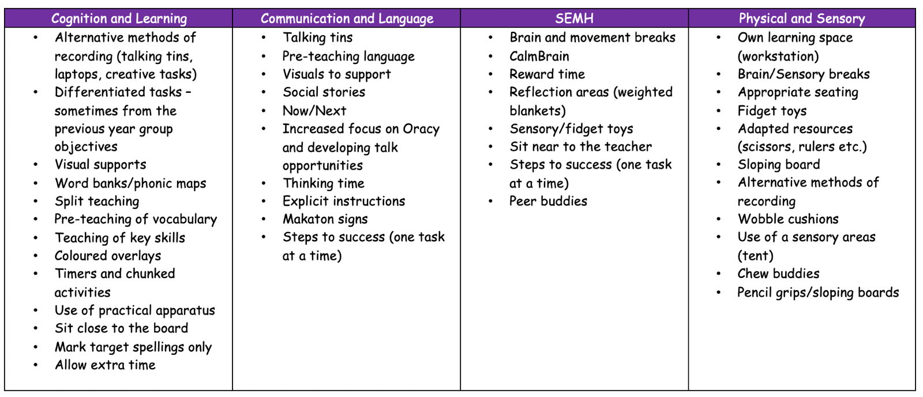

Lowest 20% offer

Text Box

|  |  |
| --- | --- |
| **EYFS**  **Loving and Compassionate**  How does Beegu show love and kindness?  **Grateful and Generous**  Why should we be thankful for the things that make us who we are?  **Curious and Active**  Why is it fun to explore new things, like Handa does on her walk?  **Attentive and discerning**  How can we be good listeners and pay attention to what's around us, just like Mr. Bear does when he's trying to sleep?  **Learned and Wise**  How do the skeletons learn new things as they go on their adventures at night?  **Faith-filled and Hopeful**  Why is it important to believe in yourself and know that you are special?  **Intentional and Prophetic**  How do the girls try to take care of the Bog Baby after they find him in the pond? | **KS1**  **Loving and Compassionate**  How does Princess Pearl show love and compassion by helping Zog and the other animals?  **Grateful and Generous**  How does Bella show generosity when she helps Dave get Dogger back?  **Curious and Active**  How does Vlad’s curiosity help him learn about the Great Fire of London?  **Attentive and Discerning**  How does Mr. Grinling pay close attention to make sure the lighthouse works and that the ships stay safe?  **Learned and Wise**  What does Sunny the meerkat learn when he travels to different places?  **Faith-filled and Hopeful**  How can having faith and hope help us turn something small into something beautiful, just like the tin forest?  **Intentional and Prophetic**  How can we be brave and stand up for others, like Traction Man, even when it's hard? |
| **LKS2**  **Loving and Compassionate**  How does Barney show love and compassion to Stig, even though they are very different?  **Grateful and Generous**  Why should we be grateful for the simple things in life and be generous in taking care of nature, like Brigg does?  **Curious and Active**  How does Alfred’s curiosity and bravery lead him to discover the truth about his kingdom?  **Attentive and Discerning**  How do the children and their community stay attentive to the needs of the rainforest and their way of life?  **Learned and Wise**  How can we be wise in handling difficult situations, like Rhodopis, and learn from our experiences?  **Faith-filled and Hopeful**  How does Phileas Fogg stay hopeful and full of faith in his plan, even when things go wrong on his journey?  **Intentional and prophetic**  How do Tranio and Livia act intentionally and show courage in trying to escape the danger of Pompeii? | **UKS2**  **Loving and Compassionate**  How does Michael show love and compassion toward Skellig, even when he doesn’t fully understand him?  **Grateful and Generous**  How does Hugo show gratitude and generosity through his relationships?  **Curious and Active**  How does Perilus’s curiosity help him discover new things and take action?  **Attentive and Discerning**  Why is it important to pay attention to the people around us and make thoughtful choices during difficult times, like George does?  **Learned and Wise**  How does Michael gain wisdom from Kensuke during their time together on the island?  **Faith-filled and Hopeful**  How does Daniel keep his hope alive, even when he’s faced with the mysteries of the Nowhere Emporium?  **Intentional and Prophetic**  How can we be intentional and brave in standing up for what is right, just like Beowulf does? |

Whole School Yearly Overviews

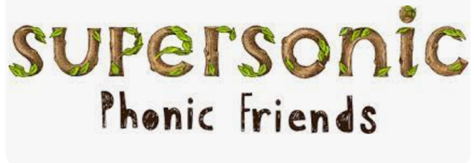

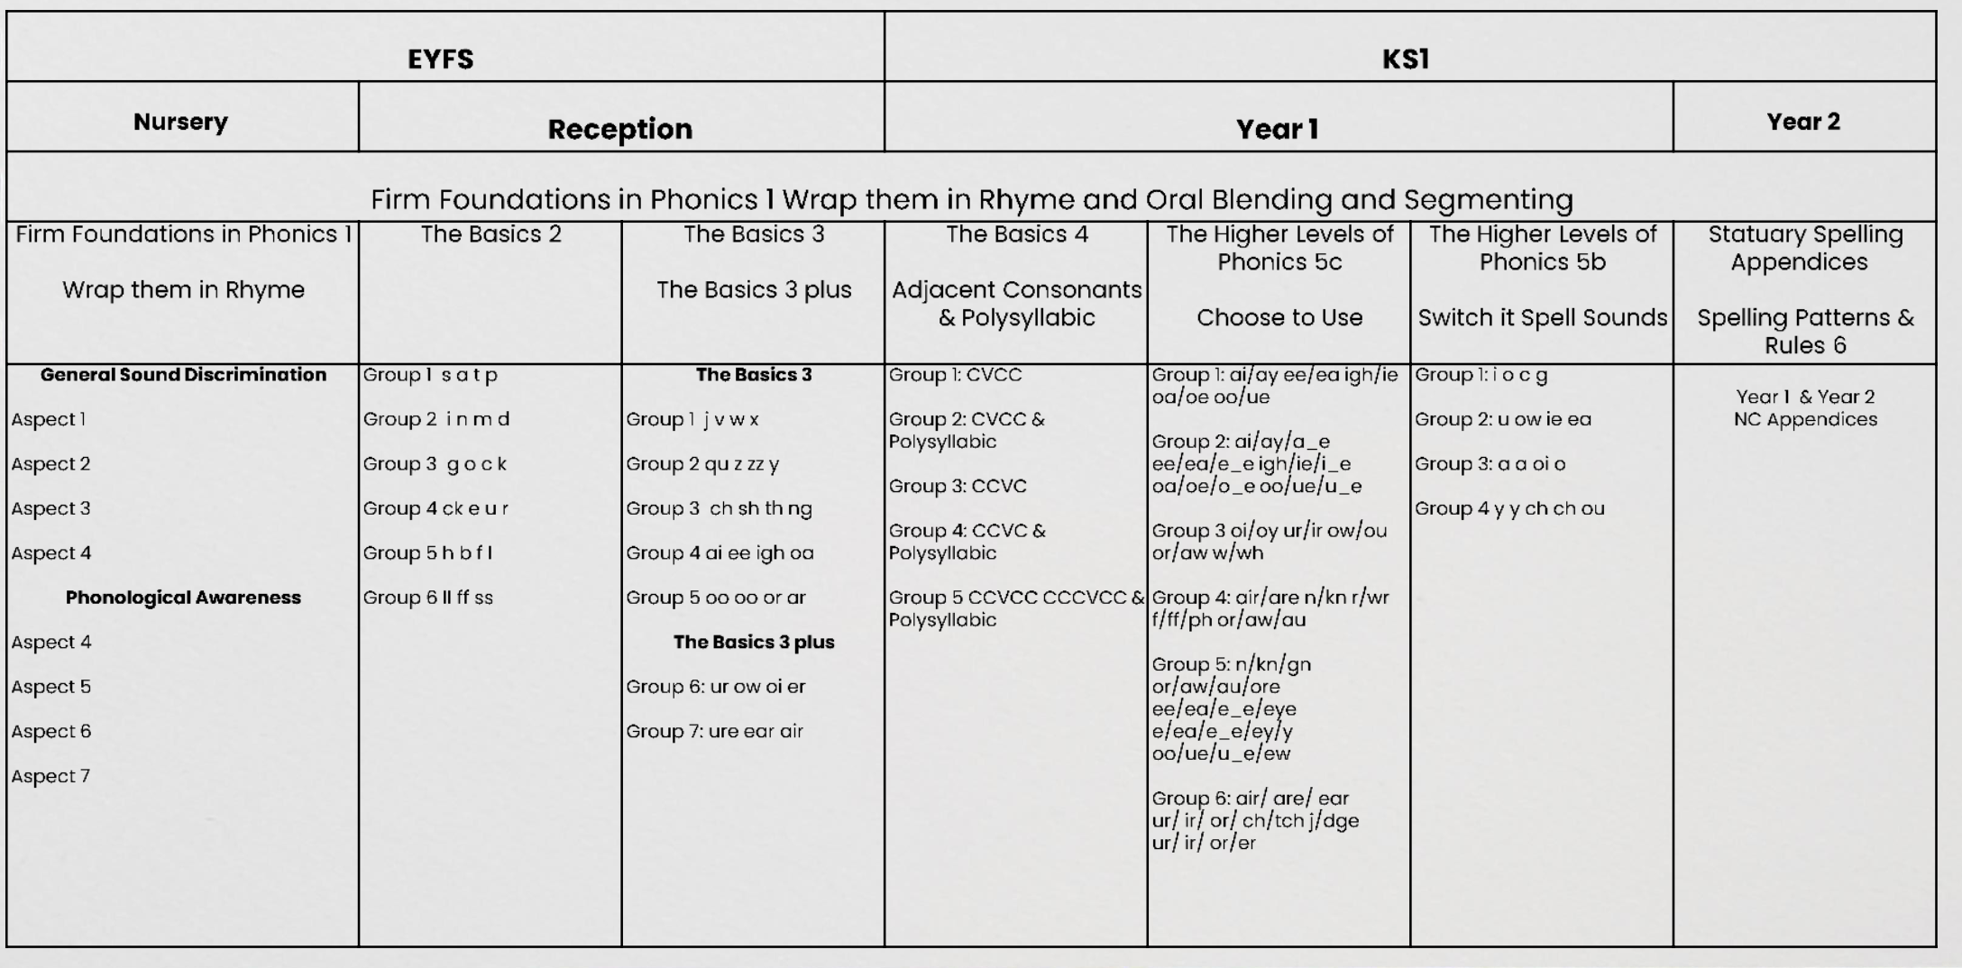

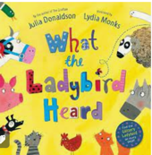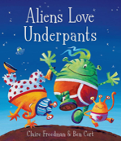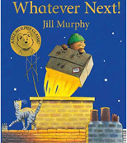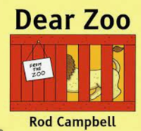

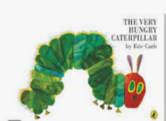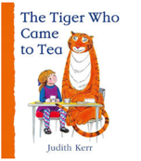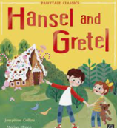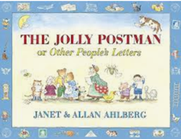Nursery

|  |  |  |  |  |  |  |
| --- | --- | --- | --- | --- | --- | --- |
|  | Autumn 1 | Autumn 2 | Spring 1 | Spring 2 | Summer 1 | Summer 2 |
| Texts | - No texts due to settling in period | -Hansel and Gretel  -Billy Goats Gruff  -Elves and the shoemaker  -Dear Zoo  -The Gruffalo  -Nativity | -Jack Frost  -Jolly Postman  -Zog and the Flying Doctor  -Mog and the VET  -Alan’s big scary teeth  -The Naughty Bus  -Dump Truck Disco | -Whatever Next  Aliens love underpants  -Supertato  -There’s a … in your book  -Alien tea on planet Zumzee  In addition there will be a child’s choice of text this half term. | -Rumble in the Jungle  -Tiger who came to tea  -The very hungry caterpillar  -Lost and found  -Where the wild things are  -How many legs  -Barry the fish with fingers | -What the ladybird heard at the seaside  -The train ride  -Shark in the Park  -Mr Grumpy’s outing  -The Frog Olympics |
| Poetry | Wheels on the bus, Pat a cake, I can sing a rainbow, Incy Wincy Spider, 1, 2, 3, 4, 5 once I caught a fish alive. | If you’re happy and you know it | Polly had a dolly | Twinkle Twinkle little star | 5 little monkeys and the crocodile | She’ll be coming around the mountain |
| Word Wizard vocabulary | 1. Pastures, gobbled  2. Leather, stitched  3. Shone, trail  4. Fierce, Scary  5. Prickles, roasted  6. Nativity | | 1. Glistening, crisp, slippery 2. Uniform, cackle, wobbled 3. Medicine, vaccinations, operations 4. Polishing, sharpening, dozing 5. Traffic, passengers, important 6. Project, excavator, equipment | 1. Roared, passengers, millions 2. Radar, underpants, flapping 3. Escaped, gasped, leapt 4. Imagine, adventure 5. Tingly, bold, hovers, dollops | 1. Rustling, chattering  2. Fury, stripy, suddenly  3. Cocoon, metamorphosis, nibbled  4. Harbour, lonely, searched  5. Ordinary, rumbling, squashed  6. Invited, rode, wiggling | 1. Perched, scrumptious, concocting 2. Gnash, mighty, cunning 3. Meadow, hauling 4. Telescope, terrible 5. Squabble, bleating, trample   Olympics, audience, bulgy |

Reception

|  |  |  |  |  |  |  |
| --- | --- | --- | --- | --- | --- | --- |
|  | Autumn 1 | Autumn 2 | Spring 1 | Spring 2 | Summer 1 | Summer 2 |
| Fiction Texts | -Funny bones  -Handa’s Surprise  -Super Duper you  -Only one you | -Peace at last  -The Bog Baby  -Beegu  -The way back home  -Father Christmas needs a wee | -Goldilocks  -Little Red Riding Hood  -The Gingerbread Man  -The three little pigs  -We’re going on a bear hunt  -Snowflake Mistake | -Egg drop by Mini Grey  -Hattie Peck Emma Levey  -Super Worm - Julia Donaldson  -The Growing story Ruth Krauss  -The Enormous Turnip  -Jack and the beanstalk | -Pirates love underpants  -How to be a pirate  -You’re not a proper pirate Sidney Green  -Pirates in the Supermarket  -A new home for a pirate | -The Rainbow fish  -The snail and the whale  -Tiddler the story telling fish  -Commotion in the Ocean  -Somebody swallowed Stanley |
| Poetry | Heads, shoulders, knees and toes | 5 little men in a flying saucer  When Santa got stuck up the chimney | When Goldilocks went to the bears house | There’s a worm at the bottom of the garden  Old McDonald | Aboard a Pirate ship | 5 fish that swim in the ocean  1,2,3,4,5, once I caught a fish alive |
| Non-fiction Texts | What makes me a me? Argh there’s a skeleton inside you | Nocturnal Animals information  Hibernating animals |  | Farm animals information  Plant and animals fact book  Insects information text | Pirate Information text | Sea: The big book of the blue |
| Word Wizard Vocabulary | Brave, berserk, wisdom, discover, cellar, texture, temperature, delicious, wonder. | Rustle, squelchy, peeped, victory, creatures, spluttered, flicker, flee, | Commands, chase, ruined, narrow, swishy, instruct, sly | Blasting, squirm, colossal, vast, bloomed, baffled, delved, swell, clambered. | Vessel, swagger, unfurl, expedition, nibbled, mob, announced. | Emerged, proud, hideous, towering, recycle, tugged, rose, captured, shivered, blubber, mighty |

Year 1

|  |  |  |  |  |  |  |
| --- | --- | --- | --- | --- | --- | --- |
|  | Autumn 1 | Autumn 2 | Spring 1 | Spring 2 | Summer 1 | Summer 2 |
| Fiction Texts |  | The Tin Forest   |  | Wild | Traction Man is Here!  (Toys in space) |  |
| Poetry | Now we are six – AA Milne |  | I opened a book – Julia Donaldson |  | Here is the seed – John Foster |  |
| Non-fiction Texts |  |  |  |  |  | Look inside a castle  Usborne - Look Inside A Castle - books4children |
| Word Wizard Vocabulary | Pointed, worn, dribbly, rather quiet, anxiously and searched. | sifting, tropical, exotic, toucans, awoke, sprouted, mingled, rustle | Keenest, soared, swooped, zigzagged, fearsome, soothing, capture and resounding. | whole, taught, strange, tame, wild, happily | rescuing, warfare, combat, captive, volunteered, overgrown, camouflage, wicked and mysterious | protected, guests, spiral, bustle, fancy, plucked, opponent, blunt and tournament. |

Year 2

|  |  |  |  |  |  |  |
| --- | --- | --- | --- | --- | --- | --- |
|  | Autumn 1 | Autumn 2 | Spring 1 | Spring 2 | Summer 1 | Summer 2 |
| Fiction Texts | The Queen’s Hat   | Meerkat Mail | Bob the man on the moon | The Lighthouse Keeper’s lunch  The Lighthouse Keeper's Lunch: Amazon.co.uk: Armitage, Ronda, Armitage,  David: Books | Vlad and the Great fire of London | Lila and the secret of rain |
| Poetry | Buckingham Palace – AA Milne |  | Rhythm of Life by Michael Rosen |  | Fruit Picking – Jack Ousbey |  |
| Non-fiction Texts | Non-fiction texts about the Queen and London |  | Non-fiction linked to explorers |  | The Great fire of London  Emma Adams |  |
| Word Wizard Vocabulary | Favourite, special, sword, monarch, landmark | Meerkat, Kalahari, relatives, disgusting, burrow, | Launch, souvenir, astronauts, tourist, craters, patiently, jetting, grubby | Perched, industrious, concocting, appetising, varmints, scrumptious, devoured, ingenious, brazen, jubilant. | Delicious, plague, flickered, blazing, encouragement, inferno, collapsing, quivering, possessions | Remained, failing, weeping, flocks, scorching, ebony, relieved. |

Year 3

|  |  |  |  |  |  |  |
| --- | --- | --- | --- | --- | --- | --- |
|  | Autumn 1 | Autumn 2 | Spring 1 | Spring 2 | Summer 1 | Summer 2 |
| Fiction Texts | Stig of the Dump | | Escape from Pompeii | Around the world in 80 days | The Egyptian Cinderella | The Lost Diary of Tutankhamun’s Mummy |
| Poetry | Please Mrs Butler – Allan Ahlberg |  | The Quangle wangles hat – Edward Lear |  | From a railway Carriage – Robert Louis Stevenson |  |
| Non-fiction Texts |  |  |  | Non- fiction texts based on water cycle |  |  |
| Word Wizard Vocabulary | Fossils, weeping, horseplay, goggling, midsummer, savage, spearman | | haggling, harbour , politicians, tremors, knucklebones, awning, pumice, Pompeii, stranded, earthquake | persuaded, stunned, idling, strode, rhythmically, procession, pyre, jeered, custodial, skulking | scoffed, gawked, soar, summoned, coaxed, papyrus, dainty, seldom | pyramids, barge, Pharoah, repetitive, hieroglyphic, broadens |

Year 4

|  |  |  |  |  |  |  |
| --- | --- | --- | --- | --- | --- | --- |
|  | Autumn 1 | Autumn 2 | Spring 1 | Spring 2 | Summer 1 | Summer 2 |
| Fiction Texts | The Beast of Buckingham Palace | | Vanishing Rainforest | The Flower John Light | Greek Myths |  |
| Poetry | On the Nong Ning Nang – Spike Milligan |  | Nature Trail – Benjamin Zephaniah |  | Leap like a Leapord – John Foster |  |
| Non-Fiction Texts |  |  | Non-fiction text on Rainforests | Once upon a raindrop: The story of water |  | Visitors Guide to Ancient Greece |
| Word Wizard Vocabulary | Fortress , Revolutionaries , Barge , Dictator , Ancient, Hobbled Samurai , Impeccable , Infinite , Centuries | | vanishing, hurried, distant, riverbank, precious, reward, offered, exchange, recovered, emergent, canopy, endangered, sustainable, rainfall, deforestation, equator | meteorites, endlessly, trail, anew, shifting, vapour, baptise, rehydrate, dim, smuggled, supposed, wandered, wrinkled, collected, disappointed, flowered, overjoyed, gravity | Hero, myth, voyage, siren, minotaur, Olympus, herculean, epic, mortal, immortal. | ancient, civilisation, philosophers, soothsayer, democracy, citizen, underworld, temple. |

Year 5

|  |  |  |  |  |  |  |
| --- | --- | --- | --- | --- | --- | --- |
|  | Autumn 1 | Autumn 2 | Spring 1 | Spring 2 | Summer 1 | Summer 2 |
| Fiction Texts | Romans on the Rampage |  | A book cover with butterflies and birds  Description automatically generated Journey to the River Sea | Nowhere Emporium | Beowulf | |
| Poetry | The Highwayman – Alfred Noyes |  | The Jabberwocky – Lewis Carroll |  | The Tale of Custard The Dragon – Ogden Nash |  |
| Non-fiction Texts |  | Wouldn’t Want to be a Roman Soldier | Shackleton’s Journey |  |  |  |
| Word Wizard Vocabulary | chariot, smithereens, remorseful, serene, engulfed, crestfallen, cawing, peevish, advised, ignorance, sauntered, jaded, abominably, obscuring, | Barracks  Centurion  Legionary  Recruits  Origin  Fort  Amputate | Ancestral, dismal, thrifty, livery, aristocrat, preserved, missionaries, septic | Occurrence, lunatic, contemplate, hearsay , solitary, glimpse, flourishes, oblivious, sarcophagus | Tousled, gnawed, imitate, poised, hoarse, parapet, ambush, scowled, charred, beckoned | |

Year 6

|  |  |  |  |  |  |  |
| --- | --- | --- | --- | --- | --- | --- |
|  | Autumn 1 | Autumn 2 | Spring 1 | Spring 2 | Summer 1 | Summer 2 |
| Fiction Texts | Blitzed  by Robert Swindells    One Boy’s War and FarTher | | Kensuke’s Kingdom by Michael Morpurgo   | Skellig by David Almond | Hugo Cabret  by Brian Selznick | |
| Poetry | In Flanders Fields |  |  | The Tyger by William Blake | Macavity’s the Mystery Cat |  |
| Non-fiction Texts |  | Non-fiction  WW2 | Charles Darwin – The Voyage of the Beagle  Or Amazing Evolution |  |  | |
| Word Wizard Vocabulary | loiter, recumbent, condemned, threshold, manoeuvred. Amends, dawdle, mildewed, larks, amid, scarce, quarrel, foe, evacuation, allies, propaganda, holocaust, conscription, rationing, annexed | | Anguish , brackish,  Cockpit, deter,  Exhilarating, flounder,glimpse, hurl, immaculate,  lurk, marooned,  obstinate, porpoise,  ravenous, skipper,  talisman, vestige,  wary | Arthritis, lurched, ancestors, wrenched, calcification, fledglings, plumes, anaesthetic, hostile | lumination, diligently, mechanism, decrepit, summon, instinctively, optimistic, accusation | |

Whole School Progression of Skills (adapted from the National Curriculum statements)

Whole School Yearly Overviews

|  |  |  |  |  |  |  |  |  |  |  |  |  |
| --- | --- | --- | --- | --- | --- | --- | --- | --- | --- | --- | --- | --- |
|  | **EYFS** | **Year 1** | **Year 2** | **Year 3** | | **Year 4** | **Year 5** | | **Year 6** | | | |
| Word Reading | Identify the taught GPCs (the sounds that the letters make) including some digraphs.  Blend the taught sounds to read CVC, CVCC and CCVC words  Read some taught common exception/ high frequency and familiar words.  Read sentences made up of words with taught sounds and common exception words | read aloud phonically-decodable texts  speedily read all 40+ letters /groups for 40+ phonemes including alternative sounds for graphemes  read Year 1 common exception words  read polysyllabic words containing taught GPCs  read common suffixes (–s, –es, –ing, –ed, –er and –est)  read contractions and understand that the apostrophe represents the omitted letter(s) | apply phonic decoding until automatic and reading is fluent  read common suffixes (-ed, -ing,-er, -est, -y, -er, -ment, -ful, -ness, -less, -ly  note punctuation to read with appropriate expression  read Year 2 common exception words  read polysyllabic words containing above graphemes  read most words quickly & accurately without overt sounding and blending | apply their growing knowledge of root words, prefixes and suffixes (morphology and etymology), both to read aloud and to understand the meaning of new words they meet  read further exception words, noting the unusual correspondences between spelling and sound, and where these occur in the word | | | apply their growing knowledge of root words, prefixes and suffixes (morphology and etymology), both to read aloud and to understand the meaning of new words that they meet | | | | |
| Vocabulary | Use phonic, semantic and syntactic knowledge to understand unfamiliar vocabulary  Use and understand recently introduced vocabulary during discussions | Can tick a word that means the same as….  Can find and copy a word that means the same as… | Can find and copy a word that means the same as…  Can tick a word/ group of words that mean the same as….  Can match a word in the text to its implied meaning | Can find and copy a word that means the same as...  Can match the underlined word in a sentence to the correct definition  Can use a dictionary to look up the meaning of a word | | | Can find and copy a word or a group of words that means the same as….  Can match the underlined word in a sentence to the correct definition  Give the meaning of words in certain sentences (words with more than one meaning) | | | | |
| Retrieval | Answer simple retrieval questions.  Describes main story settings, events and principal characters | Can locate specific information- where, when, who, what  Can tick whether a statement is true or false | Can locate specific information- who/ what/ where/ when.  Can tick whether a statement is true or false  Can give more than one answer to the same question  Can tick correct response in a table of different options | Can locate information by skimming (for a general impression) and scanning (to locate specific information)  Can use text marking to retrieve information or ideas from texts (e.g. highlighting, notes in the margin).  Can quote from the text to answer a retrieval question  Can answer true or false statements about the text | | | Can quote from the text to answer a retrieval question with more than one answer (Give 3 things)  Can identify and explain the difference between fact and opinion.  Can answer true or false statements about the text | | | | |
| Inference | Discuss the significance of the title and events  Give my opinion on what I have read. | Can tick the correct statement about a story when the information is implied and not stated  Can write down an answer to a question where the information is not directly in the text (why) | Can tick the correct statement about a story when the information is implied and not stated  Can write down one or more answer to questions where the information is implied.  Can find a quote in the text to back up their answer  Can find and copy words that show… (inferring meaning from context) | Can explain how and why main characters act in certain ways in a story or why events happen (How do you know, what evidence is there to suggest…)  Uses quotes from the text to explain their inferences | Can read between the lines, using clues from action, dialogue and description to interpret meaning and / or explain what characters are thinking / feeling and the way they act (Ticks correct answer)  Can understand and explain different characters’ points of view. (What evidence is there to suggest..)  Can infer meaning, using evidence from the text and wider experiences (uses quotes to back up answer) | | Infers straight forward answers by ticking correct meaning (As the sun rose- ticks morning)  Can refer to the text to support inferences about characters/setting/action (how can you tell that)  Can answer ‘according to the text questions’ using (PE model) | Can securely make deductions firmly rooted in the evidence in the text- ‘according to the text questions’ using (PE model point-evidence)  Infers straight forward answers by ticking correct meaning (As the sun rose- ticks morning)  Can refer to the text to support inferences about characters/setting/action (how can you tell) | | |
| Summarising  /Sequencing | Can retell familiar stories with detail, telling the main events in order.  Describe the main events in the simple stories they have read. | Can sequence pictures about a story  Can sequence events in a story by numbering statements | Can number statements about the story putting them in time order  Can sequence events in a text- picking out the key events. | Can explain what the topic of the paragraph is about  Can order events in a text referring back to the text to support this | | | Can summarise what paragraphs are about and how they are linked  Can order events in a text referring back to the text to support this | | | Can match paragraph summaries to relevant part of the text  Can order events in a text referring back to the text to support this | |
| Predicting | Suggests how a story might end  Anticipates key events and phrases in rhymes and stories | Makes predictions about the text based on what has been read | Can predict the ending or a story from what they have read so far.  Can predict what might happen to a character from details stated or implied. | Can make plausible predictions based on knowledge from text  Can back up their predictions with a quote from the text | | | Can refer to the text to support predictions and opinions (What evidence is there to suggest?)  Can make plausible predictions based on knowledge from text or what is implied  Can back up their predictions with a quote from the text using (PE model point-evidence) | | | | |
| Commentating |  |  |  | Can comment on why a title is large- to grab your attention, why something may be in bold (glossary, draw reader’s attention to it), in fiction can say how the beginning and ending of the story are similar or linked and why paragraphs are used  Can label different parts of texts studied- sub headings, title, headline, diagram etc. Matches quotes to correct part of story (setting, action etc.) | | Can use knowledge of text structure to locate information (e.g. use appropriate heading and sub-heading in non-fiction, find relevant paragraph / chapter in fiction).  Can compare the structure of different stories to discover how they differ in pace, build up, sequence, complication and resolution. | Can explain the structural devices an author has used to organise a text (e.g. going beyond the superficially obvious in fiction, such as decisions about plot structure or flash backs)  Can identify the ways in which paragraphs are linked (e.g. use of connecting adverbs, pronouns for character continuity). | Can give detailed insight into how the structural choices support the writer’s theme or purpose (e.g. decisions about plot structure, mapping character development through a whole text, flash backs)  Can discuss the range of organisational features used and how they contribute to the overall effect of the text (e.g. how a writer changes viewpoints within a text; how a writer organises information) | | |
| Author’s use of language |  |  |  | Identifies how the author uses words or phrases to paint pictures in the reader’s mind  Can explore potential meanings of ambitious vocabulary (WOW Words) read in context (using knowledge of etymology (the word origin), morphology (structure- the ‘root’ word plus prefix /suffix), or the context. | | | Can clarify the meanings of ambitious words and / or phrases in context  Can talk about the effects of different words and phrases to create different images and atmosphere (e.g. powerful verbs, descriptive adjectives and adverbs) and in non-fiction texts  Can discuss how an author builds a character through dialogue, action and description. | Can discuss the difference between literal and figurative language and the effects of imagery- what impressions do you get of..  Can evaluate how messages, moods, feelings and attitudes are conveyed in poetry, prose and non-fiction, making reference to the text.  Can say what impressions they get from the words used to describe settings/character  Can recognise the use of irony and comment on the writer’s intention (e.g. sarcasm, insincerity, mockery). | | |

|  |  |  |  |  |  |  |  |  |  |  |  |  |  |  |  |  |  |  |  |  |  |  |  |
| --- | --- | --- | --- | --- | --- | --- | --- | --- | --- | --- | --- | --- | --- | --- | --- | --- | --- | --- | --- | --- | --- | --- | --- |
| **Firm Foundations in Phonics** | | | | | | | | | | | | | | | | | | | | | | | **Which books to be sent home when?** |
| Lilac books | | | | | | | | | | | | | | | | | | | | | | | Lilac books to be sent home while Firm Foundations are being covered and Basics 2 group one introduced |
| **The Basics 2** | | | | | | | | | | | | | | | | | | | | | | |
| Group 1 | | Group 2 | | | | | Group 3 | | | | Group 4 | | | | Group 5 | | | | | Group 6 | | | To be sent home once that group of sounds have been taught |
| Pink books | | | | | | | | | | | | | | | | | | | | | | | Children consolidate their knowledge of Basics 2 sounds while Basics 3 is being introduced |
| **The Basics 3** | | | | | | | | | | | | | | | | | | | | | | |
| Group 1 | Group 2 | | | | | Group 3 | | | | Group 4 | | | Group 5 | | | | Group 6 | | | | | Group 7 | To be sent home once that group of sounds have been taught |
| Red books | | | | | | | | | | | | | | | | | | | | | | | Children consolidate their knowledge of Basics 2 sounds while Basics 4 is being introduced |
| Yellow books | | | | | | | | | | | | | | | | | | | | | | |
| **The Basics 4** | | | | | | | | | | | | | | | | | | | | | | |
| Group 1 | | | | Group 2 | | | | | Group 3 | | | | | Group 4 | | | | | Group 5 | | | | To be sent home once that group of sounds have been taught |
| Blue books | | | | | | | | | | | | | | | | | | | | | | | Children consolidate their knowledge of Basics 2 sounds while The Higher level choose to use are being introduced |
| **The Higher Levels – Choose to use** | | | | | | | | | | | | | | | | | | | | | | |
| Group 1 | | | Group 2 | | | | | Group 3 | | | | Group 4 | | | | Group 5 | | | | | Group 6 | | To be sent home once that group of sounds have been taught |
| **The Higher Levels – Switch it spellings** | | | | | | | | | | | | | | | | | | | | | | |
| Group 1 | | | | | Group 2 | | | | | | | Group 3 | | | | | | Group 4 | | | | | To be sent home once that group of sounds have been taught |
| Green books | | | | | | | | | | | | | | | | | | | | | | | Children to consolidate their knowledge of all the sounds so they become confident and fluent readers |
| Orange books | | | | | | | | | | | | | | | | | | | | | | |
| Turquoise books | | | | | | | | | | | | | | | | | | | | | | |
| Purple books | | | | | | | | | | | | | | | | | | | | | | |
| Gold books | | | | | | | | | | | | | | | | | | | | | | |
| White books | | | | | | | | | | | | | | | | | | | | | | |

Reading Assessment Grids

|  |  |  |  |
| --- | --- | --- | --- |
| EYFS | | | |
| Birth to 3 years | 3 to 4 years | ELG |
|  |  |  |

|  |  |  |
| --- | --- | --- |
| Pre-Key Stage 1 | | |
|  | Word Reading | Language Comprehension | |
| Standard 1 |  |  | |
| Standard 2 |  |  | |
| Standard 3 |  |  | |
| Standard 4 |  |  | |

|  |  |  |  |
| --- | --- | --- | --- |
| Year 1 | | | |
|  | WTS | EXS | GDS |
| Word Reading |  |  |  |
| Comprehension |  |  |  |

|  |  |  |  |
| --- | --- | --- | --- |
| Year 2 (Teacher Assessment Framework) | | | |
|  | Word Reading | Language Comprehension |
| WTS |  |  |
| EXS |  |  |
| GDS |  |  |

|  |  |  |
| --- | --- | --- |
| Pre-Key Stage 2 | | |
|  | Word Reading | Language Comprehension | |
| Standard 1 | See Pre-Key Stage 1 assessment grid | | |
| Standard 2 |
| Standard 3 |
| Standard 4 |
| Standard 5  (WTS KS1) |  |  | |
| Standard 6  (Working at KS1 expected) |  |  | |

|  |  |  |  |
| --- | --- | --- | --- |
| Year 3 | | | |
|  | WTS | EXS | GDS |
| Word Reading |  |  |  |
| Comprehension |  |  |  |

|  |  |  |  |
| --- | --- | --- | --- |
| Year 4 | | | |
|  | WTS | EXS | GDS |
| Word Reading |  |  |  |
| Comprehension |  |  |  |

|  |  |  |  |
| --- | --- | --- | --- |
| Year 5 | | | |
|  | WTS | EXS | GDS |
| Word Reading |  |  |  |
| Comprehension |  |  |  |

|  |  |  |  |
| --- | --- | --- | --- |
| Year 6 | | | |
|  | WTS | EXS | GDS |
| Word Reading |  |  |  |
| Comprehension |  |  |  |