

Geography Curriculum

 | Autumn 1 | Autumn 2 | Spring 1 | Spring 2 | Summer 1 | Summer 2
Reception | Marvellous Me  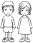 |  | The Farm   |  | Pirates  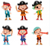
Year 1 | School/Toys  How was life like in the past?  Who am I?  What makes me me? |  | What is it like here? (including weather)    What excites me about the future? |  | What is it like to live in Shanghai?  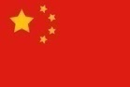  What is the most beautiful thing in the world?
Year 2 | Would you prefer to live in a hot or cold place?    How does the weather effect our mood? |  | Explorers  How have explorers changed the world?  Is it okay to try and give up? |  | Great Fire of London  Who was to blame for the Great Fire of London?  How can I demonstrate compassion?
Year 3/4  (A) | Stone Age  Would you prefer to live in Stone Age, Bronze Age or Iron Age?  What do I deserve in life? |  | Are all settlements the same? (Stoke)    What is the purpose of the earth? |  | Ancient Egypt  What were the significant achievements of the Ancient Egyptians?  Is it good that we can’t explain everything?
Year 3/4  (B) | Mayans  Who were the Mayans and what can we learn from them?  Is having belief in something important? |  | Why are rainforests important to us?    What would it be like without seasons? |  | Why do people live near volcanoes?    Why do destructive things happen?  Should we try to tame nature?
Year 5/6  (A) | Romans  Why were the Romans so powerful?  How do we know what we don’t know?  What is unknowable? |  | Why do oceans matter?    What is a perfect world and how would we achieve it?  What else is there to discover? |  | Why do populations change?    Is it better to please oneself or others first?
Year 5/6  (B) | World War II and the Battle of Britain  Why was the Battle of Britain significant in WWII?  Why do people have to suffer? What is pain? |  | Where does energy come from?    What lasts forever? |  | Local History  How did mining impact the local area of Apedale?  What is worth striving for?  Is being fair the right thing to do?

Intent, Implementation and Impact

Inspired by our Christian faith, we guide children on a personalised journey towards achievement. As a learning community, we are committed to ensuring that children are equipped with, skills and aspirations to reach their full potential in mind, body, heart and spirit.

Intent
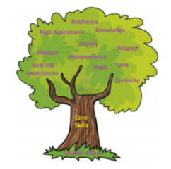
All areas of our curriculum are underpinned by our Gospel values, and we ensure that our curriculum makes links to these values. At the heart of each subject is a set of core skills which form a subject learning journey, this journey is built from EYFS through to year 6 and the skills progressive as you move through the school. Knowledge is communicated to ensure coverage of National curriculum and it is through this knowledge that children apply their skills. Children at St Giles’ and St George’s leave with a secure knowledge of both the academic knowledge and skills needed for the next stage of their education. They will have developed a clear set Christian and moral values which they can apply in all areas of their lives and will have taken part in real-life experiences which will have raised their aspirations and given them a thirst for wisdom and knowledge.

The intention of the St Giles’ and St George’s Geography learning journey is to inspire all pupils develop their knowledge of the world, an understanding where they live and their impact on our lives today and as a result understand how they can make a positive impact on the world. We focus on developing the skills, knowledge and understanding that children need in order find out about the world, so they have the skills to continually develop their skills and knowledge throughout their lives.

Implementation

St Giles’ and St George’s Geography Learning Journey focuses on a spiral curriculum model where previous skills and knowledge are revisited and built upon. Over the course of the journey, children will focus on both declarative and procedural knowledge. Declarative knowledge in Geography is the factual knowledge surrounding the world we live in. This knowledge is not a list of disconnected facts; it is explicitly linked to the content being taught. Procedural knowledge can be viewed as the know-how to apply declarative facts. This might include applying their geographical map skills in another context.

Geography is taught on alternate terms and for an hour a week or two hours every two weeks. At the start of each unit of work, children answer the key question using the knowledge that they already have. The children are then introduced to additional key knowledge around the topic which will be shared during the unit in the form of a knowledge organiser. Parts of the knowledge organiser will be shared at the start of each lesson with key knowledge for each lesson snipped. During the lesson activities are differentiated were appropriate and assessment or feedback will focus on misconceptions and next steps for learning. At the end of the topic the children answer the key question using a range of methods to allow all children to show the knowledge they have learnt. Any skills or knowledge they have used will be highlighted by the teacher followed by the teacher highlighting WTS, WW or GD on an end of unit assessment sheet. In Geography, work is recorded in an exercise book and marked in line with the marking policy.

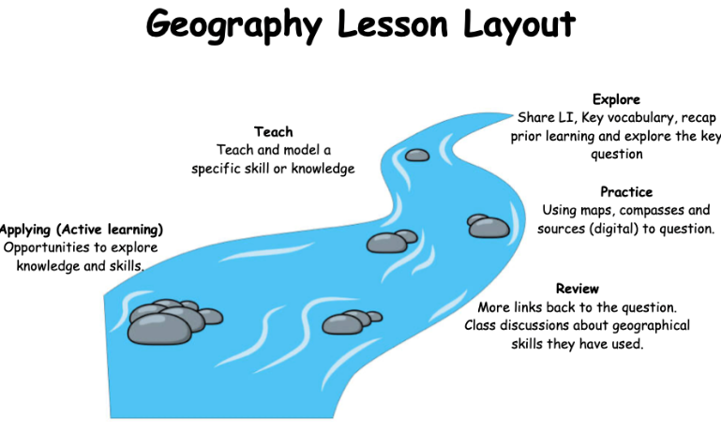
Impact
In addition to the outcomes shown on our curriculum tree the specific impact of the St Giles’ and St George’s Geography Learning Journey is that children will (as stated in the national curriculum):
- develop contextual knowledge of the location of globally significant places – both terrestrial and marine – including their defining physical and human characteristics and how these provide a geographical context for understanding the actions of processes.
- understand the processes that give rise to key physical and human geographical features of the world, how these are interdependent and how they bring about spatial variation and change over time.
- collect, analyse and communicate with a range of data gathered through experiences of fieldwork that deepen their understanding of geographical processes.
- interpret a range of sources of geographical information, including maps, diagrams, globes, aerial photographs and Geographical Information Systems (GIS)
- communicate geographical information in a variety of ways, including through maps, numerical and quantitative skills and writing at length.
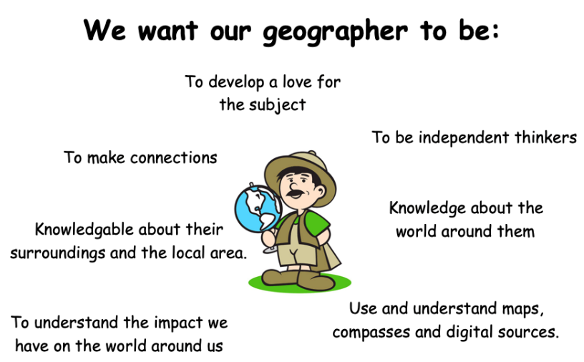
Formative assessment takes part in each lesson and misconception and next steps of the focus for feedback. Summative assessment is completed for each child at the end of each unit of teaching using the assessment framework at the end of this document. A best fit approach to statements achieved results in an end of year summative grade.
EYFS
As part of Development Matters (2021), Geography is taught in relation to the strand ‘Understanding the world’. Children have a key question which is planned for each half term. Lessons take the form of adult-led inputs. The amount varies dependent on the theme. There will then be an independent activity relating to the input.

All classrooms have an investigation station. As part of this, Humanities based enhanced provision will be planned for each half term. Humanities based enhanced and child-initiated provision may also be found in the Construction area, for instance building a farm or a city. Humanities may also be found in the outside provision, either enhanced or child-initiated, such as treasure hunts, map drawing.

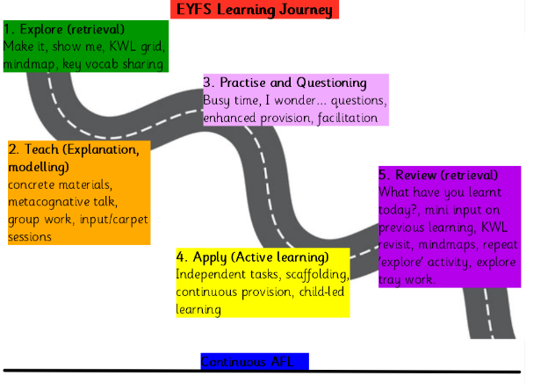

GOSPEL VALUES
EYFS  Attentive and Discerning:  What is the weather like at this time of year?  Curious and Active  How does where we live compare to the woods?  Earth or the moon, where would you prefer to live?  What do I like about where I live?  Faith- filled and Hopeful  Where do I hope to travel to? | KS1  Loving and Compassionate  What is there for me to do at the seaside?  Faith- filled and Hopeful  Locate the churches of St Giles and St Georges on a local map.  When have I had to have faith and be brave?  Grateful and Generous  What am I thankful for in our world?  Are we lucky to live in the United Kingdom?
LKS2  Grateful and Generous  Is everyone lucky enough to have water?  Curious and Active  How do Earth’s actions affect people and the environment?  How can we be more conscious of where our food comes from?  Learned and Wise:  What changes can I make to look after our planet? | UKS2  Compassionate and loving:  What do I like most about my local area?  Faith filled and hopeful:  How can we protect the Amazon?  Attentive and Discerning:  What changes in the world might take place again that will affect me in my lifetime?  Learned and Wise  How should we look after our land?

SEN Adjustments
In our history lessons we adjust our lessons using the following strategies:

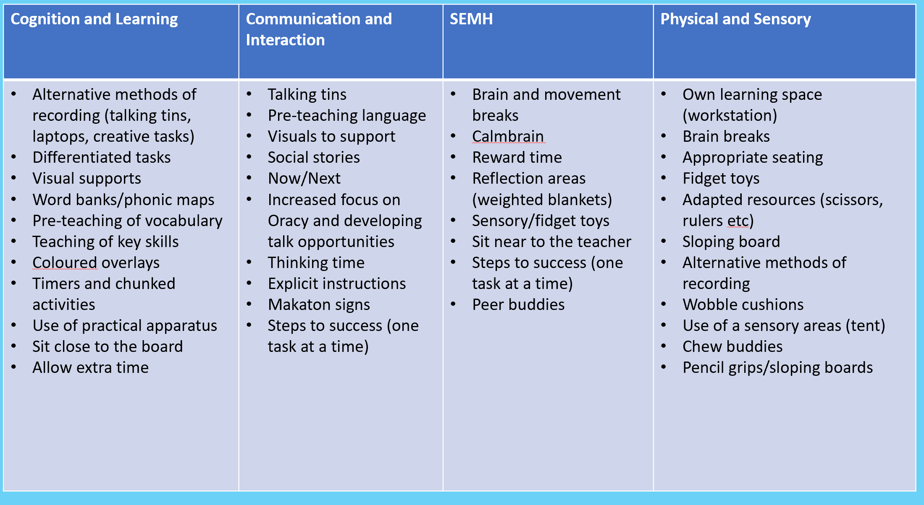

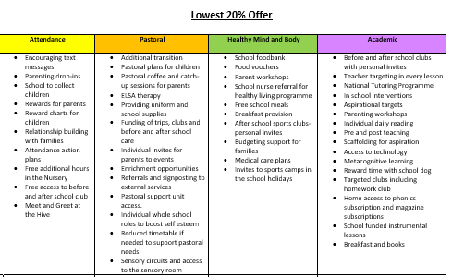
Geographical Knowledge and Skills

Locational Knowledge
 | EYFS | KS1 | LKS2 | UKS2
Knowledge | Know that there are different countries in the world. | To know that the United Kingdom is made up of four countries and their names.  To name some characteristics of the four capital cities of the UK  To name the capital cities of the four countries of the UK | To know the names of countries and major cities that we have studied.  To know the main types of land use (Agricultural, industrial, commercial, residential, recreational and transportation).  To start to know the four main types of settlements.  To know the world’s different climate zones (equatorial, tropical, hot desert, temperate and polar).  To know the Tropics of Cancer and Capricorn are lines of latitude and mark the equatorial region, the countries with the hottest climates. | To know most counties and cities in the UK.  To know that London and the Southeast regions have the largest population in the UK.  To start to know all the world’s biomes.
Skills | Use a map to locate their local area. | Using an atlas to locate the four capital cities of the UK (Belfast, London, Cardiff and Edinburgh).  Using a world map, globe and atlas to locate all the world’s seven continents.  Using a world map, globe and atlas to locate the world’s five oceans. | Beginning to use maps at more than one scale.  Using atlases, maps, globes, satellite images and beginning to use digital mapping to locate different countries.  Using atlases, maps, globes and beginning to use digital mapping to recognise and describe physical features and human features in different countries.  Using the scale bar on a map to estimate distances.  Finding features of different countries in an atlas using contents and index.  Zooming in and out of a digital map. | Confidently use and understand maps at more than one scale.  Using atlases, maps, globes and digital mapping to locate different countries.  Using atlases, maps, globes and beginning to use digital mapping to recognise and describe physical features and human features of different countries.  Using the scale bar on a map to calculate distances.  Recognising an increasing range of Ordnance Survey symbols on maps and locating features using six-figure grid references.  Recognising the difference between Ordnance Survey and other maps and when it is most appropriate to use each.  Beginning to use thematic maps to recognise and describe human and physical features studied Using models and maps to talk about contours and slopes.  Selecting a map for a specific purpose.
Place Knowledge
 | EYFS | KS1 | LKS2 | UKS2
Knowledge | Understand that some places are special to members of their community. | Naming some key similarities and differences between Newcastle under Lyme and another country (Size, location, culture and environment).  Describing and begin to explain some key similarities and differences between two different countries (Size, location, culture and environment). | Describing and begin to explain similarities and differences between Stoke on Trent and surrounding areas (Size, location, culture and environment).  Describing how and why humans have responded in different ways to their local environments.  Describing and explaining similarities and differences between two countries (Size, location, culture and environment).  Describing how and why humans have responded in different ways to their local environments.  Discussing how climates have an impact on trade, land use and settlement.  To know the negative and positive effects of living near a volcano and impact of an earthquake. | Describe and explain with confidence the similarities and difference between England and Australia (Size, location, culture and environment).  Explaining how and why humans have responded in different ways to their local environments in two contrasting regions (London and Sydney). Understanding how climates impact on trade, land use and settlement.  With confidence, describe and explain similarities and difference between two environmental regions studied (Size, location, culture and environment).  Explaining how and why humans have responded in different ways to their local environments in two contrasting regions (Any countries that have been studied).  Understanding how climates impact on trade, land use and settlement.  Explaining how humans have used desert environments.
Skills | Use a wide range of vocabulary to talk about what they see. |  | Start to discuss how climates have an impact on trade, land use and settlement.
Human Knowledge
 | EYFS | KS1 | LKS2 | UKS2
Knowledge | Begin to understand the need to respect and care for the natural environment and all living things. | Recognising some human features in Newcastle-Under-Lyme (housing, town, cinema and shops). To know that human features mean any feature of an area that was made or built by humans. Describing the key human features of Kenya and Finland using subject specific vocabulary. To know that human features change over time. Describing and understanding the differences between a city, town and village. | Start to describe and understand types of settlement and land use.  Start to explain why people might prefer to live in an urban or rural place.  Explaining why a settlement and community has grown in a particular location.  Describing how a locality has changed over time, giving examples human features.  Describing and understanding types of settlement and land use.  Explaining why a settlement and community has grown in a particular location.  Describing how a locality has changed over time, giving examples human features.  Describing how humans can impact the environment both positively and negatively. To know the threats to the rainforest both on a local and global scale. | To know which factors are considered before people build settlements.  Describing the ‘push’ and ‘pull’ factors that people may consider when migrating.  Recognising geographical issues affecting people in different places and environments. Understanding the distribution of natural resources globally.  To know some positive and negative impacts of humans on the environment.  To know which factors are considered before people build settlements.  Understanding how land-use has changed over time in the United States.  Recognising geographical issues affecting people in different places and environments. Describe and understand economic activity including trade links.  Understanding the distribution of natural resources both globally and within the United States.  To know that natural resources can be used to make energy.  To know some positive and negative impacts of humans on the environment.
Skills | Recognise some environments are different to the one in which they live. |  | Identifying key human characteristics of local area and another area.  Identifying key human characteristics of different locations (key landmarks such as housing, transport and historic landmarks). | Identifying key human characteristics of key cities (key landmarks such as housing, transport and historic landmarks).  Identifying key human characteristics of different specific locations (key landmarks such as housing, transport and historic landmarks).
Physical Features
 | EYFS | KS1 | LKS2 | UKS2
Knowledge | Begin to understand the need to respect and care for the natural environment and all living things.  Recognise some environments that are different to the one in which they live. | To know that physical features mean any feature of an area that is on the Earth naturally. Recognising some physical features in Newcastle-Under-Lyme (Lyme Valley Park, River Trent and farmland).  Describing how the weather changes with each season in the UK.  Describing the daily weather patterns in Newcastle Under Lyme.  To know the four seasons of the UK.  To know that different parts of the UK often experience different weather.  To know that weather conditions can be measured and recorded.  Describing what physical features may occur in a hot place in comparison to a cold place. To know that hot and cold countries will experience different weather conditions.  To know that the Equator is an imaginary line around the middle of the Earth. | Describing how physical features has changed over time (Lyme Valley Park, River Trent and farmland).  Describing how physical features has changed over time (Amazon rain forest and Mount Fuji). Describing and explaining how physical features such as rivers, mountains, volcanoes and earthquakes have had an impact upon the surrounding landscape and communities. To know the world’s biomes and the hottest biomes are found between the tropic of cancer and Capricorn.  Understanding some of the causes of climate change (Cutting down forests and transport).  To know that climates can influence the foods able to grow.  To know that the water cycle is the processes and stores which move water around our Earth and to be able to name these.  To know the courses and key features of a river. | Start to describe and understanding the key aspects of the six biomes.  Start to describe and understand the key aspects of the six climate zones. Understanding more causes of climate change (Cutting down forests, transport and powering).  To know why the ocean is important.  Understanding how land-use has changed over time in the United States. Describing and understanding the key aspects of the six climate zones. Understanding more causes of climate change (Cutting down forests, transport, generating and using powering). Describing and understanding the key aspects and distribution of the vegetation belts in relation to the six biomes, climate and weather. Giving examples of alternative viewpoints and solutions regarding an environmental issue and explaining its links to climate change.
Skills |  | Identifying physical characteristics of the four capital cities of the UK (Parks, Rivers and the surrounding areas). | Locating some key physical features in Stoke (Parks, Rivers and the surrounding areas).  Identifying some physical characteristics of the geographical regions (Mount Fuji and River Amazon). | Identifying physical characteristics of the geographical regions (ocean beds and coral reefs). Locating key physical features of London and Australia (The river Themes and the great barrier reef).  Identifying physical characteristics of the geographical regions (Parks, Rivers and the surrounding areas).
Geography Progression of Skills
 | EYFS | KS1 | LKS2 | UKS2
Question   | Ask questions about the world around them. | Recognising there are different ways to answer a question. | Beginning to choose the best approach to answer an enquiry question. | Developing their own enquiry questions.
Observe   | Commenting on the features they see in their school and school grounds. | Asking and answering simple questions about human and physical features of the area surrounding their school grounds. | Observing, recording, and naming geographical features in their local environments. | Making an independent or collaborative plan of how they wish to collect data to answer an enquiry-based question.
Measure  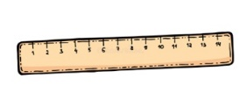 | Answering simple questions, guided by the teacher. | Collecting quantitative data through a small survey of the local area/school to answer an enquiry question. | Designing a questionnaire / interviews to collect quantitative fieldwork data. | Selecting appropriate methods for data collection.
Record   | Creating some of the features they notice in their school and school grounds. | Drawing some of the features they notice in their school and school grounds in correct relation to each other on a sketch map. | Making annotated sketches, field drawings and freehand maps to record observations during fieldwork. | Using a simplified Likert Scale to record their judgements of environmental quality.
Present   | Expressing their likes and dislikes about a specific place and its features, beginning to explain their reasoning. | Presenting data in simple tally charts or pictograms and commenting on what the data shows. | Presenting data using plans, freehand sketch maps, annotated drawings, graphs, presentations and writing. | Deciding how to present data using plans, freehand sketch maps, annotated drawings, graphs, presentations, writing and digital technologies
Using maps   | Beginning to look at and talk about maps (real or imaginary) in stories, non-fiction books, atlases and on globes. | Use world maps, atlases and globes to identify the United Kingdom and its countries, as well as the countries, continents and oceans studied | Using atlases, maps, globes, satellite images and beginning to use digital mapping to locate countries studied  Labelling some features on an aerial photograph and then locating these on an OS map of the same locality and scale in regions studied. | Identifying, analysing and asking questions about distributions and relationships between features using maps (e.g settlement distribution).  Recognising the difference between Ordnance Survey and other maps and when it is most appropriate to use each.
Locational and directional language   | Beginning to use modelled directional vocabulary when describing features in the surrounding environment. | Using locational language and the compass points (N, S, E, W) to describe the location of features on a map. | Accurately using 4-figure grid references to locate features on a map in regions studied.  Beginning to locate features using the 8 points of a compass. | Accurately using 6-figure Grid References to locate features on a map in regions studied.  Confidently locating features using the 8 points of a compass.
Creating maps   | Recognising features on maps (real or imaginary). | Drawing a simple sketch map of the playground or school grounds using symbols to represent human and physical features. | Using a simple key on their own map to show an example of both physical and human features. | Beginning to draw objects to scale (e.g show the school playground is smaller than the school or school field).  Using an aerial photograph to draw a simple sketch map using basic symbols for a key.
  Vocabulary | Local area, map, direction (up, down, left, right), feature (tree, playground, classroom), environment, nature, place, school, park | Human features (buildings, roads, parks, schools) physical features (hills, rivers, trees), survey, map, pictogram, telly chart, ocean, North, South, East and West  near, far, left, right, atlas, globe, nation, symbol (and previous year) | Geographical features (rivers, forests, urban areas), quantitative data, OS map, fieldwork, compass points (N, E, S, W, NE, SE, SW, NW), scale, aerial photograph, geographical inquiry (and previous year) | Biomes, vegetation belts, environment, Likert Scale, settlement, grid reference, urban, rural, aerial images, special distribution, topography, geospatial technology, environmental impact (climate change) (and previous year)

National Curriculum links

EYFS |  |  | KS1 |  |  | LKS2 |  |  | UKS2
All about me | The Farm | Pirates | Would you prefer to live in a hot or cold place? | What is it like to live here? (including weather) | What is it like to live in Shanghai | Are all settlements the same? | Why are rainforests important to us? | Why do people live near volcanoes? | Why do oceans matter? | Why do populations change? | Where does energy come from?
Talk about members of their immediate family and community.  Name and describe people who are familiar to them.  Comment on images of familiar situations in the past. | Explore the natural world around them.  Describe what they see, hear and feel whilst outside.  Recognise some environments that are different from the one in which they live. | Draw information from a simple map. | Name and locate the world’s seven continents and five oceans.  Compare the location of hot and cold areas of the world in relation to the Equator and the North and South Poles.  Use basic geographical vocabulary to refer to key physical features and key human features.  Use world maps, atlases and globes to identify countries, continents and oceans. | Identify seasonal and daily weather patterns in the UK.  Name, locate and identify characteristics of the four countries and capital cities of the UK and its surrounding seas.  Use basic geographical vocabulary to refer to key physical and human features.  Use world maps, atlases and globes to identify the UK and its countries.  Use simple compass directions to describe the location of features and routes on a map.  Use aerial photographs and plan perspectives to recognise landmarks and basic human and physical features; devise a simple map; and use and construct basic symbols in a key.  Use simple fieldwork and observational skills to study the geography of their school and its grounds and the key human and physical features of its surrounding environment. | Understand geographical similarities and differences through studying the human and physical geography of a small area of the UK and of a small area in a contrasting non-European country.  Use basic geographical vocabulary to refer to key physical features and key human features.  Use world maps, atlases and globes to identify the UK and its countries, as well as countries, continents and oceans.  Use aerial photographs and plan perspectives to recognise landmarks and basic human and physical features; devise a simple map; and use and construct basic symbols in a key. | Locate the world’s countries, using maps to focus on Europe and North and South America, concentrating on their environmental regions, key physical and human characteristics, countries, and major cities.  Name and locate counties and cities of the UK, geographical regions and their identifying human and physical characteristics, key topographical features (including hills, mountains, coasts and rivers), and land-use patterns; and understand how some of these aspects have changed over time.  Understand geographical similarities and differences through the study of human and physical geography of a region of the UK, a region in a European country, and a region within North or South America.  Describe and understand key aspects of: human geography, including: types of settlement and land use, economic activity including trade links, and the distribution of natural resources including energy, food, minerals and water.  Use maps, atlases, globes and digital/computer mapping to locate countries and describe features studied.  Use the eight points of a compass, four and six-figure grid references, symbols and key (including the use of Ordnance Survey maps) to build their knowledge of the UK and the wider world.  Use fieldwork to observe, measure, record and present the human and physical features in the local area using a range of methods, including sketch maps, plans and graphs, and digital technologies. | Describe and understand key aspects of physical geography, including climate zones, biomes and vegetation, rivers and the water cycle.  Describe and understand key aspects of: human geography, including: types of settlement and land use, economic activity including trade links, and the distribution of natural resources including energy, food, minerals and water.  Use maps, atlases, globes and digital/computer mapping to locate countries and describe features studied.  Use fieldwork to observe, measure, record and present the human and physical features in the local area using a range of methods, including sketch maps, plans and graphs, and digital technologies. | Locate the world’s countries, using maps to focus on Europe and North and South America, concentrating on their environmental regions, key physical and human characteristics, countries, and major cities.  Understand geographical similarities and differences through the study of human and physical geography of a region of the UK, a region in a European country, and a region within North or South America.  Describe and understand key aspects of: physical geography, including: belts, volcanoes and earthquakes.  Describe and understand key aspects of: human geography, including: types of settlement and land use, energy, food, minerals and water.  Use maps, atlases, globes and digital/computer mapping to locate countries and describe features studied.  Use fieldwork to observe, measure, record and present the human and physical features in the local area using a range of methods, including sketch maps, plans and graphs, and digital technologies. | Locate the world’s countries, using maps to focus on Europe (including the location of Russia) and North and South America, concentrating on their environmental regions, key physical and human characteristics, countries, and major cities.  Name and locate counties and cities of the UK, geographical regions and their identifying human and physical characteristics, key topographical features (including hills, mountains, coasts and rivers), and land-use patterns; and understand how some of these aspects have changed over time.  Describe and understand key aspects of: physical geography, including: climate zones, biomes and vegetation belts, rivers, mountains, volcanoes and earthquakes, and the water cycle.  Describe and understand key aspects of: human geography, including: types of settlement and land use, economic activity including trade links, and the distribution of natural resources including energy, food, minerals and water.  Use maps, atlases, globes and digital/computer mapping to locate countries and describe features studied.  Use fieldwork to observe, measure, record and present the human and physical features in the local area using a range of methods, including sketch maps, plans and graphs, and digital technologies. | Locate the world’s countries, using maps to focus on Europe (including the location of Russia) and North and South America, concentrating on their environmental regions, key physical and human characteristics, countries, and major cities.  Name and locate counties and cities of the United Kingdom, geographical regions and their identifying human and physical characteristics, key topographical features (including hills, mountains, coasts and rivers), and land-use patterns; and understand how some of these aspects have changed over time.  Understand geographical similarities and differences through the study of human and physical geography of a region of the UK, a region in a European country, and a region within North or South America.  Describe and understand key aspects of: human geography, including: types of settlement and land use, economic activity including trade links, and the distribution of natural resources including energy, food, minerals and water.  Use maps, atlases, globes and digital/computer mapping to locate countries and describe features studied.  Use fieldwork to observe, measure, record and present the human and physical features in the local area using a range of methods, including sketch maps, plans and graphs, and digital technologies. | Locate the world’s countries, using maps to focus on Europe (including the location of Russia) and North and South America, concentrating on their environmental regions, key physical and human characteristics, countries, and major cities.  Name and locate counties and cities of the UK, geographical regions and their identifying human and physical characteristics, key topographical features (including hills, mountains, coasts and rivers), and land-use patterns; and understand how some of these aspects have changed over time.  Identify the position and significance of latitude, longitude, Equator, Northern Hemisphere, Southern Hemisphere, the Tropics of Cancer and Capricorn, Arctic and Antarctic Circle, the Prime/Greenwich Meridian and time zones (including day and night.  Understand geographical similarities and differences through the study of human and physical geography of a region of the UK, a region in a European country, and a region within North or South America.  Describe and understand key aspects of: human geography, including: types of settlement and land use, economic activity including trade links, and the distribution of natural resources including energy, food, minerals and water.  Use maps, atlases, globes and digital/computer mapping to locate countries and describe features studied.  Use the eight points of a compass, four and six-figure grid references, symbols and key (including the use of Ordnance Survey maps) to build their knowledge of the UK and the wider world.  Use fieldwork to observe, measure, record and present the human and physical features in the local area using a range of methods, including sketch maps, plans and graphs, and digital technologies.

Knowledge Organisers

 | Reception
Marvellous me | Knowledge  Since your grandparents and parent’s childhood lots of things have changed and stayed the same.  The children will know the name of the town they are growing up in (Newcastle-under-Lyme)  Introduce the children to key vocabulary where appropriate.  - Change (When something is different)  - Difference (A way in which people or things are different)  - Similarities (Something being similar)  - Newcastle-under-Lyme (A town in Staffordshire, England) | Skills  Ask questions about my own past.  Talk about and draw things from the past or present.  Look closely at similarities, differences, patterns and change.  To observe images of their surroundings.  Look at arial views of the town they are growing up in (Newcastle-under-Lyme) and notice buildings, open spaces, roads and other simple features.  Use a range of images, clips, texts and other resources.
The farm | Knowledge  A farm is a part of land that is used for raising animals or growing crops.  There are different types of farms e.g. dairy and poultry farms.  UK farms often grow crops such as wheat, barley and vegetables.  UK farms often raise a range of animals such as cows, sheep, chicken, goats and pigs.  Know where your food comes from – eggs from hens, bacon from pigs, sausages from pigs, beef from a cow, lamb from a baby sheep and milk comes from a cow or goat.  The children will identify farms around Newcastle-under-Lyme.  The children will be able to name and explain the purpose of farmland.  Introduce the children to key vocabulary where appropriate.  - Animals (A living being that feeds, has sense and breathes. They need food and water to survive)  - Land (Solid part of the surface of the earth. An area of ground or soil)  - Newcastle-under-Lyme (A town in Staffordshire, England) | Skills  Answer simple questions about my immediate environment.  I can identify similarities and differences between places.  Recognise changes in my environment (e.g. the weather, seasons).  Understand that maps show us where places are.  Ask simple questions when exploring my environment.  Use a range of images, clips, texts and other resources. The children will start to draw a simple map of the farm using a simple key.
Pirates | Knowledge  The children will explore different places in the world in contrast with their local area. The children will use non-fiction texts to help aid their understanding of contrasting environments.  Introduce the children to key vocabulary where appropriate.  - Map (A drawing of all or parts of the earth’s surface which helps you find your way)  - Country (A nation with its own government) | Skills  Answer simple questions about my immediate environment.  I can identify similarities and differences between places.  Recognise changes in my environment (e.g. the weather, seasons).  Understand that maps show us where places are.  Ask simple questions when exploring my environment. The children will start to draw a simple map of the farm using a simple key. Use a range of images, clips, texts and other resources

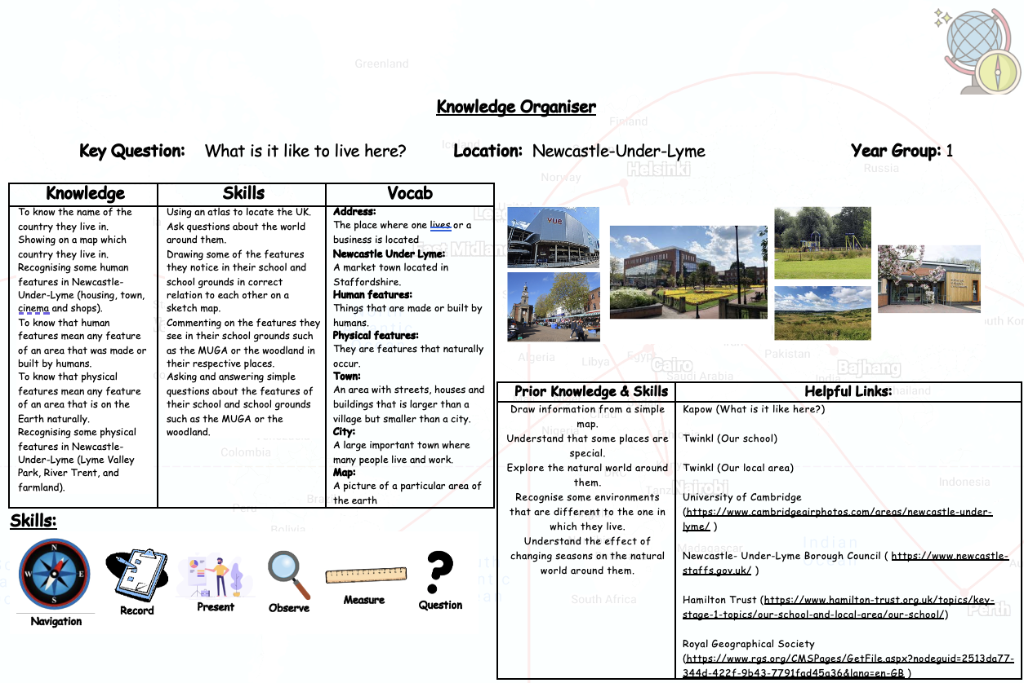
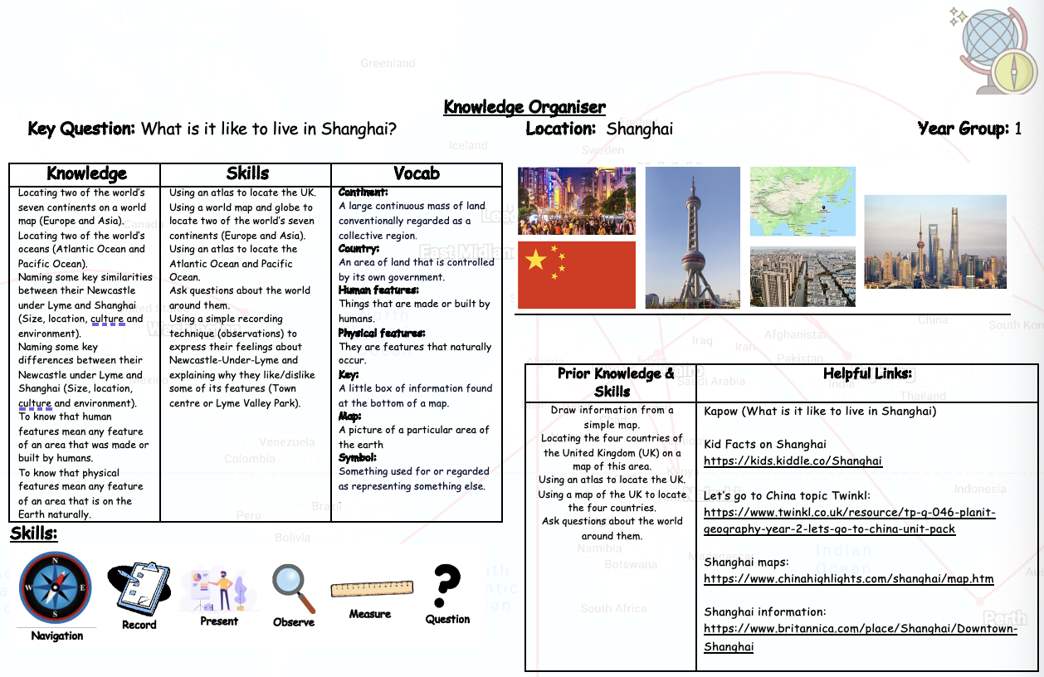
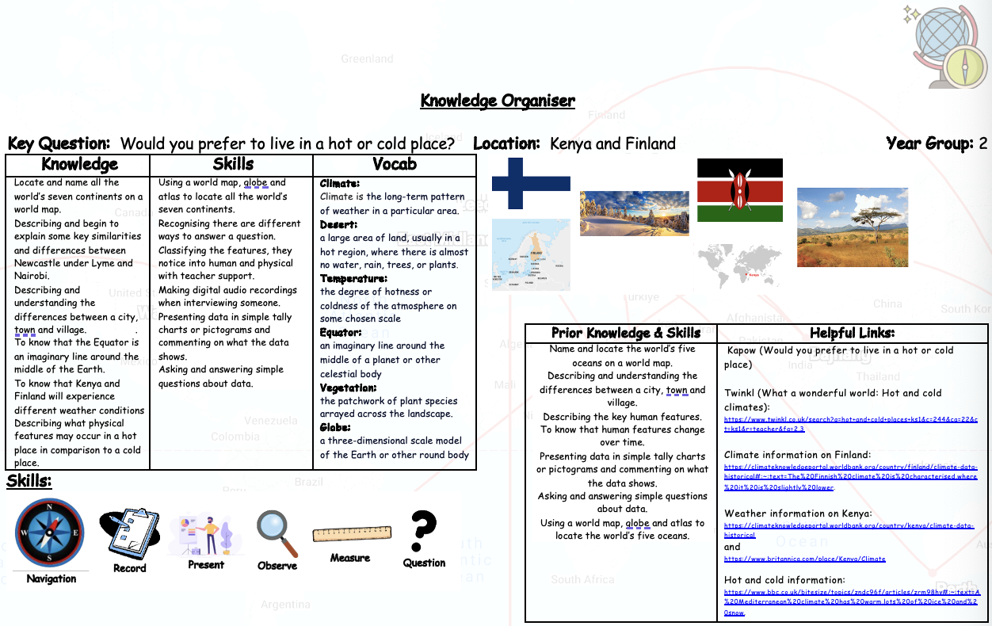
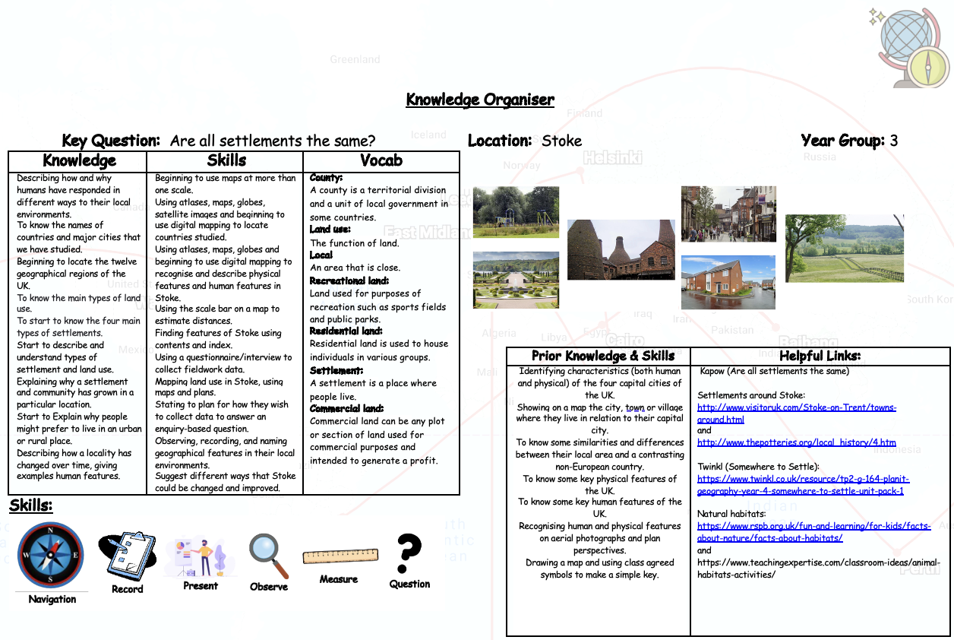
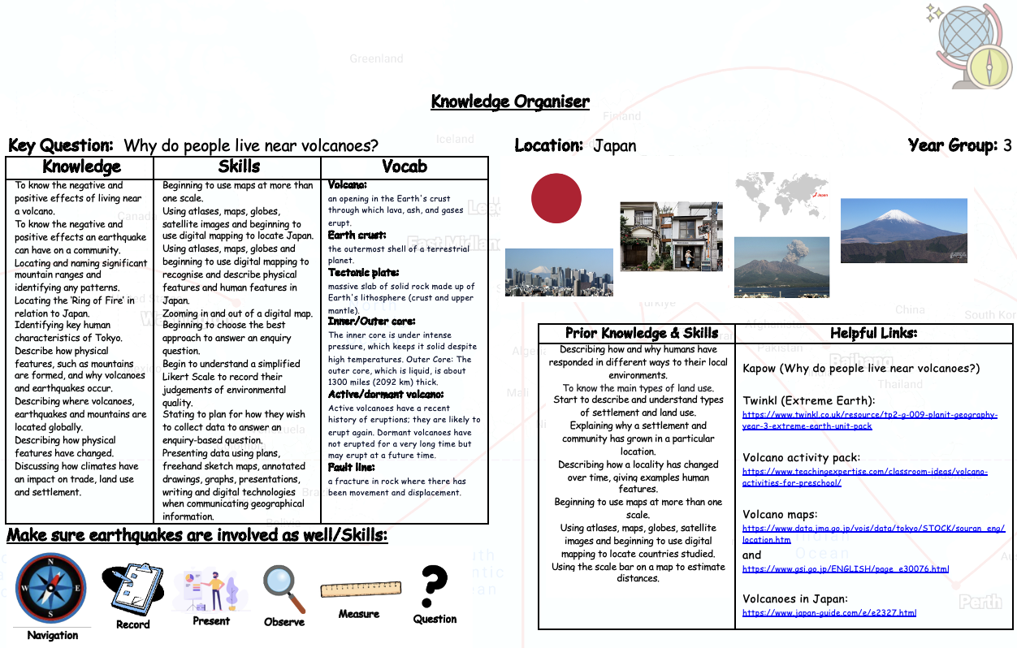
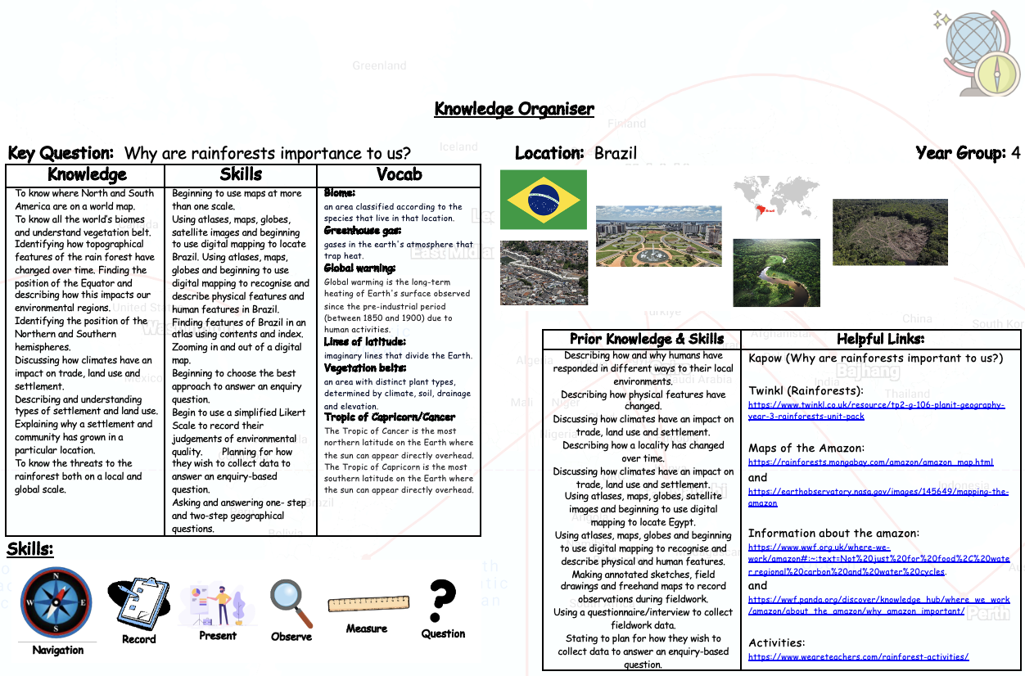
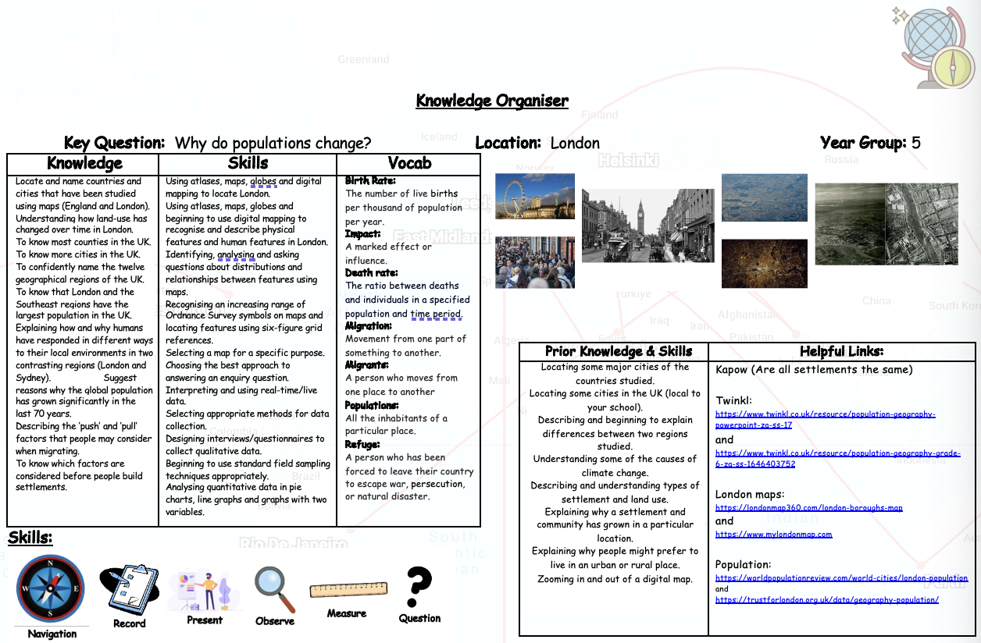
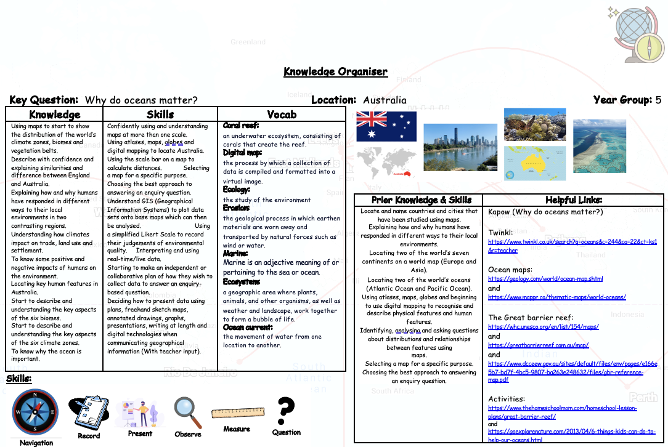
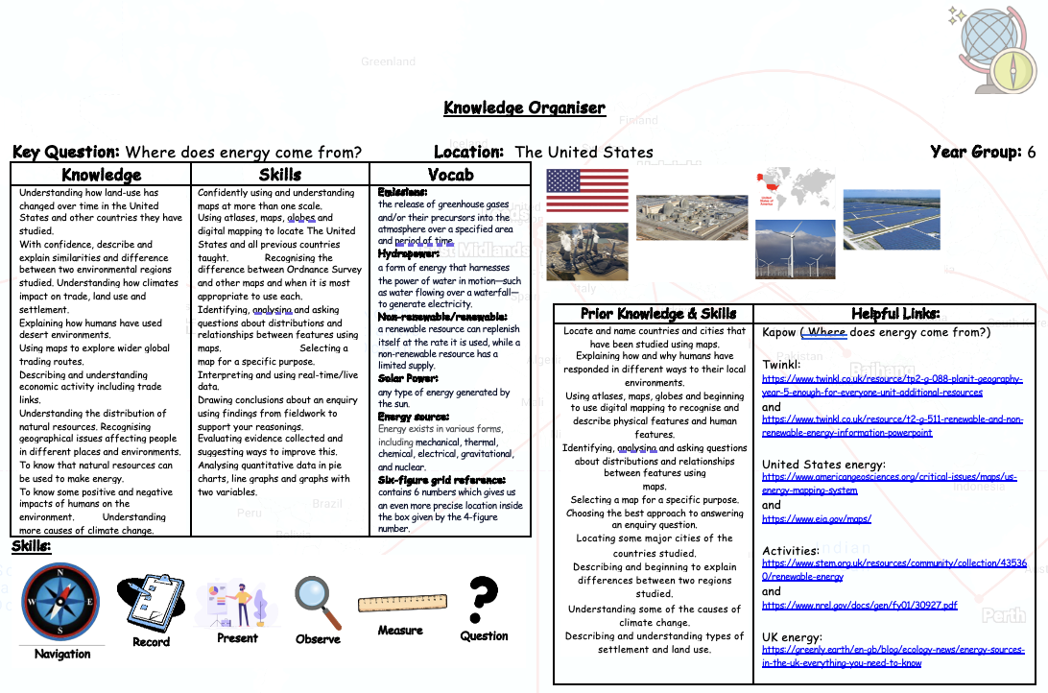

Assessment

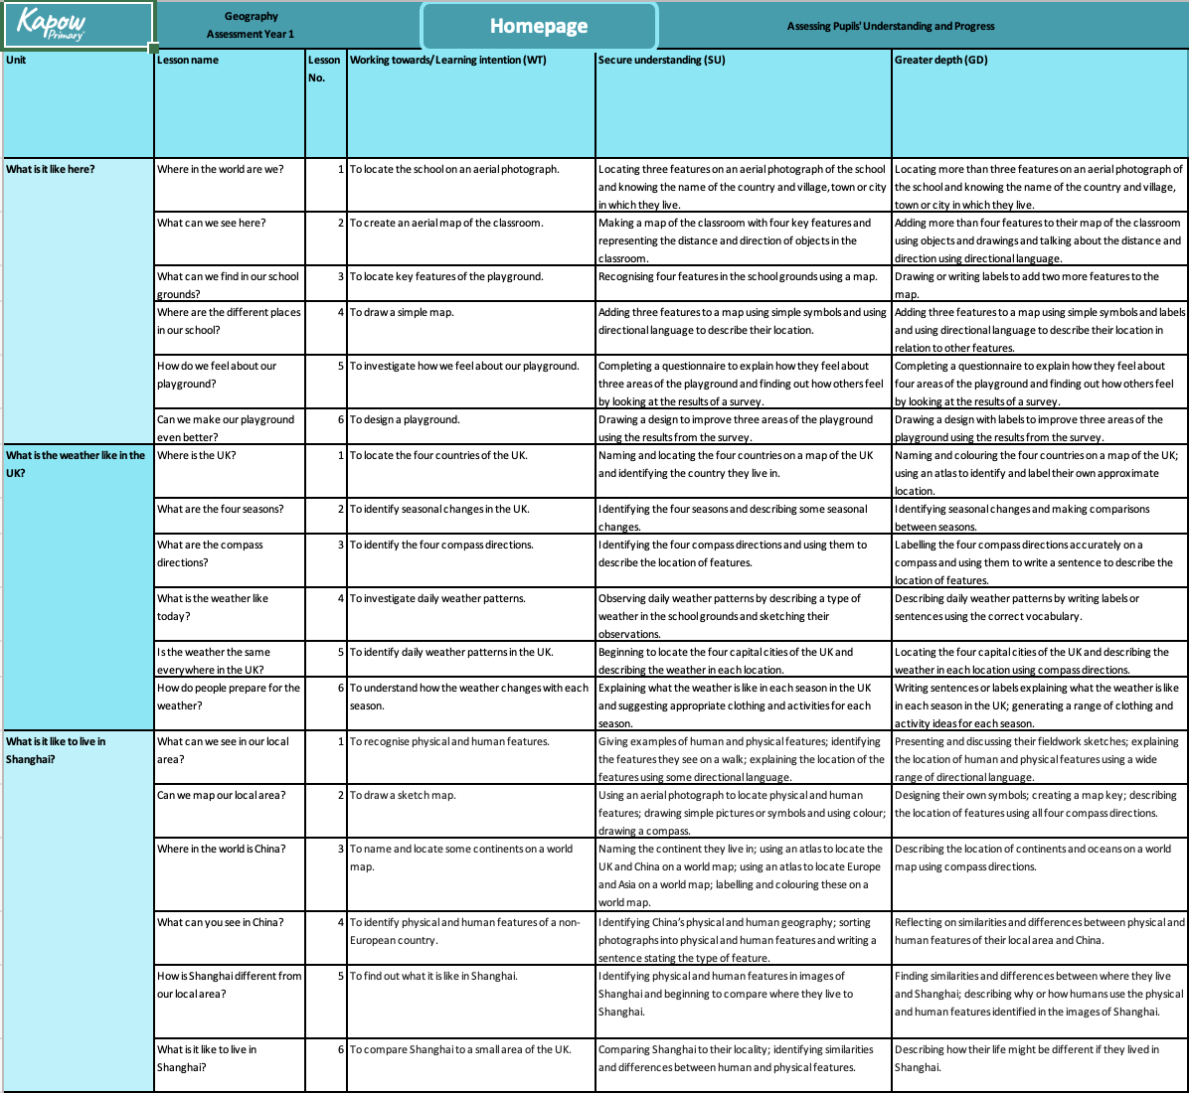
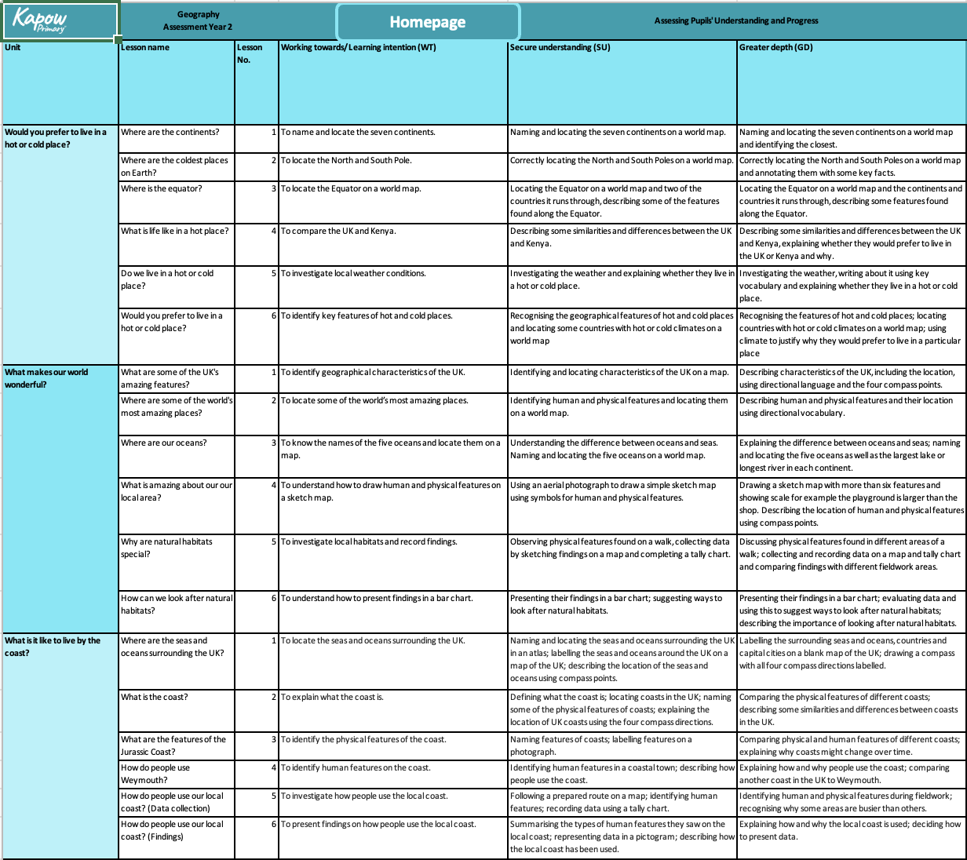
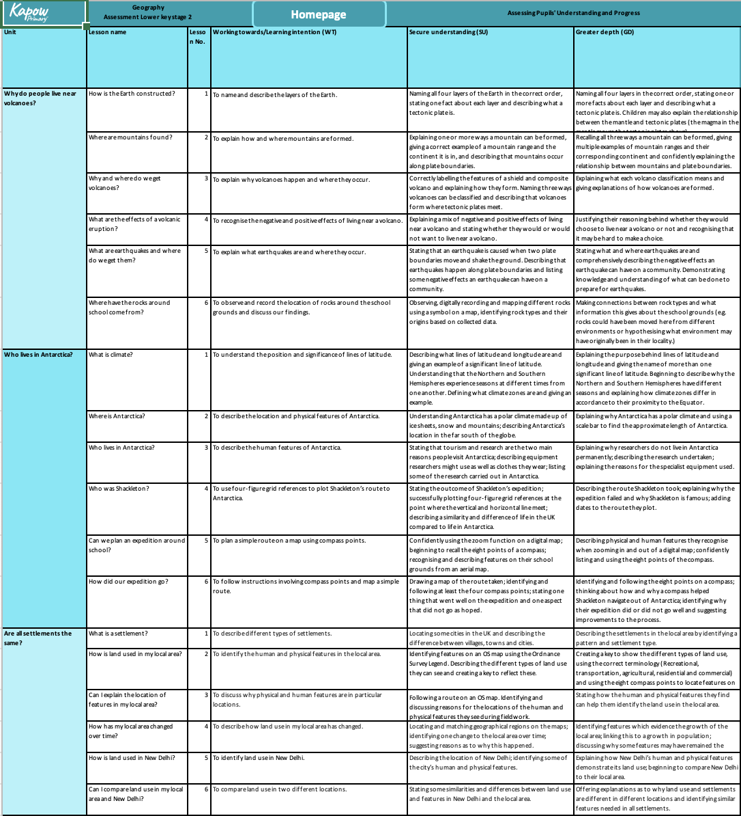
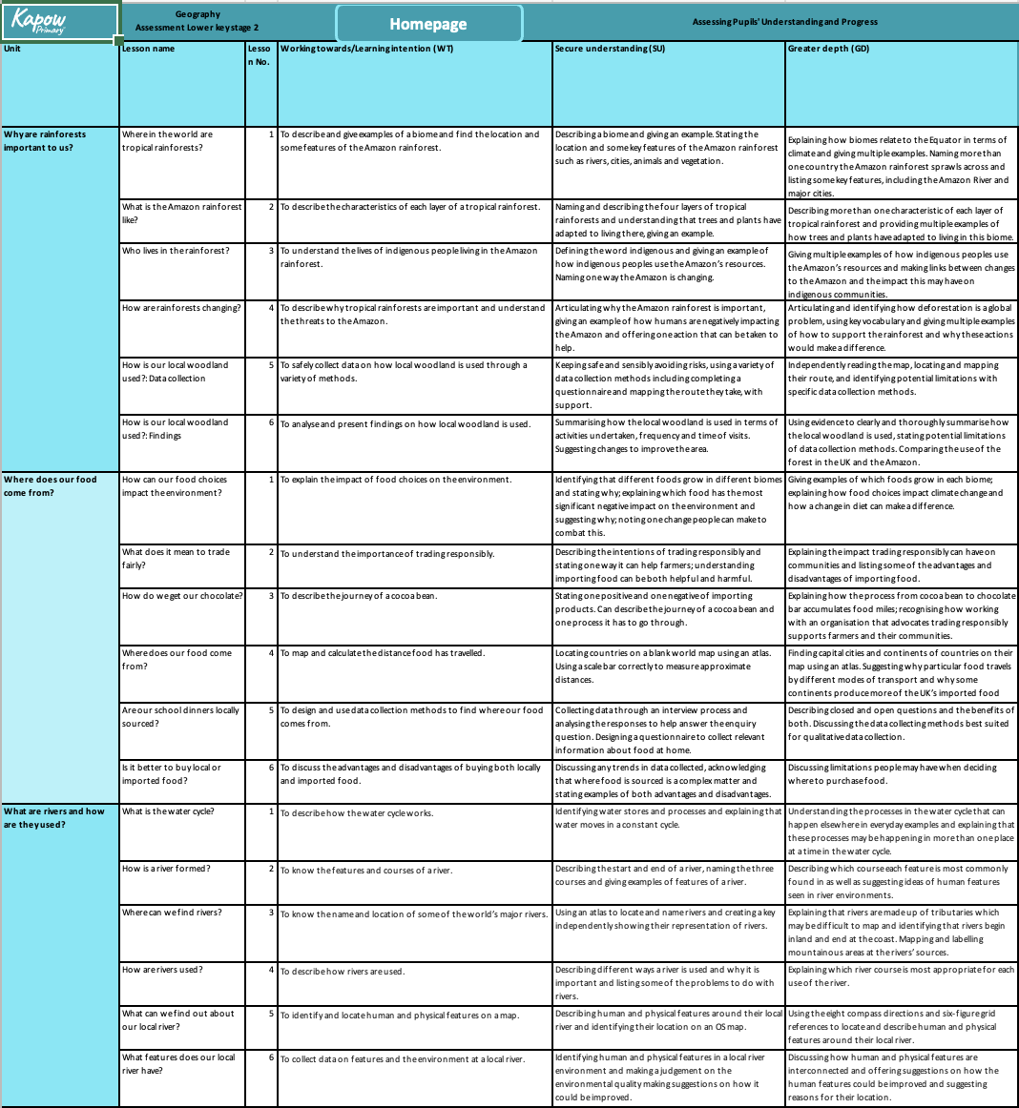
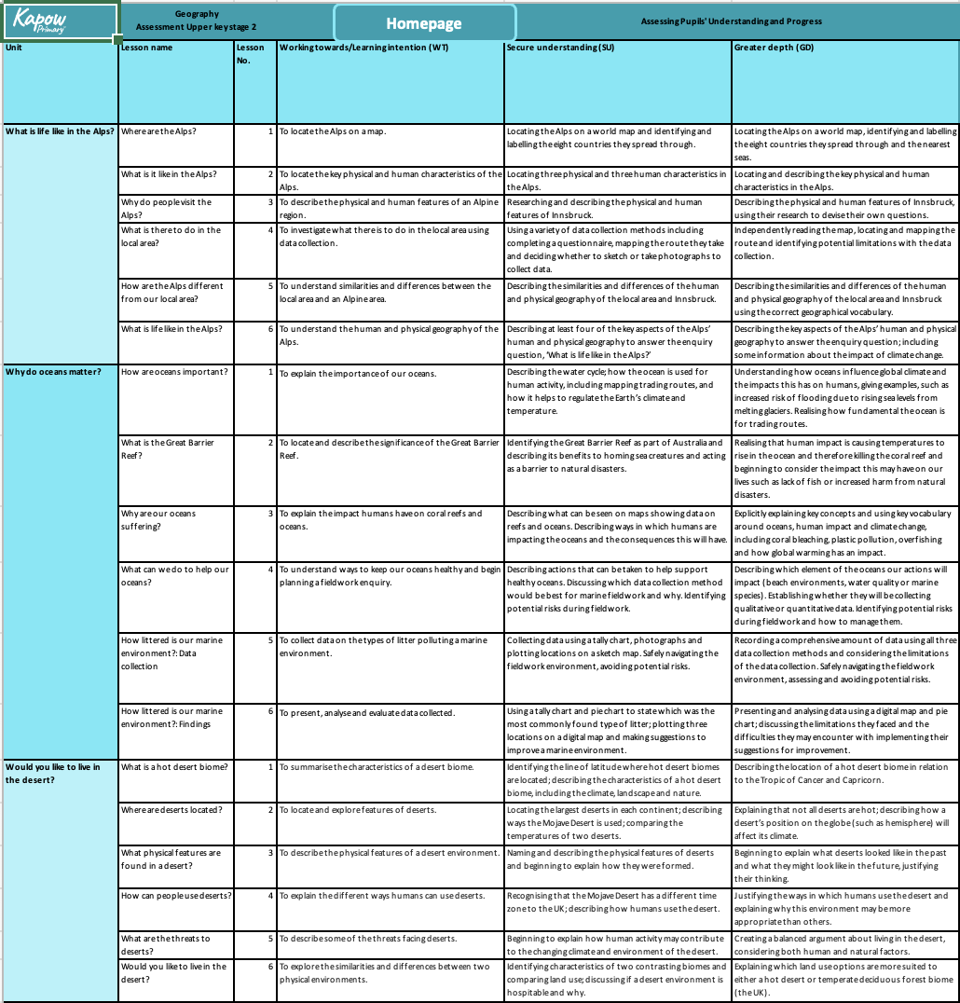
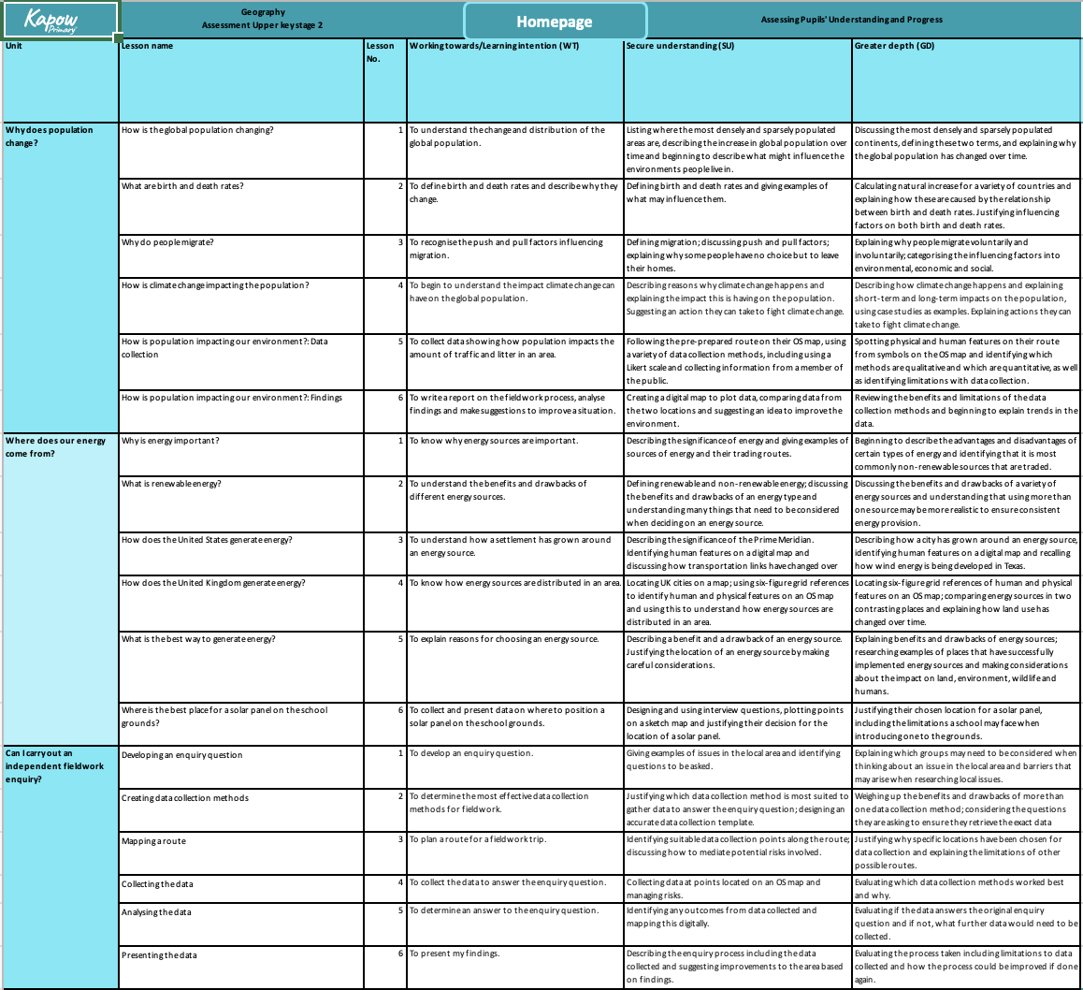
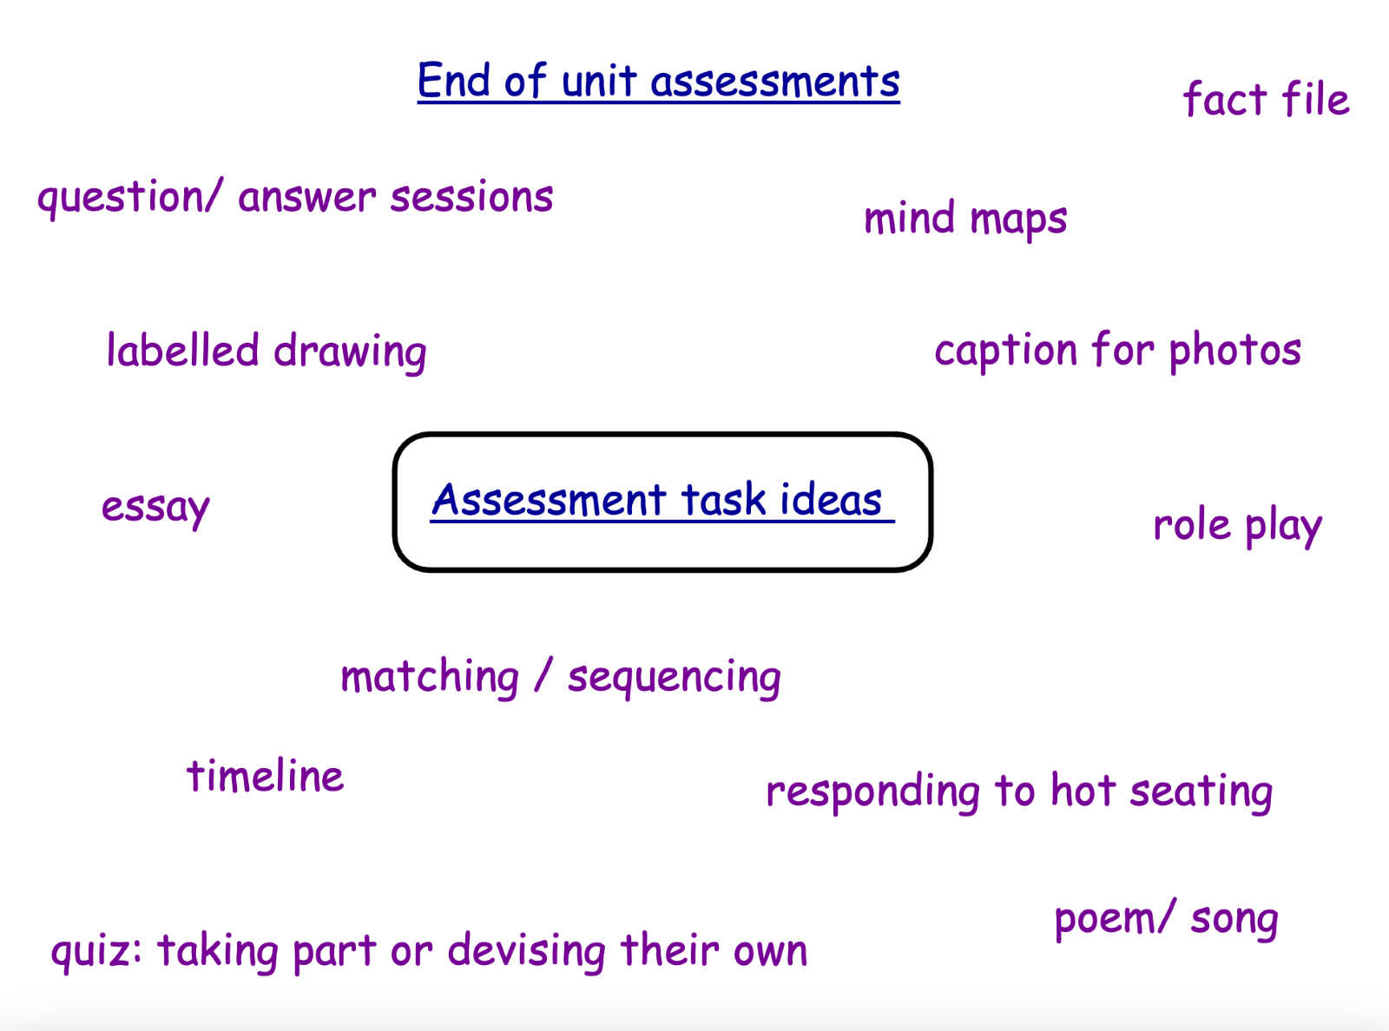
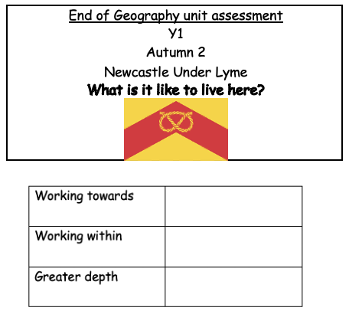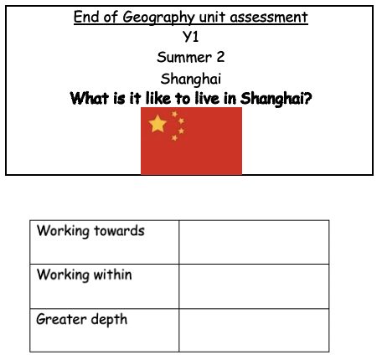

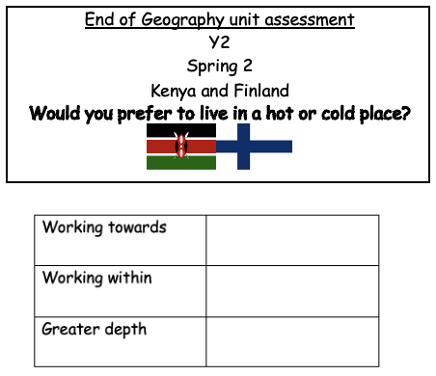
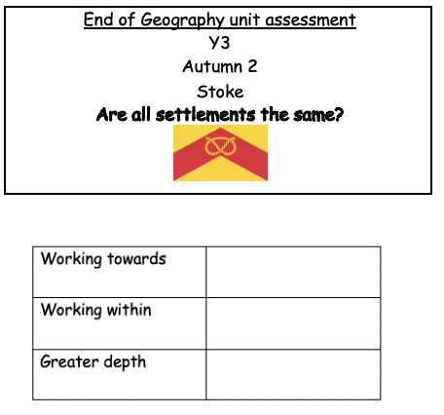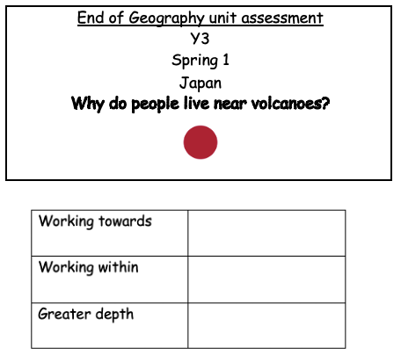

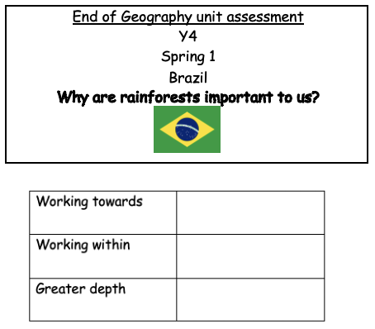
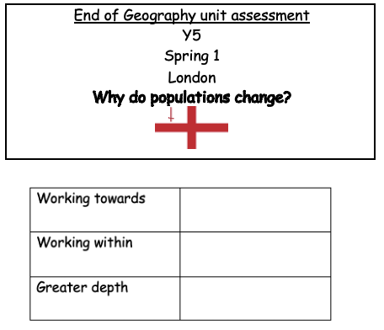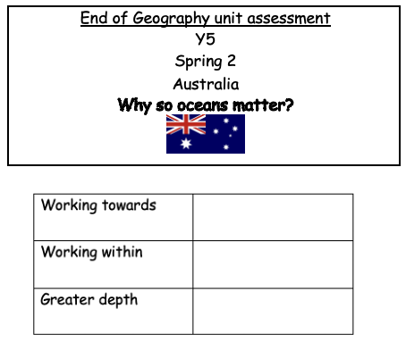

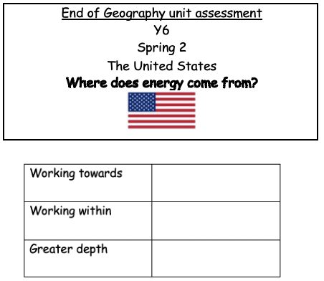

Extra

A lesson and topic layout/must have: 

- Highlighted Knowledge organiser 
- Explore/Teach/Practice
- Challenges
- Recap
- Learning Intention focus
- Enquiry focus on the last lesson

