EYFS Policy

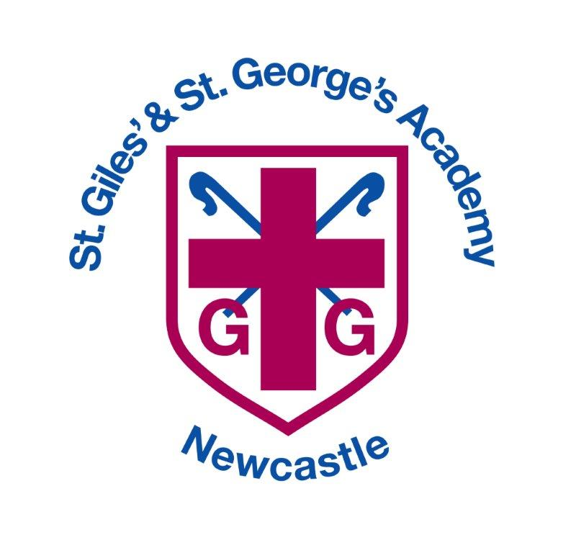

|  |  |  |
| --- | --- | --- |
| **Approved by:** |  | **Date:** March 2024 |
| **Last reviewed on:** | June 2022 | |
| **Next review due by:** | March 2025 | |

**Contents**

1. Aims 2

2. Legislation 2

3. Structure of the EYFS 2

4. Curriculum 3

5. Assessment 4

6. Transition……………………………………………………………………………………………….4

7. Working with parents 5

8. Safeguarding and welfare procedures 5

9. Monitoring arrangements 5

Appendix 1. List of statutory policies and procedures for the EYFS

Appendix 2. Planning Proformas

Appendix 3: Injury on arrival forms

# 1. Aims

This policy aims to ensure:

* That children access a broad and balanced curriculum that gives them the broad range of knowledge and skills needed for good progress through school and life
* Quality and consistency in teaching and learning so that every child makes at least good progress and no child gets left behind
* Close partnership working between practitioners and with parents and/or carers
* Every child is included and supported through equality of opportunity and anti-discriminatory practice

# 2. Legislation

This policy is based on requirements set out in the [Statutory framework for the early years foundation stage (publishing.service.gov.uk)](https://assets.publishing.service.gov.uk/government/uploads/system/uploads/attachment_data/file/974907/EYFS_framework_-_March_2021.pdf) published in March 2021.

# 3. Structure of the EYFS

The Early Years Foundation Stage applies to children from birth to the end of the reception year. At St. Giles’ and St. George’s Academy, our Early Years setting consists of a Pre-Nursery intake, a Nursery cohort, and Reception cohort, each led by a qualified Teacher/Early Years practitioner and supported by Teaching Assistants and apprentices.

Children are able to join our Pre-Nursery the term after their third birthday, when funding begins. However, parents and carers have the opportunity to admit their child the day after they turn 3, whilst paying wraparound fees. Nursery age children are admitted to our setting in the following September. Reception age children are admitted in the September following their fourth birthday.

We offer both 15 hour and 30 hour funding in our setting and offer wraparound care for parents that need it. Any child allocated 15 Hours can pay for additional sessions at a charge of £10 per session.

Our school day runs from 8.40am until 3.15pm for Reception age children. The morning session for Nursery age children runs from 8.40am-12noon and the afternoon session in which Pre-Nursery children attend runs from 12.15pm-3.15pm.

Our setting offers two mixed nursery and reception age classes called Badgers and Hedgehogs and one mixed pre-nursery and nursery age class called Squirrels. For children who find being in a mainstream EYFS classroom full time, we offer a safe haven called The Den which caters for children’s individual needs through intervention, sensory breaks, specialist staff and personalised activities.

# 4. Curriculum

Our early years setting follows the curriculum as outlined in the 2021 statutory framework of the EYFS.

The EYFS framework includes 7 areas of learning and development that are equally important and inter-connected. However, 3 areas known as the prime areas are seen as particularly important for igniting curiosity and enthusiasm for learning, and for building children’s capacity to learn, form relationships and thrive, as well as providing the firm foundations in order to succeed in the specific areas.

The prime areas are:

* Communication and language
* Physical development
* Personal, social and emotional development

The four specific areas are:

* Literacy
* Mathematics
* Understanding the world
* Expressive arts and design

**4.1 Planning**

Staff plan activities and experiences for children that enable them to develop and learn effectively. We aim to support **all** children to become independent and collaborative learners. We provide a curriculum that will enable each child to develop personally, socially, emotionally, spiritually, physically, creatively and intellectually to their full potential.

In order to do this, practitioners working with the youngest children are expected to focus strongly on the 3 prime areas in order to develop the foundations to achieve in the specific areas. These three prime areas can then be embedded and applied within the 4 specific areas.

Staff also take into account the individual needs, interests, and stage of development of each child in their care, and use this information to plan a challenging and enjoyable experience. Where a child may have a special educational need or disability, staff consider whether specialist support is required, linking with relevant services from other agencies, where appropriate.

Planning is also informed by the school’s subject learning journeys. Each subject’s expectations are mapped out through a spiral curriculum, starting from Nursery age to provide a clear progression of knowledge and skills throughout the school, which build upon each other.

Our planning is in the following format, consistent across the whole EYFS setting.

* A long-term overview of areas
* A medium-term plan for each half term
* Weekly Maths, English and Communication and Language plan.
* Weekly Continuous Provision plan (See Appendix 2.)

The weekly planning provides more detail about the adult led teaching opportunities, skills to be taught and challenges set for the children throughout the week. The continuous provision plan provides details of the independent opportunities that children will have to practise and consolidate their skills, both inside and outside.

**4.2 Teaching**

Each area of learning and development is implemented through planned, purposeful play, and through a mix of adult-led, enhanced provision and child-initiated activities. Practitioners respond to each child’s emerging needs and interests, guiding their development through warm, positive interaction and appropriate facilitation.

Where possible, learning is based on real life, hands-on experiences that are stimulating and engaging for the children and in our Early Years setting, children have the opportunity to learn outside as well as inside every day.

As children grow older, and as their development allows, the balance gradually shifts towards more adult-led activities to help children prepare for more formal learning, ready for year 1.

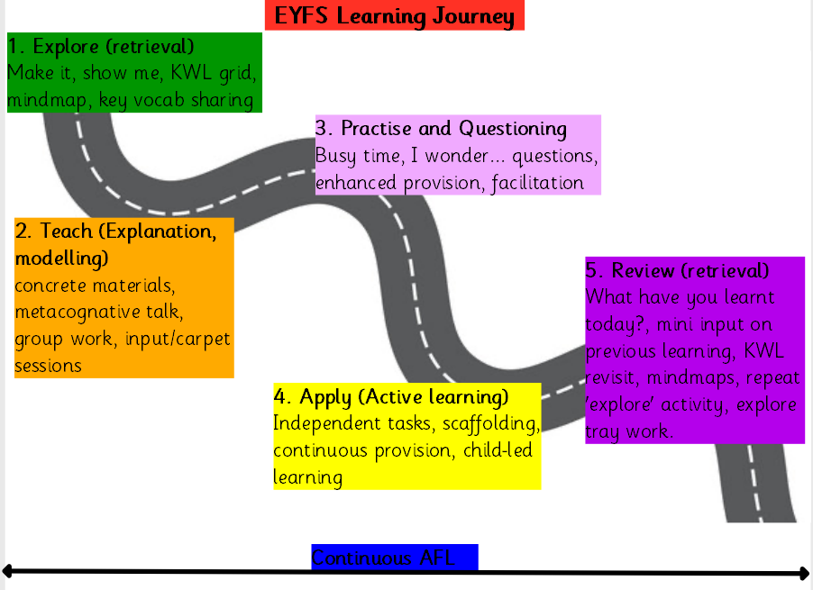Below highlights a child’s learning experiences in the EYFS to ensure that learning is revisited, consolidated and applied before moving on to new learning.

# 5. Assessment

At St.Giles’ and St. George’s Academy, ongoing assessment is an integral part of the learning and development process. Staff observe pupils and gather evidence using Evidence Me, to identify their level of achievement, interests and learning styles. These observations are used to shape future planning and are shared with parents and carers. Parents receive at least one ‘Parent Share’ a week, as well as a PDF document, show casing their achievements at the end of the year.

At St Giles’ and St George’s Academy, we recognise that from the moment children join us at the beginning of the school day, until they go home, every minute possible is best spent with the children. We value the knowledge that staff have of each individual child, from their on-going interaction, facilitation and observation. We ensure that staff communicate this understanding of each child effectively in order to gain an accurate assessment of each child.

Teachers use Evidence Me and individual folders to show case each child’s own personal WOW moments only, to ensure that evidence collection purposeful without being an onerous task. Parents are also encouraged to add ‘parent submissions’ of WOW moments that they see at home, in order to cement the partnership in learning.

Observations and evidence gathered helps staff to input children’s levels on DCPro to indicate whether children are working towards (Emerging), within (Expected) or Above (Greater Depth) within the three age bands of 0-3 years, 3-4 years and Reception for reading, writing and maths in the Reception year.

Staff also meet to discuss the child as a whole and assess who is on-track and not on-track to get a Good Level of Development (GLD). As a team, staff then identify individual barriers and next steps to addressing these.

In our Early Years setting, practitioners review children’s progress regularly and provide parents and carers with a written summary of the child’s development each term. This ‘progress check’ highlights the areas in which a child is progressing well and the areas in which additional support is needed.

At the end of the Reception year, staff complete the EYFS profile for each child. Pupils are assessed against the 17 early learning goals, indicating whether they are:

* Meeting expected levels of development, or
* Not yet reaching expected levels (‘emerging’)

If children have achieved all ELG’s in all three prime areas, as well as literacy and maths, they are said to have a Good Level of Development (GLD).

The profile reflects ongoing observations and discussions with parents and carers. Staff also provide a short commentary about each child’s skills and abilities in relation to the characteristics of effective learning on the end of year report. The results of the EYFS profile and the characteristics of learning are then shared with both parents and carers and the child’s Year One teacher as part of our transition dialogue.

**6. Transition**

Starting school can be a difficult time for young children; we therefore plan this time carefully to support children with the transition and to ensure it is as smooth as possible for each child and that they settle into their new class quickly and happily.

Parents of all children entering EYFS in the next academic year will be invited to an Induction Meeting. This takes place in the Summer term and is a chance to meet their child’s new teacher and other key staff and learn more about the Academy and our mission and vision.

Parents are provided with an induction booklet containing up to date information about

* Staffing
* The school day
* Wraparound care
* Uniform
* The EYFS curriculum
* School meals
* School policies
* Parental involvement.

The children are given opportunities to come in to school to meet their new class teacher and other children in their class. They will spend sessions in their new class. The children will be welcomed by key staff and transition activities will be set up. Parents can leave their child during this session, or stay if they choose. Staff will ensure that we have relevant contact information and allergy advice before the child is left, and that staffing ratios are still accurate.

This means that before they join their new class the environment is already a familiar place to them. Arrangements are also made for the children’s new class teachers to visit them in their current nursery/home settings.  Personalised transition arrangements can be made on an individual basis between school and parents if needed.

Starting in Key Stage 1 (Year 1) - Throughout the Reception year, each child’s involvement in whole school life will have been built upon; many of the teaching and support staff will already be familiar to them. Children have the opportunity to meet their new class teacher and spend sessions in their new class during the summer term, as well as their new teacher spending time with them in their current classroom, where they feel the most secure.

Handover meetings will take place between staff to pass on important and relevant information about the children including assessments, SEND, any safeguarding information.

# 7. Working with parents

We recognise that children learn and develop well when there is a strong partnership between practitioners and parents and/or carers.

Parents and/or carers are kept up to date with their child’s progress and development at termly parent’s meetings. The progress reports, the sharing of observations and the EYFS profile helps to provide parents and carers with a well-rounded picture of their child’s knowledge, understanding and abilities.

Each child is assigned a key person who helps to ensure that their learning and care is tailored to meet their needs. The key person supports parents and carers in guiding their child’s development at home. The key person also helps families to engage with more specialist support, if appropriate

Staff make themselves available at the beginning and end of each school day/session to speak to parents and appointments can be made if there are any issues or concerns to be addressed.

At the beginning of each academic year, parents are also linked up to their child’s Class Dojo account. This enables them to see the positive dojos that the children are receiving and the reasons for these. It also provides effective and timely communication between staff and parents/carers.

Parents are invited to come into school on a number of occasions. Whole school celebrations such as mother’s/father’s day, Christmas plays, sports day etc… but also for more specific time with their child’s class. These include homework sharing events and shine mornings where parents can be involved in their children’s learning based on their current theme. We also offer a range of parents workshops where parents have the opportunity to find out how we teach certain skills at school and how they can help their child at home, such as ‘Phonics’ and ‘Developing Early Writing’.

# 8. Safeguarding and welfare procedures

Our safeguarding and welfare procedures are outlined in our safeguarding policy.

In addition, all parents of Pre-Nursery, Nursery and Reception age children are expected to complete an ‘Injury On Arrival’ form if their child has a new injury which has occurred outside of school. (See Appendix 3) Forms are then uploaded to My Concern and monitored. These forms can be found outside each EYFS classroom door, as well as the main school office and care club.

# 9. Monitoring arrangements

Monitoring of the EYFS may be done by any member of staff, the SLT, EYFS lead or subject leaders. A monitoring overview will be provided to let staff know the focus of the monitoring.

Monitoring may be done in a range of ways: observations, learning walks, book scrutiny, Evidence scrutiny, data analysis.

Assessment judgements will be moderated termly by EYFS staff and across key stages and with other schools where possible. End of reception judgements will be moderated by the local authority every four years as part of a cycle of moderation visits.

This policy will be reviewed and approved by March 2025.

At every review, the policy will be shared with the governing board.

# Appendix 1. List of statutory policies and procedures for the EYFS

| Statutory policy or procedure for the EYFS | Where can it be found? |
| --- | --- |
| Safeguarding policy and procedures | See child protection and safeguarding policy |
| Procedure for responding to illness | See health and safety policy |
| Administering medicines policy | See supporting pupils with medical conditions policy |
| Emergency evacuation procedure | See health and safety policy |
| Procedure for checking the identity of visitors | See child protection and safeguarding policy |
| Procedures for a parent failing to collect a child and for missing children | See child protection and safeguarding policy |
| Procedure for dealing with concerns and complaints | See complaints policy |

**Appendix 2. EYFS Planning Proformas**

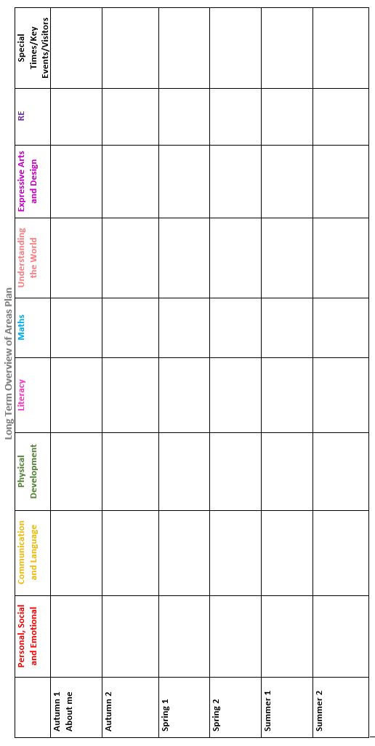

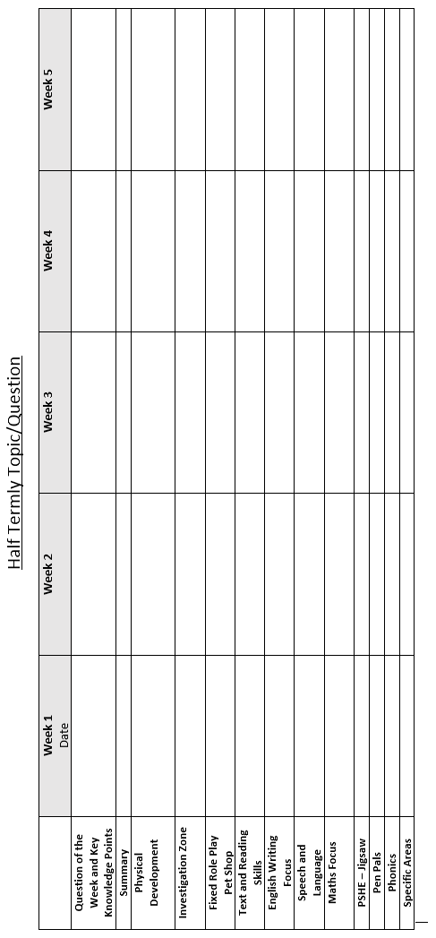

Weekly Maths/English/Communication and Language Planning.

Week:

|  |  |  |  |  |
| --- | --- | --- | --- | --- |
| **English** | | Text: | | |
|  | Objective(s) | Input | Activity | Challenge (Alternate days to work) |
| **Monday** |  |  |  |  |
| **Friday** |  |  |  |  |
| **Maths** | | Area: | | |
|  | Objective(s) | Input | Activity | Challenge (Alternate days to work) |
| **Tuesday** |  |  |  |  |
| **Thursday** |  |  |  |  |
| **Communication and Language** | |  | | |
|  | Objective(s) | Input | | Opportunity |
| **Monday** |  |  | | **Snack Time** |
| **Tuesday** |  |  | |  |
| **Wednesday** |  |  | |  |
| **Thursday** |  |  | |  |
| **Friday** |  |  | |  |

**Continuous Provision Planning**

|  |  |  |
| --- | --- | --- |
| **Enhanced Area** | **Activity/Resources** | **Key Questions** |
| Doodle Den |  |  |
| Magic Maths |  |  |
| Funky Fingers |  |  |
| Investigation Station |  |  |
| Creative Corner |  |  |
| Phonics |  |  |
| **Continuous Provision inside** | **Activity/resources** | **Key Questions** |
| Social Station |  |  |
| Curiosity Cube |  |  |
| Reading |  |  |
| Role play |  |  |
| Construction/Small World |  |  |
| **Continuous provision outside** | **Activity/resources** | **Key Questions** |
| Doodle Den/writing opportunities  (PD) |  |  |
| Magic Maths  (Tuff tray) |  |  |
| Mud kitchen  (PD) |  |  |
| Water/sand (PD) |  |  |
| Phonics  (Tuff Tray) |  |  |
| Construction/Small World (PD) |  |  |
| General outdoors (PD) |  |  |

**Appendix 3: Injury on arrival form**

