


DT Curriculum


Design and Technology
Intent, Implementation and Impact

Our community is inspired by our Christian values to enable all to flourish in mind, body, heart and spirit.

INTENT
All areas of our curriculum are underpinned by our Gospel Values, and we ensure that our curriculum
makes links to these values. At the heart of each subject is a set of core skills, which form a subject learning journey. This journey is built from EYFS through to Year 6 and the skills are progressive as you move through the school. Knowledge is communicated to ensure coverage of the National Curriculum and it is through this knowledge that children apply their skills.

Children at St. Giles’ and St. George’s leave with both secure academic knowledge and skills needed for the next stage of their education. They will have developed a clear set of Christian and moral values which they can apply in all areas of their lives. They will have taken part in real-life experiences which will have raised their aspirations and given them a thirst for wisdom and knowledge.
The intention of the St. Giles’ and St. George’s DT learning journey is first and foremost to help develop children’s thinking skills and provide opportunities for them to design and make quality products. It is our intention that DT contributes to the development of the whole child emotionally, aesthetically, spiritually, intellectually and socially. We intend to create, in the child, a sense of enjoyment and purpose and provide pupils with a unique way of perceiving themselves which is essential to their learning. We intend DT to be inspiring, rigorous and practical. We want our children to use creativity and imagination to design and make products that solve real and relevant problems within a variety of contexts, considering their own and other needs, wants and values. We want DT to prepare our children, give them opportunities, responsibilities and experiences they need to be successful innovators later in life.

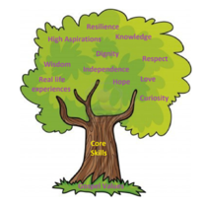

IMPLEMENTATION

Design and Technology units are organised into: Mechanisms, Textiles, Structures, Cooking and nutrition, Electrical systems (KS2), Digital world (KS2). All units focus on:

- Design
- Make
- Evaluate
- Technical Knowledge
- Cooking and Nutrition

Units of lessons are sequential, allowing children to build skills and knowledge which are revisited again and again in increasing complexity using a spiral curriculum model.

DT is taught for 1 hour each week or 2 hours every two weeks, depending on the unit and year group being taught. Each new unit of learning is introduced by exploring previous skills and knowledge. Children are then introduced to the key knowledge of the unit in the form of a knowledge organiser. Key vocabulary for that lesson is shared. During the lesson, a lesson journey is followed consisting of ‘Explore-Teach/Practise-Active Learning (Apply) – Review’. Where appropriate, assessment and feedback will focus on misconceptions and next steps for learning.

In KS1, DT is recorded in ‘ideas books’.
In KS2, DT is recorded in a workbook.

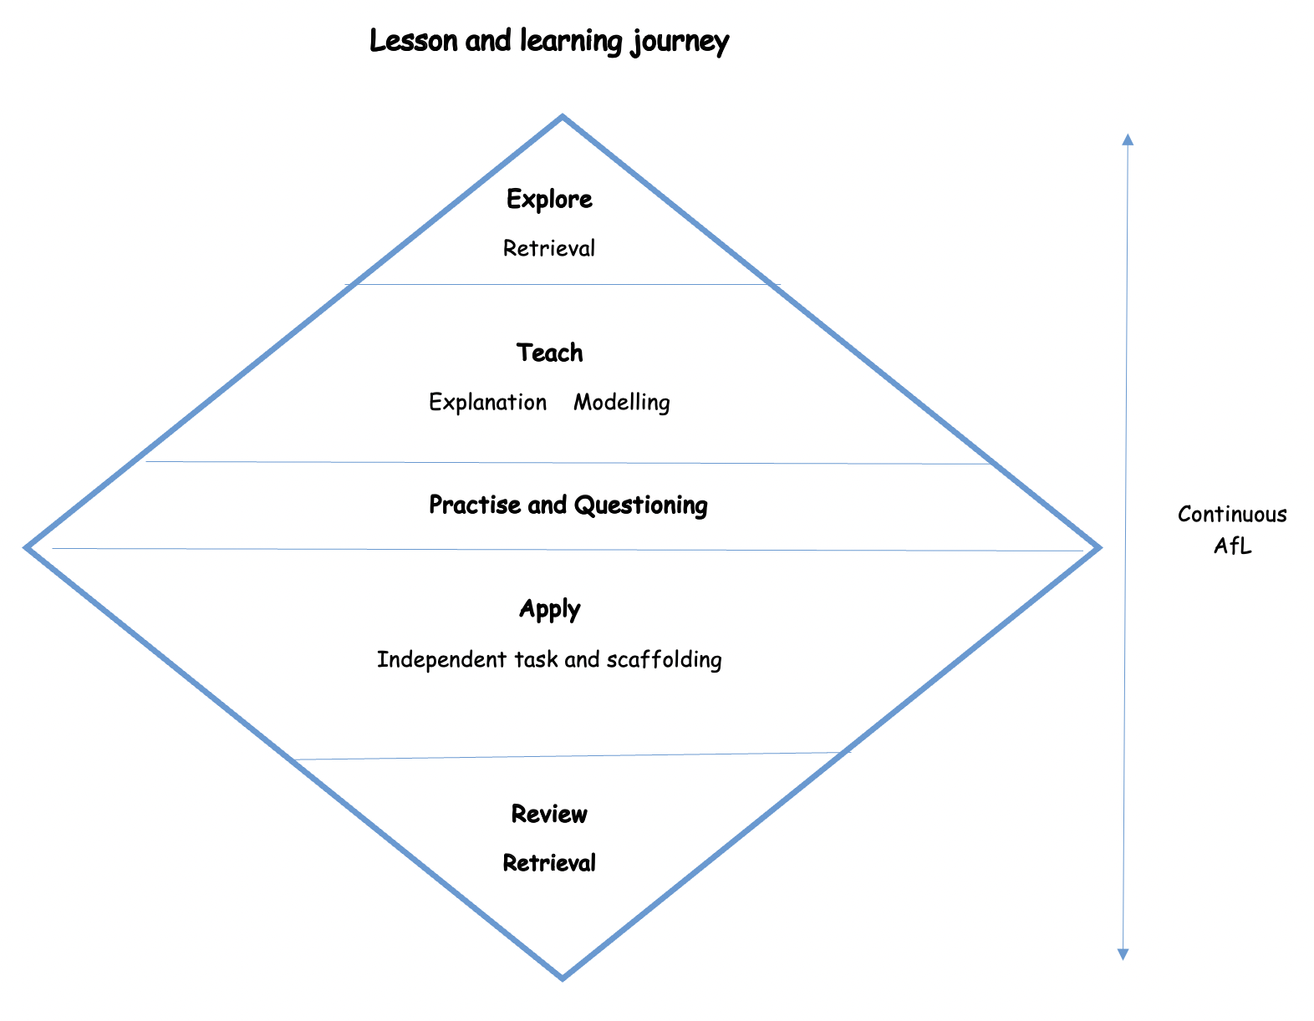

EYFS
The most relevant Development Matters (2021) statements for Design and Technology are taken from the following areas of learning:
Expressive Art and Design
Physical Development.

EYFS have three DT projects throughout the year, one per half term. Children will have adult-led input sessions focusing on an aspect of DT.
Activities may be initiated after adult input sessions in an afternoon. Activities relating to the half-termly project may be planned for as an enhanced provision activity in the Creative Corner for that week.
Children also have free access to a range of tools and resources as part of the child-initiated provision, enabling them to follow their own interests in designing, making and creating. Resources include paint, brushes, junk modelling, string, hole punches, staplers, lolly sticks and papers.

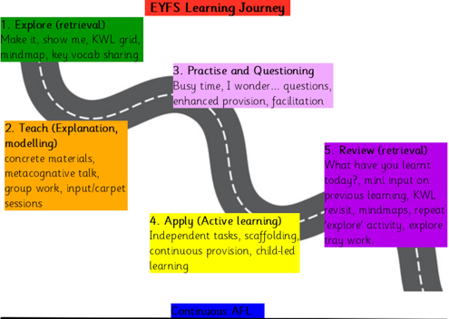

IMPACT

In addition to the outcomes shown on our curriculum tree, the specific impact of the St. Giles’ and St. George’s DT learning journey is that children will be able to:

- Understand the functional and aesthetic properties of a range of materials and resources
- Understand how to use and combine tools to carry out different processes for shaping, decorating and manufacturing products
- Build and apply a repertoire of skills, knowledge and understanding to produce high quality, innovative outcomes, including models, prototypes, CAD and products to fulfil the needs of users, clients and scenarios
- Understand and apply the principles of healthy eating, diets and recipes, including key processes, food groups and cooking equipment
- Have an appreciation for key individuals, inventions and events in history and of today that impact our world
- Recognise where our decisions can impact the wider world in terms of community, social and environmental issues
- Self-evaluate and reflect on learning at different stages and identify areas to improve
- Meet the end of key stage expectations outlined in the National Curriculum for Design and Technology

Formative assessment takes part in each lesson, leading to misconceptions and next steps being the focus for feedback. Summative assessment is completed for each child at the end of each unit of teaching, using the assessment framework at the end of this document. A best fit approach to statements achieved results in an end of year summative grade.

DT Overview
 | Autumn Term |  | Spring Term |  | Summer Term
 | Autumn 1 | Autumn 2 | Spring 1 | Spring 2 | Summer 1 | Summer 2
Nursery |  |  | DT  Mechanisms:  Junk Model Vehicle  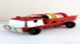  (Our community) |  | DT  Cooking and nutrition:    Baking and decorating cakes  (Super safari) | DT  Structures:  Lighthouses    (Seaside and holidays)
Reception |  | DT  Structures:  Junk model homes  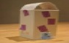  (Marvellous me)    What do you do in your time after school? |  | DT  Cooking and nutrition:  Fruit Kebabs    (Healthy me) | DT  Mechanisms:  Design a pirate ship    (Pirates)
Year 1 |  |  | DT  Textiles:  Puppets  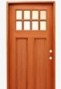    What gives colour their moods? |  |  | DT  Mechanisms:    Making a moving story book  (Writing: Look Inside a Castle flip book)
Year 2 | DT  Structures:    Baby bear’s chair    (History: Make a throne)  If I try to succeed and fail, what have I learnt? |  | DT  Mechanisms:    Making a moving monster  (Geography: explorers – different animals discovered)    What am I scared of? | DT  Cooking and nutrition:    A balanced diet  (PSHE: Healthy me)    What am I worth?

DT Overview
 | Autumn Term |  | Spring Term |  | Summer Term
 | Autumn 1 | Autumn 2 | Spring 1 | Spring 2 | Summer 1 | Summer 2
Year 3 |  |  | DT  Structures:  Castles  (History: Settlements)  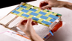  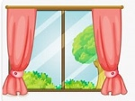  Will we ever live in a world without fighting? |  | DT  Textiles:  Cushions  (History: Ancient Egypt)  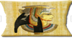  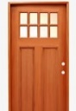  Is it good that scientists can’t explain everything?
Year 4 |  |  |  |  | DT  Digital world:  Light up wearables  
Year 5 |  |  |  |  | DT  Structures:  Bridges  (Geography)  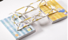
Year 6 |  |  | DT  Electrical systems:  Steady hand game  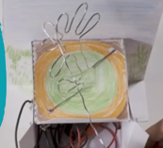 | DT  Cooking and nutrition:  Come dine with me      (PSHE: Healthy me)  Should you respect yourself over all things? | DT  Mechanical Systems:  Automata toys  (English: Hugo)  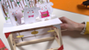

SEN Adjustments
In our DT Lessons, we cater for our SEN children using the following strategies

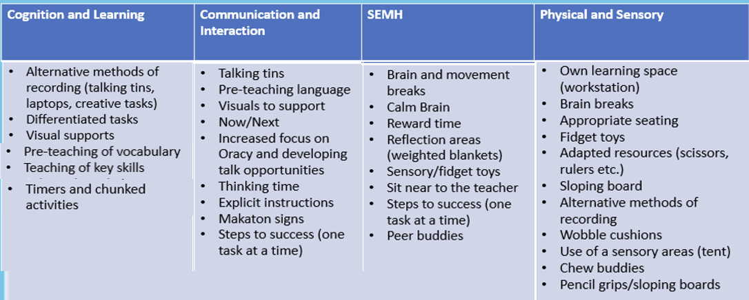

Lowest 20% offer

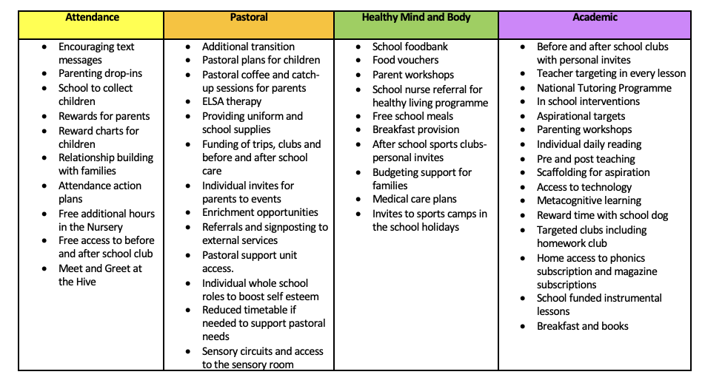

Gospel Values

EYFS  Loving and Compassionate  In what different ways do we celebrate the people we love?  Grateful and Generous  How can we show that we are grateful to the people who help us?  Curious and Active  Which animals live by the seaside?  Intentional & Prophetic  Why is it important to make the right choices?  Learned and Wise  How can we make sure that we keep our minds and bodies healthy?  Faith-filled and Hopeful  Can having faith help us to grow? | KS1  Loving and Compassionate  Why do children love their toys?  Grateful and Generous  How can I help people less fortunate than me?  Curious and Active  Does eating healthily help us to be active?  Attentive and Discerning  What kind of world has God made for us?  Learned and Wise  Why do we need renewable energy in the form of windmills?  Faith-filled and Hopeful  What celebrations would you find in other religions?
LKS2  Loving and Compassionate  If you make a sculpture of someone does that show that you love them?  Grateful and Generous  What did the Stone Age teach us?  Curious and Active  How does Jesus shine a light in our lives?  Attentive and Discerning  What artistic talents has God given you?  Learned and Wise  Why were the Greeks good at building?  Faith-filled and Hopeful  What effect does religious art have on our faith? | UKS2  Loving and Compassionate  How could you use art to show someone you love them?  Grateful and Generous  Who could you donate your automata toy to?  Curious and Active  Is healthy eating a way to praise God?  Attentive and Discerning  How does your card/story give joy to others?  Learned and Wise  How does Art/DT celebrate God?  Faith-filled and Hopeful  What does the past teach us about the future?

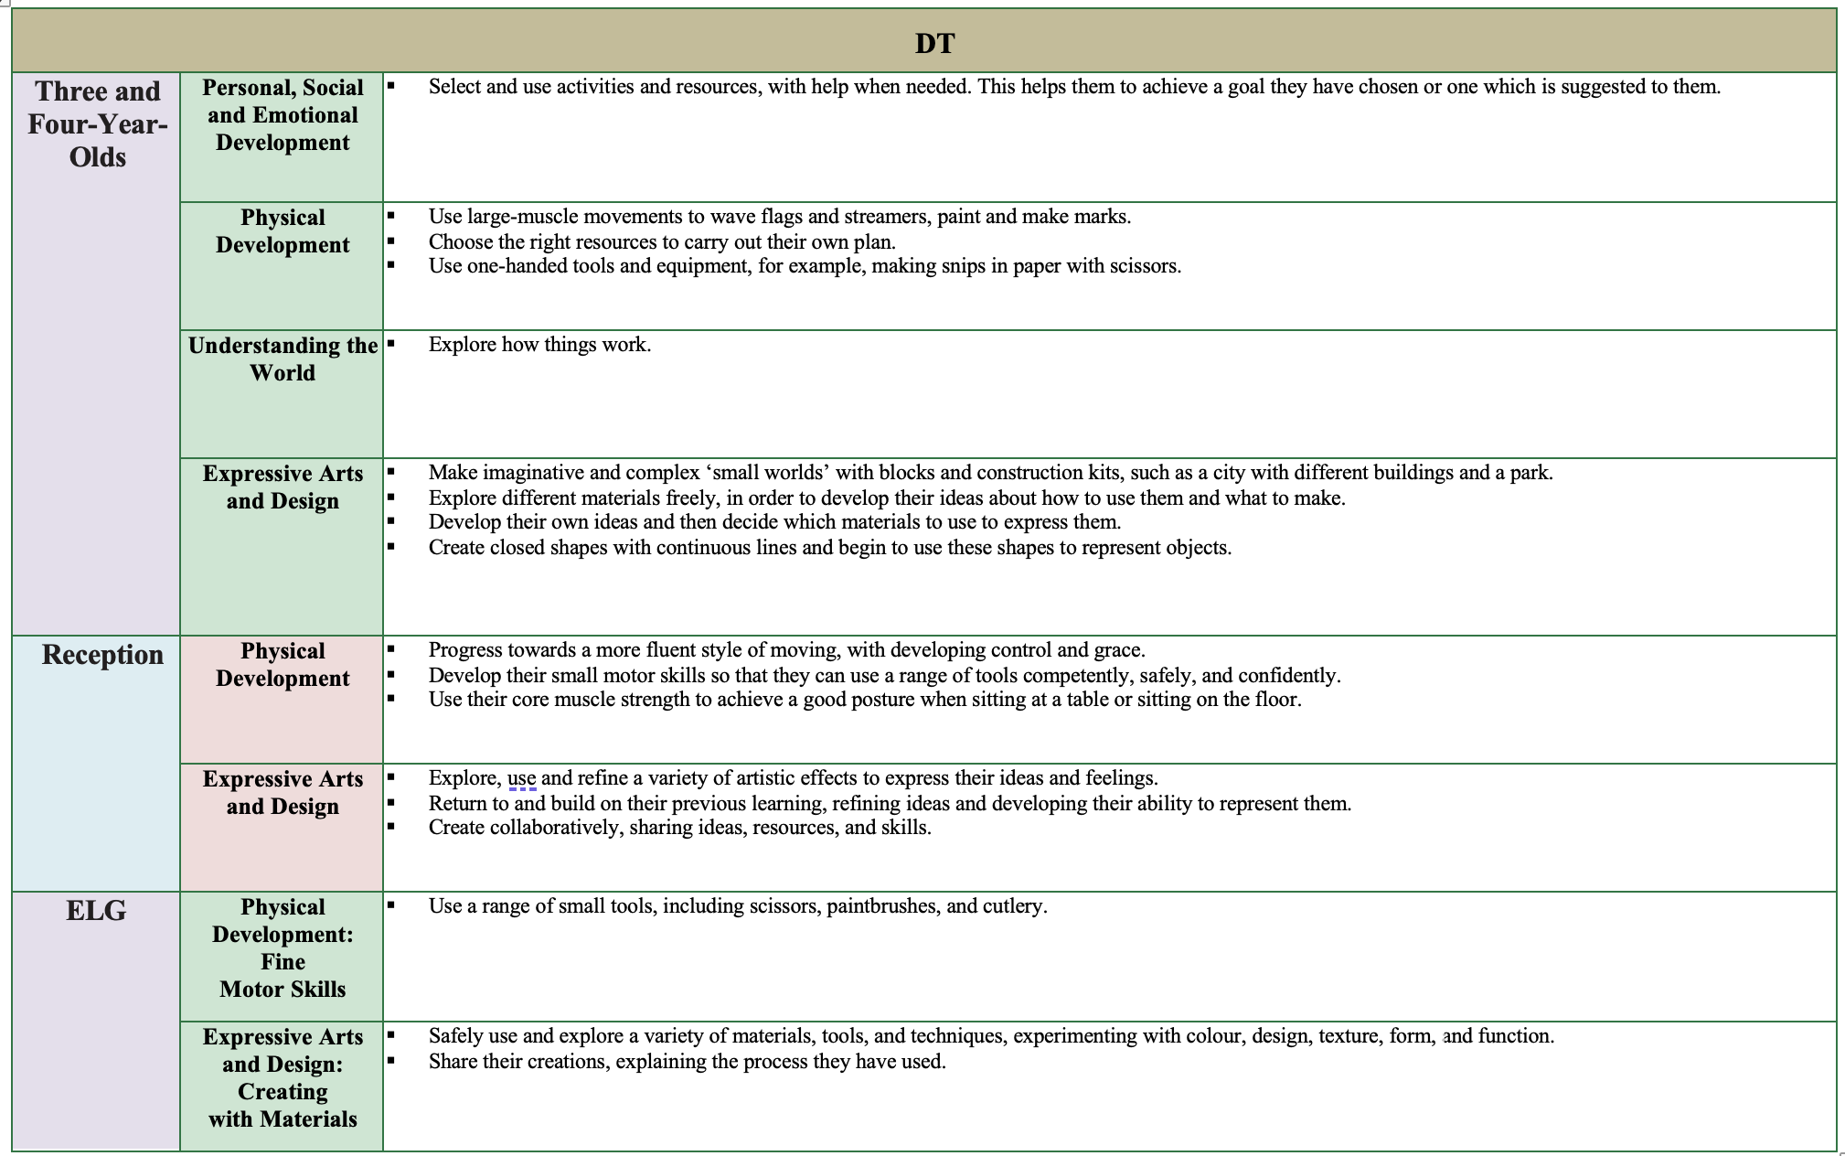
EYFS

DT - Structures
Skills
 | Year 2 – Baby Bear’s chair | Year 3 – Castles | Year 5 – Bridges
Design | - Generating and communicating ideas using sketching and modelling | - Designing with key features to appeal to a specific person/purpose.  - Drawing and labelling a castle design using 2D shapes, labelling: -the 3D shapes that will create the features - materials needed and colours. | - Designing a stable structure that is able to support weight  - Creating frame structure with focus on triangulation
Make | - Making a structure according to design criteria  - Creating joints and structures from paper/card and tape | - Constructing a range of 3D geometric shapes using nets.  - Creating special features for individual designs.  - Making facades from a range of recycled materials. | - Create truss bridges that span a given distance and supports a load, reinforcing where needed.  - Independently measuring and marking wood accurately  - Selecting appropriate tools and equipment and techniques for particular tasks
Evaluate | - Testing the strength of own structures  - Evaluating the strength, stiffness and stability of own structure | - Evaluating own work and the work of others based on the aesthetic of the finished product and in comparison, to the original design.  - Suggesting points of modification of the individual designs. | - Adapting and improving own bridge structure by identifying points of weakness and reinforcing them as necessary  - Suggesting points for improvements for own bridges and those designed by others
Knowledge
Technical | - To know that materials can be manipulated to improve strength and stiffness  - To know that a structure is something which has been formed or made from parts  - To know that a ‘strong and stable’ structure is one which does not break easily and is firmly fixed | - To understand that wide and flat based objects are more stable.  - To understand the importance of strength and stiffness in structures. | - To understand some different ways to reinforce structures  - To understand why material selection is important based on their properties  - To understand the material (functional and aesthetic) properties of wood
Additional | N/A | - To know that a design specification is a list of success criteria for a product.  - To understand why castles had to be strong, know the features of a castle and their purpose. | - To understand the difference between arch, beam, truss and suspension bridges  - To understand how to carry and use a saw safely
Skills and Knowledge Progression

Mechanisms/Mechanical systems

Skills
 | Year 1 – Making a moving story book | Year 2 - Making a moving monster | Year 6 – Automata toys
Design | - Explaining how to adapt mechanisms, using bridges or guides to control the movement  - Designing a moving story book for a given audience | - Creating a class design criteria for a moving monster  - Designing a moving monster for a specific audience in accordance with a design criteria | - Creating a design for an automata toy based on a choice of cam to create a desired movement  - Understanding how linkages change the direction of a force  - Understanding and drawing cross-sectional diagrams to show the inner-working
Make | - Following a design to create moving models that use levers and sliders | - Making linkages using card for levers and split pins for pivots | - Measuring, marking, cutting and checking the accuracy of the components.
Evaluate | - Testing a finished product, seeing whether it moves as planned and if not, explaining why and how it can be fixed  - Reviewing the success of a product by testing it with its intended audience | - Evaluating own designs against design criteria  - Using peer feedback to modify a final design | - Evaluating the work of others and receiving feedback on own work  - Describing changes they would make/do if they were to do the project again
Knowledge
Technical | - To know that a mechanism is the parts of an object that move together  - To know that a slider mechanism moves an object from side to side | - To know that mechanisms are a collection of moving parts that work together as a machine to produce movement.  - To know that there is always an input (energy to start something) and output (movement / result) in a mechanism | - To understand that the mechanism in an automata uses a system of cams, axles and followers  - To understand that different shaped cams produce different outputs
Additional | - To know that in Design and technology we call a plan a ‘design | - To know some real-life objects that contain mechanisms | - To know that a cross-sectional diagram shows the inner workings of a product  - To know that a set square can be used to help mark 90° angles

DT - Electrical Systems
Skills
 | Year 6 – Steady Hand Game
Design | - Designing a steady hand game - identifying and naming the components required  - Drawing a design from three different perspectives, generating ideas through sketch and discussion  - Modelling ideas through prototypes
Make | - Constructing and decorating a stable base for a game  - Accurately cutting, folding and assembling a net  - Making and testing a circuit Incorporating a circuit into a base
Evaluate | - Testing own and others finished games, identifying what went well and making suggestions for improvement  - Gathering images and information about existing children’s toys  - Analysing a selection of existing children’s toys
Knowledge
Technical | - To know that batteries contain acid, which can be dangerous if they leak  - To know the names of the components in a basic series circuit including a buzzer
Additional | - To know the difference between 'form' and 'function'  - To understand that 'fit for purpose' means that a product works how it should and is easy to use  - To know the importance of ‘form follows function’ when designing: the product must be designed primarily with the function in mind

DT – Cooking and nutrition

Skills
 | Year 2 – A Balanced Diet | Year 6 – Come Dine With Me
Design | - Designing a healthy wrap based on a food combination which work well together | - Writing a recipe, explaining the key steps, method and ingredients  - Including facts and drawings from research undertaken
Make | - Slicing food safely using the bridge or claw grip • Constructing a wrap that meets a design brief | - Following a recipe, including using the correct quantities of each ingredient  - Adapting a recipe based on research  - Working safely and hygienically with independence
Evaluate | - Describing the taste, texture and smell of fruit and vegetables  - Describing the information that should be included on a label  - Evaluating which grip was most effective | - Evaluating a recipe, considering: taste, smell, texture and origin of the food group  - Taste testing and scoring final products, evaluating how they could be improved.  - Evaluating health and safety in production to minimise cross contamination
Knowledge
Cooking and Nutrition | - To know that ‘diet’ means the food and drink that a person or animal usually eats  - To understand what makes a balanced diet  - To know that the five main food groups are: Carbohydrates, fruits and vegetables, protein, dairy and foods high in fat and sugar  - To know that ‘ingredients’ means the items in a mixture or recipe | - To know that many countries have ‘national dishes’ which are recipes associated with that country  - To know that ‘processed food’ means food that has been put through multiple changes in a factory  - To understand that it is important to wash fruit and vegetables before eating to remove any dirt and insecticides  - To understand what happens to a certain food before it appears on the supermarket shelf (Farm to Fork)

Knowledge
Technical | - To know that ‘joining technique’ means connecting two pieces of material together  - To understand that a template (or fabric pattern) is used to cut out the same shape multiple times  - To know that drawing a design idea is useful to see how an idea will look | - To know that applique is a way of mending or decorating a textile by applying smaller pieces of fabric  - To know that when two edges of fabric have been joined together it is called a seam  - To know that it is important to leave space on the fabric for the seam

DT – Textiles

Skills
 | Year 1 - Puppets | Year 3 - Cushions
Design | - Using a template to create a design for a puppet | - Designing and making a template from an existing cushion and applying individual design criteria
Make | - Cutting fabric neatly with scissors  - Using joining methods to decorate a puppet  - Sequencing steps for construction | - Following design criteria to create a cushion  - Cutting fabric, threading needles and tying knots with greater independence  - Sewing using cross stitch and running stitch to join fabric and apply appliqué
Evaluate | - Reflecting on a finished product, explaining likes and dislikes | - Evaluating an end product and thinking of other ways in which to create similar items

DT – Digital World
Skills
 | Year 4 – Wearable Technology
Design | - Problem solving by suggesting which features on a micro:bit might be useful and justifying my ideas.  - Developing design ideas through annotated sketches to create a product concept.  - Developing design criteria to respond to a design brief.
Make | - Following a list of design requirements.  - Writing a program to control (button press) and/or monitor (sense light) that will initiate a flashing LED algorithm.
Evaluate | - Analysing and evaluating wearable technology.  - Using feedback from peers to improve design.
Knowledge
Technical | - To understand that, in programming, a ‘loop’ is code that repeats something again and again until stopped.  - To know that a micro:bit is a pocket-sized, codeable computer.  - To know that a simulator is able to replicate the functions of an existing piece of technology.
Additional | - To understand what is meant by ‘point of sale display.’  - To know that CAD stands for Computer-aided design.  - To know what a focus group is by taking part in one.

EYFS  National Curriculum Coverage - DT | Key Stage 1 | Key Stage 2
- Select and use activities and resources, with help when needed. | - Design purposeful, functional, appealing products for themselves and other users based on design criteria | - Use research and develop design criteria to inform the design of innovative, functional, appealing products that are fit for purpose, aimed at particular individuals or groups
- Create collaboratively, sharing ideas, resources and skills. | - Generate, develop, model and communicate their ideas through talking, drawing, templates, mock- ups and, where appropriate, information and communication technology | - Generate, develop, model and communicate their ideas through discussion, annotated sketches, cross-sectional and exploded diagrams, prototypes, pattern pieces and computer- aided design
- Choose the right resources to carry out their own plan. | - Select from and use a range of tools and equipment to perform practical tasks (for example, cutting, shaping, joining and finishing) | - Select from and use a wider range of tools and equipment to perform practical tasks (for example, cutting, shaping, joining and finishing) accurately
- Explore different materials freely, in order to develop their ideas about how to use them and what to make. | - Select from and use a wide range of materials and components, including construction materials, textiles and ingredients, according to their characteristics | - Select from and use a wide range of materials and components, including construction materials, textiles and ingredients, according to their characteristics
- Explore how things work. | - Explore and evaluate a range of existing products | - Investigate and analyse a range of existing products
- Return and build on their previous learning, refining ideas and developing their ability to represent them. | - Evaluate their ideas and products against design criteria | - Evaluate their ideas and products against their own design criteria and consider the views of others to improve their work
- Safely use and explore a variety of materials, tools and techniques, experimenting with colour, design, texture, form and function. | - Build structures, exploring how they can be made stronger, stiffer and more stable | - Apply their understanding of how to strengthen, stiffen and reinforce more complex structures
- Explore how things work. | - Explore and use mechanisms (for example, levers, sliders, wheels and axles) in their products. | - Understand and use mechanical systems in their products (for example, gears, pulleys, cams, levers and linkages)
 | - Use basic principles of a healthy and varied diet to prepare dishes | - Understand and apply principles of a healthy and varied diet  - Prepare and cook variety of predominantly savoury dishes using a range of cooking techniques
 | - Understand where food comes from | - Understand seasonality, and know where and how a variety of ingredients are grown, reared, caught and processed
- Apply their understanding of computing to program, monitor and control their products
- Understand and use electrical systems in their products (for example, series circuits incorporating switches, bulbs, buzzers and motors)
- Understand how key events and individuals in design and technology have helped shape the world

Key Stage 1 | Puppets | Story book | Baby bear | Balanced diet | Monster
Design purposeful, functional, appealing products for themselves and other users based on design criteria

Generate, develop, model and communicate their ideas through talking, drawing, templates, mock- ups and, where appropriate, information and communication technology

Select from and use a range of tools and equipment to perform practical tasks (for example, cutting, shaping, joining and finishing)

Select from and use a wide range of materials and components, including construction materials, textiles and ingredients, according to their characteristics

Explore and evaluate a range of existing products

Evaluate their ideas and products against design criteria

Build structures, exploring how they can be made stronger, stiffer and more stable

Explore and use mechanisms (for example, levers, sliders, wheels and axles) in their products.

Use basic principles of a healthy and varied diet to prepare dishes

Understand where food comes from

Key Stage 2 | Castles | Wearables | Cushion | Bridges | Steady game | Come dine | Automata
Use research and develop design criteria to inform the design of innovative, functional, appealing products that are fit for purpose, aimed at particular individuals or groups
Generate, develop, model and communicate their ideas through discussion, annotated sketches, cross-sectional and exploded diagrams, prototypes, pattern pieces and computer- aided design
Select from and use a wider range of tools and equipment to perform practical tasks (for example, cutting, shaping, joining and finishing) accurately
Select from and use a wide range of materials and components, including construction materials, textiles and ingredients, according to their characteristics
Investigate and analyse a range of existing products
Evaluate their ideas and products against their own design criteria and consider the views of others to improve their work
Understand how key events and individuals in design and technology have helped shape the world
Apply their understanding of how to strengthen, stiffen and reinforce more complex structures
Understand and use mechanical systems in their products (for example, gears, pulleys, cams, levers and linkages)
Understand and use electrical systems in their products (for example, series circuits incorporating switches, bulbs, buzzers and motors)
Apply their understanding of computing to program, monitor and control their products
Understand and apply principles of a healthy and varied diet
Prepare and cook variety of predominantly savoury dishes using a range of cooking techniques
Understand seasonality, and know where and how a variety of ingredients are grown, reared, caught and processed

Year 1 Knowledge Organisers

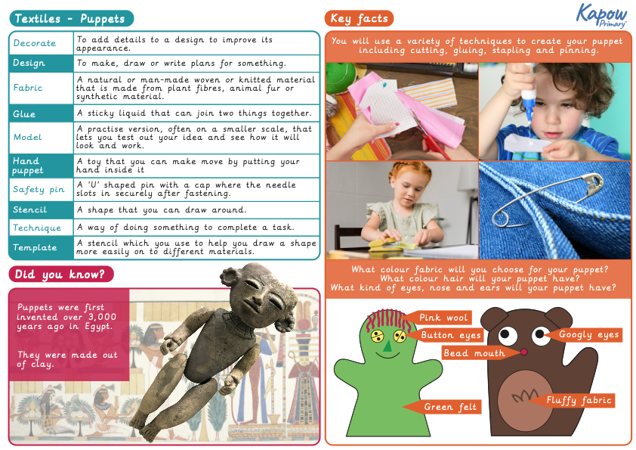

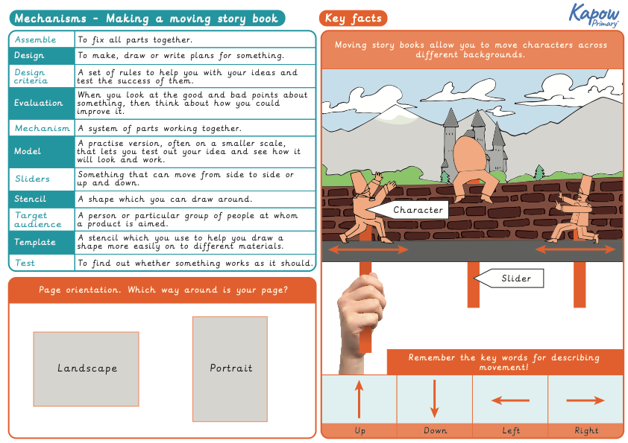
Year 2 Knowledge Organisers

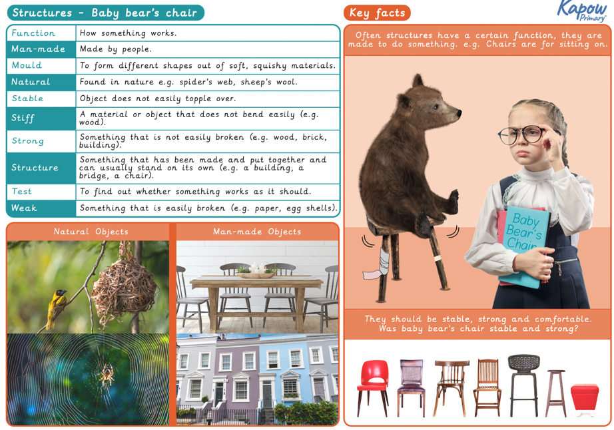

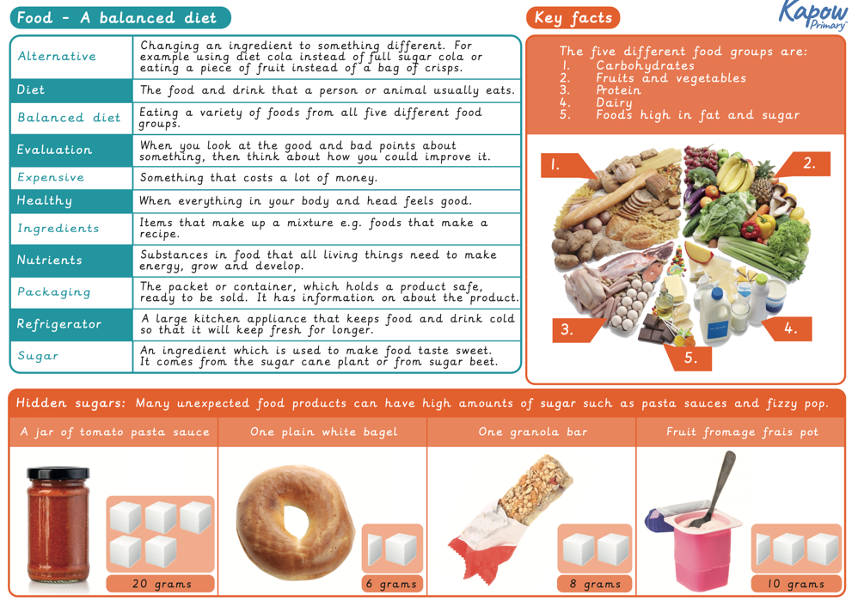
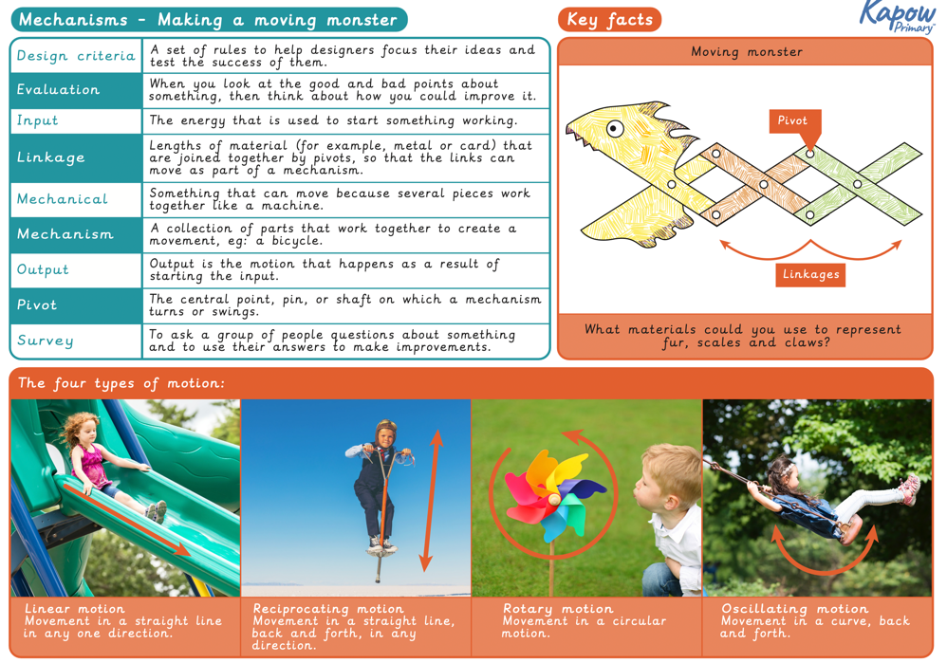
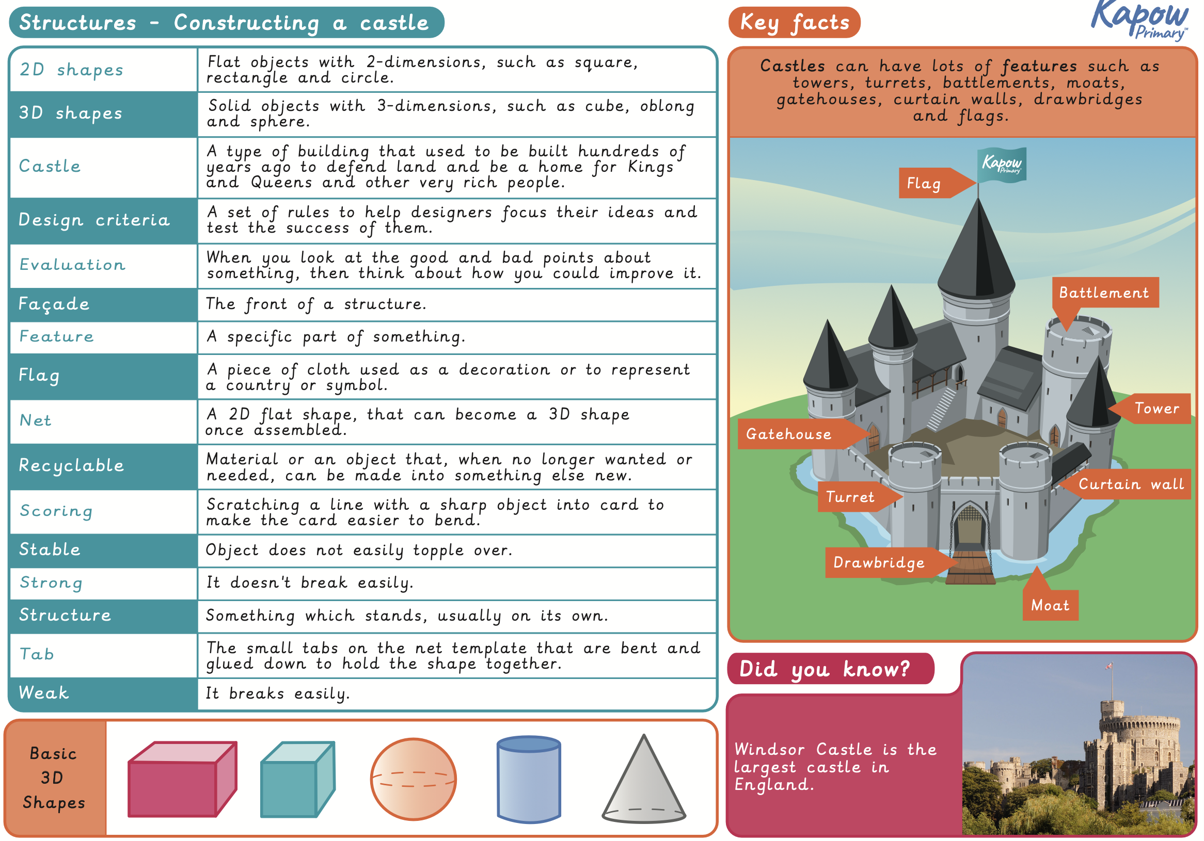
Year 3 Knowledge Organisers
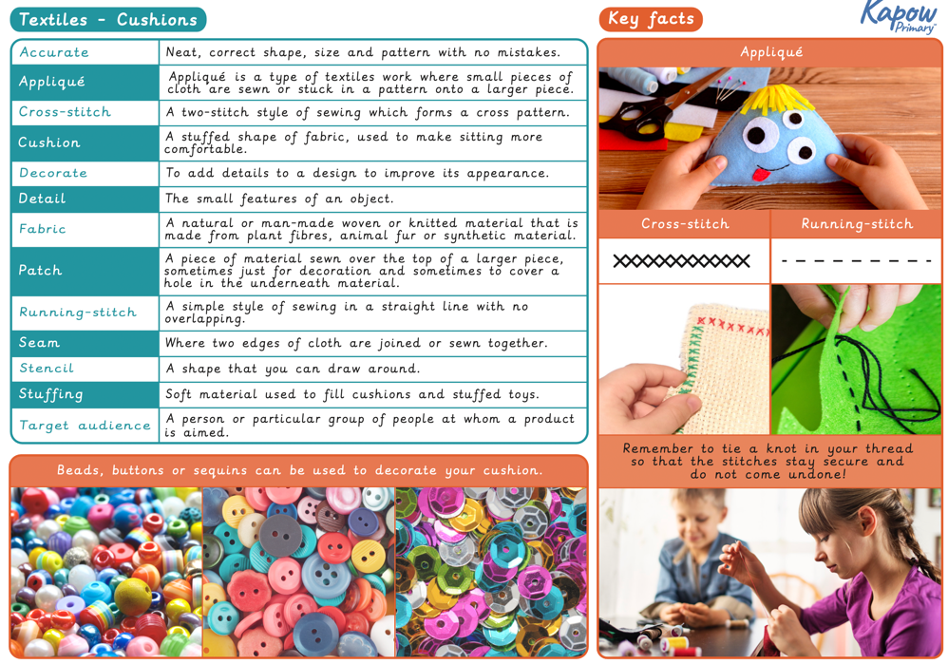
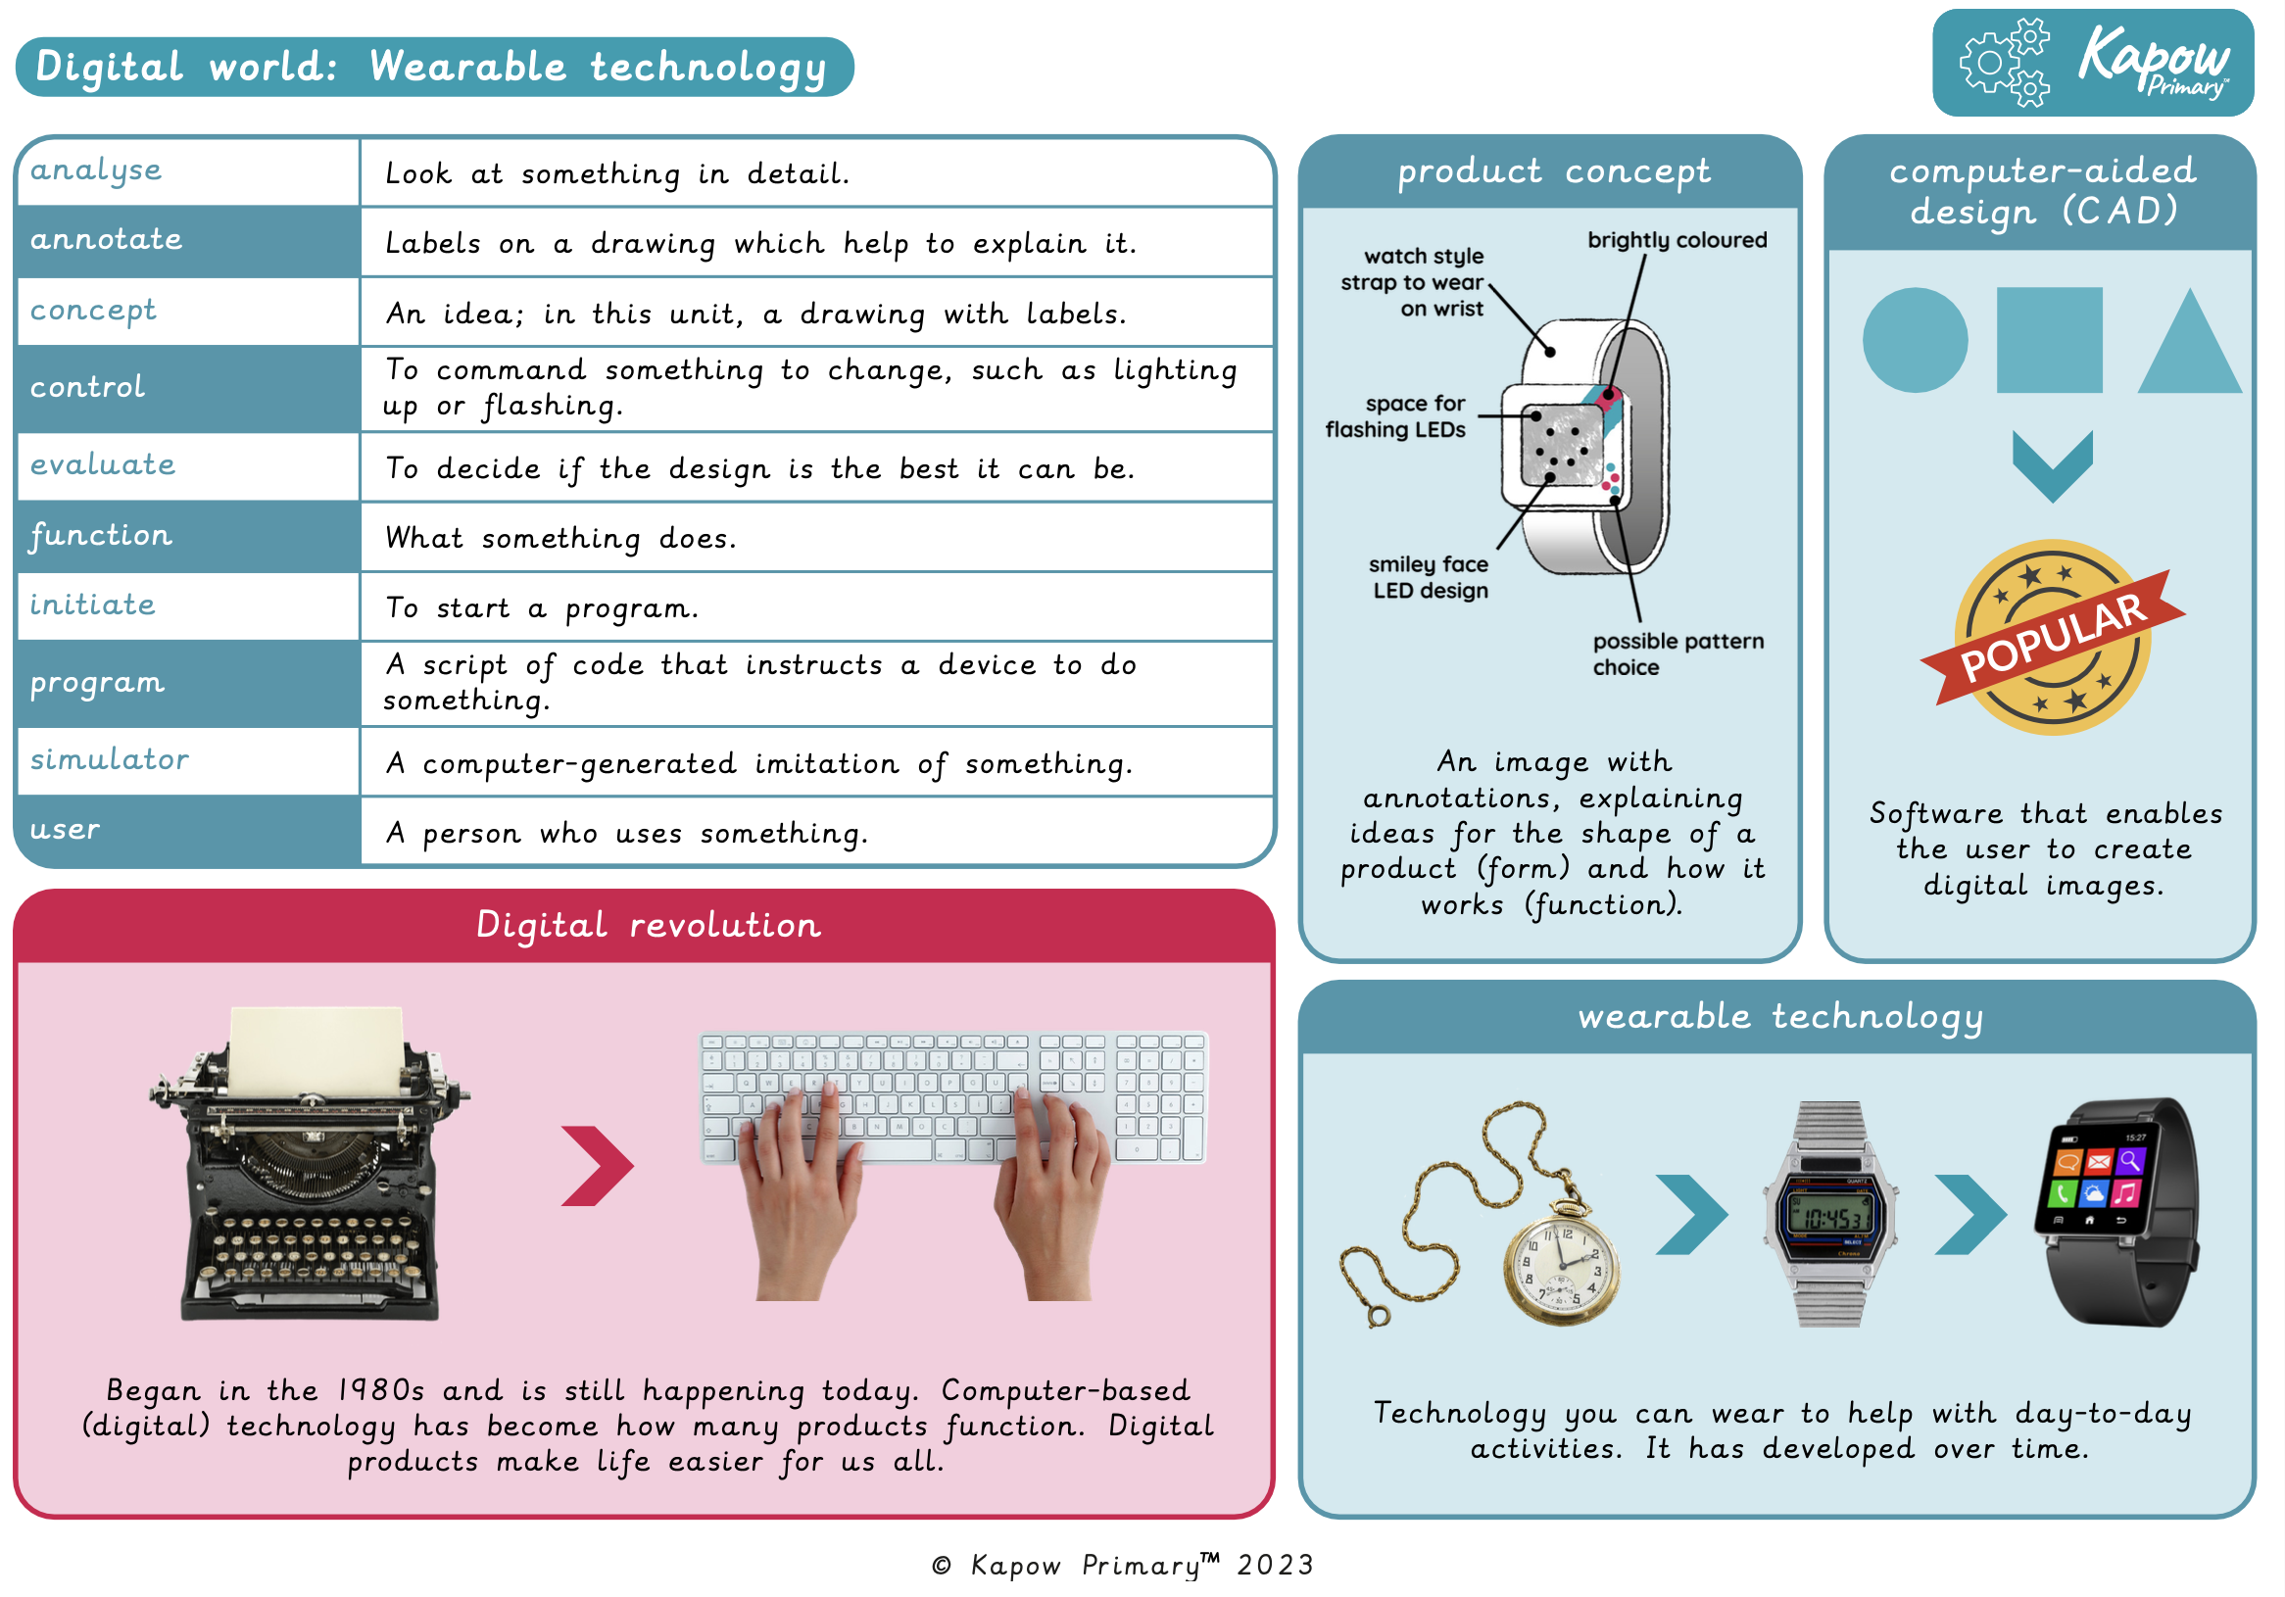
Year 4 Knowledge Organisers

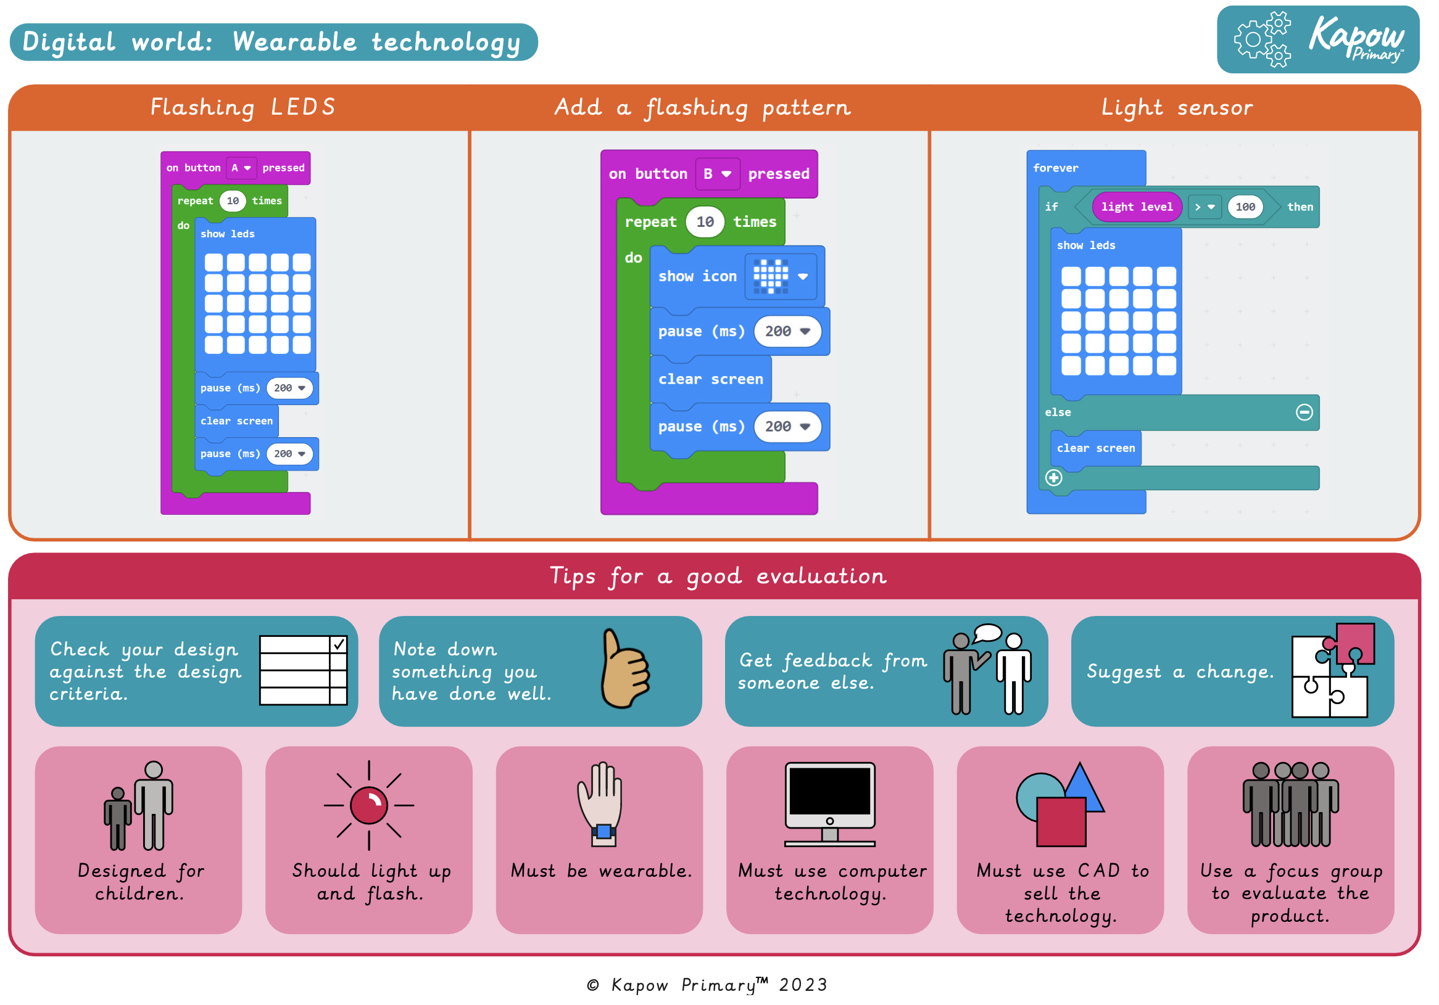
Year 5 Knowledge Organisers

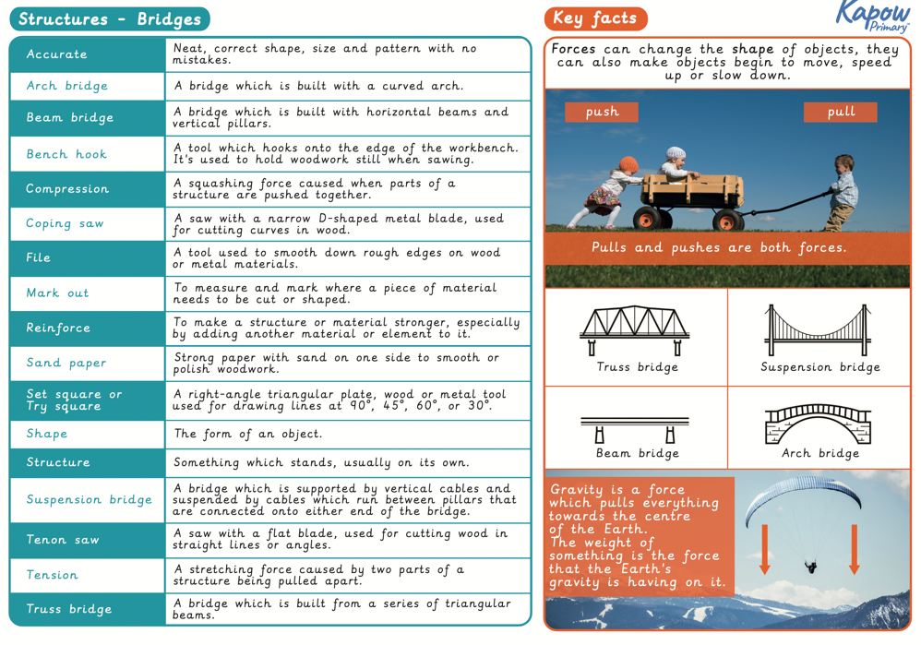

Year 6 Knowledge Organisers
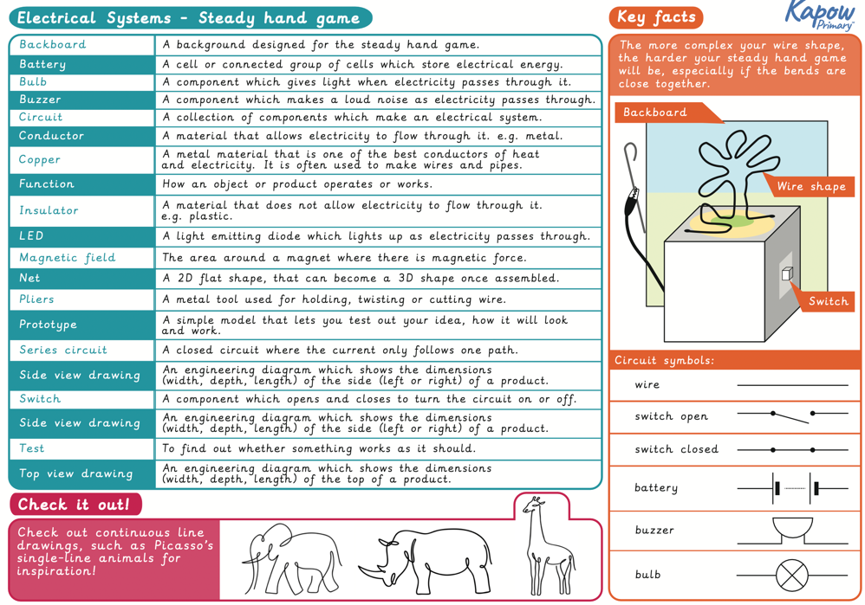
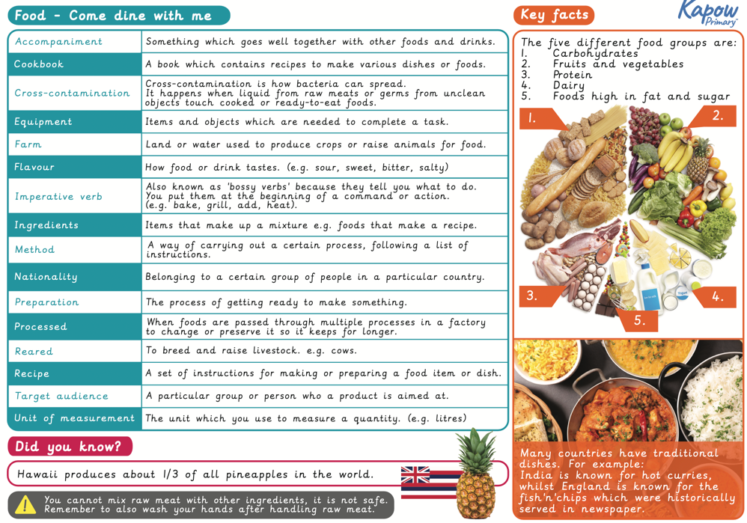
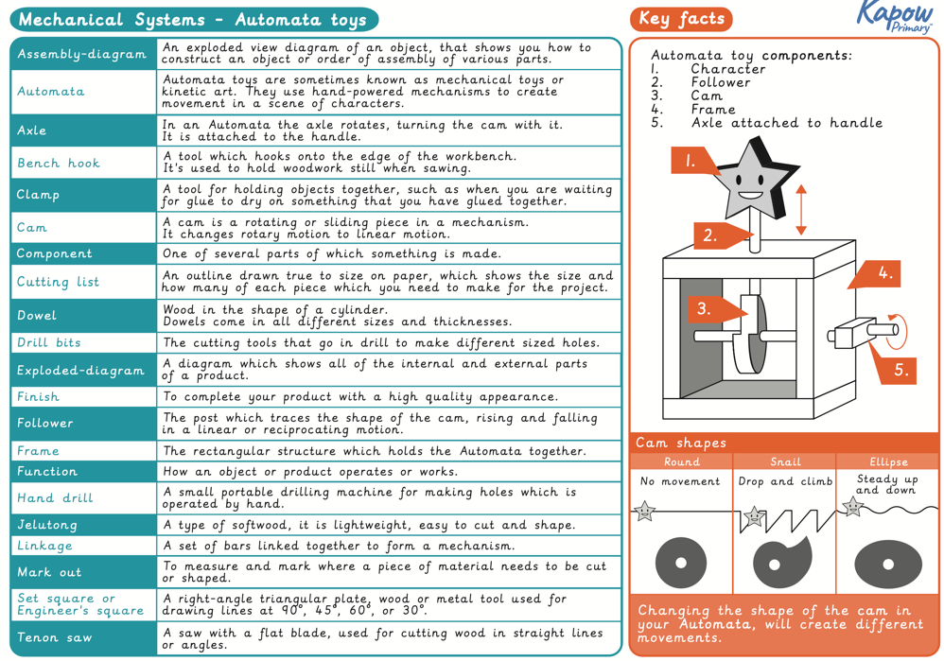
Design and Technology Assessment Grids
Year 1 | Working towards (WT) | Working within (WW) | Greater depth (GD)
Textiles: Puppets | Joining fabrics together using different techniques; pinning, stapling and gluing | Joining fabrics together using staples, pins or glue. | Joining fabrics together using staples, pins or glue as well as deciding which joining method is most suitable for the desired outcome.
 | Using a template to design a puppet | Designing a puppet and using a template. | Designing a puppet that reflects a chosen character and using a template, cutting with a consistent level of accuracy.
 | Joining two fabrics together accurately | Joining the two puppets’ faces together as one, aligning the two pieces of fabric. | Accurately and neatly joining the two puppets’ faces together as one, with even spacing.
 | To embellish a design using joining methods | Decorating a puppet to match a design using joining methods | Adapting a design to decorate a puppet so that it represents a chosen character which features a range and/or quality of joining techniques used to decorate the puppet.
Mechanisms: Making a Moving Story Book | Exploring mechanisms, learning that levers and sliders can make things move, creating moving models that use levers and sliders and using the vocabulary to describe movement (up, down, left, right, vertical and horizontal) | Identifying whether a mechanism is a lever or slider and determining what movement the mechanism will make | Identifying if a mechanism is a lever or slider and being able to determine what movement the mechanism will make. Explaining how a mechanism can be adapted, using bridges or guides to control the movement
 | Designing a moving story book, drawing background pictures and the moving parts, deciding whether to use a lever or a slider on each page and labelling the movement of each | Clearly labelling drawings to show which parts of the design will move and in which direction | Clearly labelling the moving parts and mechanism of a design that has multiple parts, moving in different ways on each page
 | Constructing a moving picture by: drawing a background, drawing and cutting the moving parts, making levers and sliders and then putting all the parts together | Creating a picture which meets the design criteria, with parts that move purposefully as planned | Creating a finished product with multiple parts that move purposefully as planned. Where parts do not move as planned they are able to explain why and how they would be fixed. The design also includes guides and bridges
 | Evaluating a finished product by reviewing it against the design criteria and testing it with its intended audience | Evaluating the main strengths and weaknesses of a finished product and suggesting alterations | Evaluating the main strengths and weaknesses of a finished product and suggesting meaningful alterations that will address any weakness
Structures: Constructing a Windmill | Describing the purpose of a given structure and including individual preferences and requirements within a design | Identifying and articulating some features and a design that would appeal to the character within a given story | Identifying a greater range of features that would appeal to the character within a given story, which may go beyond basic aesthetic considerations, such as colour, and focus on functional aspects, such as doors and windows. Extending the structure to include a roof
 | Making a stable structure - following instructions to cut and assemble the supporting structure of the windmill. Knowing that the shape of materials can be changed to improve the strength and stiffness of structures and that cylinders are a strong type of structure | Making stable structures from card, tape and glue which will eventually support the turbine | Cutting and sticking with accuracy to create a strong and stable structure. Successfully securing a separate structure for the roof of the windmill
 | Cutting and assembling the turbine correctly, understanding that windmill turbines use wind to turn and make the machines inside work, knowing that axles are used in structures and mechanisms to make parts turn in a circle and testing that the turbine turns in the structure and altering the parts if it doesn't | Articulating historical and contemporary uses of windmills and cutting and assembling components with accuracy | Explaining the function of windmills in different times and situations. Creating more sophisticated products through greater attention to accuracy and precision during the making process
 | Evaluating the windmill according to the design criteria, testing it's strength and stability and reinforcing it if necessary. Testing that the turbine turns in the structure and altering the parts if it doesn’t and testing that it turns freely in when blown on | Making functioning turbines and axles which are assembled into the main supporting structure. Identifying what is good about the structure and what could be done better | Creating more sophisticated products through greater attention to accuracy and precision during the making process. Evaluating the outcome by referencing the ‘Success and Design Criteria’

Year 2 | Working towards (WT) | Working within (WW) | Greater depth (GD)
Structures: Baby Bear's Chair | Comparing the stability of different shapes, identifying when a structure is more or less stable than another. Learning that shapes and structures with wide, flat bases or legs are most stable. Identify natural and man-made structures | Identifying man-made/natural structures. Contributing to discussions. Identifying stable and unstable structural shapes. Identifying features that make a chair stable | Ability to explore a wider range of structural shapes and interpret the results of the tip-test. Accurately identifying the information above, making more detailed observations/records and drawing accurate conclusions independently
 | Exploring strength in different structures, learning that the shape of the structure affects its strength. Building a strong and stiff structure by folding paper and learning that there are different ways paper can be folded to improve it. Testing the strength of a structure | Explaining the definition of strength. Identifying the strongest and weakest shaped and part of a structure. Making and testing a structure | Accurately distinguishing between strength and stability. Making accurate, functional structures and testing them independently. Articulating why cylindrical structures are stronger than those with corners
 | Making a structure according to design criteria. Knowing that chairs are structures and that they need to be strong, stiff and stable. Creating joints and structures from paper/card and tape | Working independently to use the materials as demonstrated to begin to make a stable structure. Explaining how their ideas would be suitable for the given brief | Working independently to produce a more demanding design and working with a wider range of materials and construction methods. Using more complicated joining techniques and producing neat results. Articulating why their designs will be suitable for the given brief and identifying how it could be made even better
 | Producing a finished strong, stuff and stable structure and evaluating it against the design criteria | Producing a model that satisfies the given brief, using the appropriate materials and construction techniques and explaining how they made it strong, stiff and stable | Producing a model that satisfies the given brief, made using a range of materials and construction techniques to produce a more demanding design. Explaining how they made it strong, stiff and stable and how to improve it
Food:  A Balanced Diet | Learning what makes a balanced diet and that there are five food groups (fruit and vegetables, starchy carbohydrates, proteins, dairy and oil and spreads). Knowing where to find the nutritional information on a drinks container | Naming the four main food groups and identifying foods that belong to each group | Secure knowledge of the four main food groups and the foods that belong in each. Identifying the dangers of hidden sugars in drinks
 | Taste testing food combinations. Experiencing food through touch and smell and knowing that the ideal ingredient combinations for a dish will contain foods from more than one food group | Identifying the correct food group of a given food and describing its taste, texture and smell | Carefully considering why flavour combinations do or don't work and using varied vocabulary to describe smells, textures or tastes
 | Remembering which food combinations work well together and designing three possible wraps based on these, then selecting one to make. Learning how to slice food safely using the bridge or claw grip | The ability to think of four different wrap ideas, giving consideration to flavour combinations | Carefully considering combinations that include complementary flavours and textures and justifying this
 | Making a healthy wrap, preparing the food safely and reviewing the final design | Constructing a wrap that meets the design brief and plan | Constructing a wrap that meets the design brief and plan and that has been adapted where necessary, eg: the size of the ingredients in the wrap
Mechanisms: Making a Moving Monster | Understanding that mechanisms are a collection of moving parts that work together in a machine, learning that there is always an input and output in a mechanism and identifying mechanisms in everyday objects. Learning that a lever is something that turns on a pivot and that a linkage is a system of levers that are connected by pivots. Devising a whole-class Design Criteria | Using key terms accurately. Identifying the correct terms for levers, linkages and pivots. Analysing popular toys with the correct terminology | Applying technical knowledge to more sophisticated mechanisms. Using a wider range of observations when analysing products. Identifying a more sophisticated design criteria
 | Learning that linkages use levers and pivots to create motion. Drawing two moving monster designs that satisfy the Design Criteria and include the linkage required to make the monster move | Designing monsters suitable for children, which satisfy most of the design criteria. Selecting the suitable linkage system to produce the desired motions. Evaluating two designs against the design criteria, and deciding selecting a favourite based on this and the feedback of their peers | Producing more sophisticated and suitable monster designs using complex linkage systems of their own creation (rather than selected from a stock of suggested systems). Explaining in greater depth why they have selected their chosen design
 | Learning that linkages use levers and pivots to create motion. Making linkages using card for levers and split pins for pivots, experimenting with the linkages by changing the widths, lengths and thicknesses of card | Creating functional linkages that produce the desired input and output motions | Creating imaginative and functional linkages that produce the desired input and output motions. Deviating from original designs with intent, working out how to produce more complex designs. Producing work of a high quality (neatly cut and assembled components)
 | Creating a moving monster, making linkages by connecting levers and pivots. Designing and making the features of the monster. Selecting materials according to their characteristics and evaluating how functional the monster is and whether it meets the Design Criteria | Selecting and assembling materials to create planned monster features. Assembling the monster to the linkages without affecting the function of them. Evaluating the final product against the design criteria | Selecting, assembling and using materials creatively to make planned monster features with sophistication and greater complexity. Assembling the finished monster to linkages without impeding the function. Evaluating the final product against the Design Criteria and determining ways to improve the design to be more effective

Year 3 | Working towards (WT) | Working within (WW) | Greater depth (GD)
Structures: Castles | To recognise how multiple shapes (2D and 3D) are combined to form a strong and stable structure. | Drawing a simple castle that includes the most common features and labelling the drawing | Drawing a more comprehensive castle with all of the features of the castle included. Labeling the drawing with key words and definitions of each feature
 | To design a castle. | Designing a castle with key features which appeals to a given person/purpose | Identifying specific details of the design, eg: materials, colours. Designing a castle in detail, incorporating basic features as well as other useful features specific to the person or purpose they’re designing for
 | To construct 3D nets. | Constructing a range of 3D geometric shapes using a net by:  Cutting along the bold lines  Folding along the dotted lines  Keeping the tabs the correct size  Making crisp folded edges  Gluing securely to assemble the geometric shape | Working creatively and accurately to make the unique features found in their initial design through more complex structures. Constructing nets with accuracy and designing their own nets
 | To construct and evaluate my final product. | Building a complex structure from simple geometric shapes. Evaluating own work by answering simple questions | Building a complex structure from simple geometric shapes with accuracy and creativity, justifying design decisions and identifying ways to improve own work. Evaluating own work and the work of others in relation to the original design
Textiles: Cushions | Sewing cross stitch and appliqué | Using cross stitch to join two pieces of fabric together | Using a neat and considered cross stitch to join an appliqué patch to another fabric and attempt reverse appliqué
 | Design a cushion, using a paper template and cutting fabric accurately | Designing and cutting the template for a cushion | Designing a cushion, considering how the different elements will work together and neatly cutting the template for a cushion in an interesting shape
 | Decorating fabric using appliqué and cross stitch and following a design criteria | Using cross stitch and appliqué to decorate a cushion face | Sewing cross stitch neatly, with consistently sized stitches, and appliqué to decorate a cushion face
 | Assembling the cushion, using stitches to join fabrics, leaving space for a seam | Making a cushion that includes appliqué and cross stitch | Making a cushion that includes appliqué and cross stitch using small, neat stitches that closely matches the design

Year 4 | Working towards (WT) | Working within (WW) | Greater depth (GD)
Digital world: Wearable technology | To research and evaluate existing products. | Explaining who might use a product; recognising the function of a product. | Recognising what makes a product useful; making links between older and newer products; suggesting reasons for product changes.
 | To develop design criteria. | Developing specific criteria so that a product fits the needs of those who will most likely use it. | Suggesting how each part of the design criteria can be accomplished without guidance.
 | To use code to program and control a product. | Writing a program that initiates a flashing LED panel when a button is pressed; checking code against an example that is correct to check for errors and debug. | Writing the program with minimal guidance; suggesting the next steps in a code independently; debugging or fixing errors in programming independently.
 | To develop and communicate ideas. | Creating a drawing of a product that represents an idea of how the final product could look; explaining to a user what each feature on the product does using annotations. | Creating a product concept drawing, but with care taken to explain the choices for design features; considering material choices and how the properties of those materials improve the ‘usability’ of the product.
 | To develop ideas through computer-aided design. | Describing what is meant by ‘point of sale display’ and giving an example; following simple design requirements; using computer-aided design software to create a POS badge; evaluating their design. | Describing and explaining what a point of sale display can include, with examples (including from their own experience); following the design requirements, including their own additions with justification and any extension work; evaluating their design, including positive points to improve it with an explanation.
 | To improve a design based on feedback | Providing opinions about the quality of the overall design and specific choices that others have made; making decisions about changes they could make to their design based on the feedback of others. | Explaining the opinions they provide about the overall design quality; providing helpful feedback to others to assist them in making design changes; being critical of their design by suggesting meaningful changes based on the feedback of the focus group.

Year 5 | Working towards (WT) | Working within (WW) | Greater depth (GD)
Structures: Bridges | Identifying arch and beam bridges and understanding ‘compression and tension’. Making a range of different shaped beam bridges, identifying stronger and weaker structures and finding different ways to reinforce structures | Articulating the definition of ‘tension and compression’ and identifying stronger and weaker shapes and points where structures typically failed | Articulating the definition of ‘tension and compression’ and identifying where it is utilised in different structures. Suggesting a variety of ways to reinforce structures at the points at which they failed
 | Building a spaghetti truss bridge  Identifying and building suspension and truss bridges, using triangles to create truss bridges and testing them, understanding how triangles can be used to reinforce bridges | Identifying suspension and truss bridges and using triangles to create a simple truss bridge that spans a given distance and supports a load. | Articulating the difference between beam, arch, truss and suspension bridges and making an accurate and well constructed truss bridge, explaining where some bridges are stronger or weaker than others.
 | Building a wooden bridge structure, measuring and marking the wood accurately, selecting appropriate tools and equipment, using saws safely and using card corners to reinforce the structure | Independently measuring and marking out wood and using correct techniques to cut it safely | Independently creating accurate, neat and secure joints by using correct techniques to cut the wood safely and using card corners where they determine they need to reinforce their structure
 | Improving and reinforcing a bridge structure, identifying points of weakness and reinforce them as necessary and adding road markings | Evaluating the success of the bridge, making improvements and reinforcements as necessary | Independently building the bridge design, adapting and improving the structure as necessary by identifying points of weakness as well as adding road markings to the bridge surface for a high quality finish

Year 6 | Working towards (WT) | Working within (WW) | Greater depth (GD)
Electrical Systems: Steady Hand Game | Understanding how electromagnetic motors work and making one, tweaking the motor to improve its function | Knowing that batteries contain acid, which can be dangerous if they leak and that when electricity enters a magnetic field it can make a motor work. Creating a functioning homopolar motor | Knowing that batteries contain acid, which can be dangerous if they leak and that when electricity enters a magnetic field it can make a motor work. Creating a homopolar motor which works reliably and explaining how it works.
 | To design a steady hand game, creating clear design criteria and drawing it from three different perspectives | Identifying components in a steady hand game and designing one in accordance to the design criteria, using four different perspective drawings | Identifying components in a steady hand game and designing one in accordance to the design criteria, using four different perspective drawings and a more complex shape as the base. Designing a backboard for the game
 | Cutting and assembling a net and decorating the base | Creating a secure base with neat edges, ensuring that the sides of the base are aligned when glued and decorating the base to a good quality finish | Creating a secure base with neat edges, ensuring that the sides of the base are aligned when glued, decorating the base to a high quality, detailed finish and adding a backboard which follows the same theme and references the original design
 | Incorporating a circuit into a game | Making and testing a functioning circuit, naming the components and assembling it within the case. | Creating a complex wire shape for their game and attaching this securely to their base and naming all the components within the circuit
Food: Come Dine With Me | Designing a three course meal, researching a recipe by ingredient, listing the required ingredients and equipment and reading the method | Finding a suitable recipe for a given course and ingredient and recording the relevant ingredients and equipment needed to make it | Finding a suitable recipe for a given course and ingredient and recording the relevant ingredients and equipment needed to make it. Understanding the combinations of food that will complement one another
 | Safely preparing a meal following a recipe, describing the process of ‘Farm to Fork’ for a given ingredient and contributing a recipe to a class cookbook using imperative verbs, adjectives and illustrations | Following a recipe, including using the correct quantities of each ingredient. Writing a recipe: explaining the process taken. Explaining where certain key foods come from before they appear on the supermarket shelf | Following a recipe, including using the correct quantities of each ingredient and adapting the recipe based on research. Writing a recipe: explaining the key steps, method and ingredients needed. Explaining where certain foods come from before they reach the supermarket and explaining what impact different methods of farming have on the wider world
 | Safely preparing a meal following a recipe, describing the process of ‘Farm to Fork’ for a given ingredient and contributing a recipe to a class cookbook using imperative verbs, adjectives and illustrations | Following a recipe, including using the correct quantities of each ingredient. Writing a recipe: explaining the process taken. Explaining where certain key foods come from before they appear on the supermarket shelf | Following a recipe, including using the correct quantities of each ingredient and adapting the recipe based on research. Writing a recipe: explaining the key steps, method and ingredients needed. Explaining where certain foods come from before they reach the supermarket and explaining what impact different methods of farming have on the wider world
 | Safely preparing a meal following a recipe, describing the process of ‘Farm to Fork’ for a given ingredient and contributing a recipe to a class cookbook using imperative verbs, adjectives and illustrations | Following a recipe, including using the correct quantities of each ingredient. Writing a recipe: explaining the process taken. Explaining where certain key foods come from before they appear on the supermarket shelf | Following a recipe, including using the correct quantities of each ingredient and adapting the recipe based on research. Writing a recipe: explaining the key steps, method and ingredients needed. Explaining where certain foods come from before they reach the supermarket and explaining what impact different methods of farming have on the wider world
Mechanical Systems: Automata Toy | Measuring, marking and checking the accuracy of the jelutong and dowel pieces required, using wood work tools safely and measuring and cutting the required card components accurately | Cutting the jelutong pieces with accuracy, using tools and equipment safely, knowing that saws have sharp teeth and can be dangerous if not used properly | Cutting all of the jelutong pieces with accuracy and perhaps pace and understanding that saws have sharp teeth and can be dangerous of not used properly
 | Cutting and assembling the components to make a frame, securing the joints of the frame at right angles and using a glue gun safely | Cutting all of the pieces with accuracy, using tools and equipment safely. Assembling the frame securely according to the diagram | Cutting all the pieces with greater accuracy, neatness and pace. Assembling the frame securely with 90 degree right angles
 | Undertaking research to inform the design of the window display, exploring cams and understanding that different shaped cams produce different follower movements | Experimenting with a range of cams and deciding on the most effective for their design ideas. Communicating design ideas through labelled sketches | Experimenting with a range of cams and deciding on the most effective for their design ideas with more sophisticated mechanisms. Clearly communicating design ideas through more labelled sketches
 | Making and assembling a window display, focusing on the decorative elements | Creating the appropriate component parts and assembling them using the correct methods, neatly, accurately and securely, choosing the correct glue according to the materials being joined and the speed at which the glue needs to dry | Applying a more in depth knowledge of mechanisms to their work and creating components with greater skill and accuracy.

