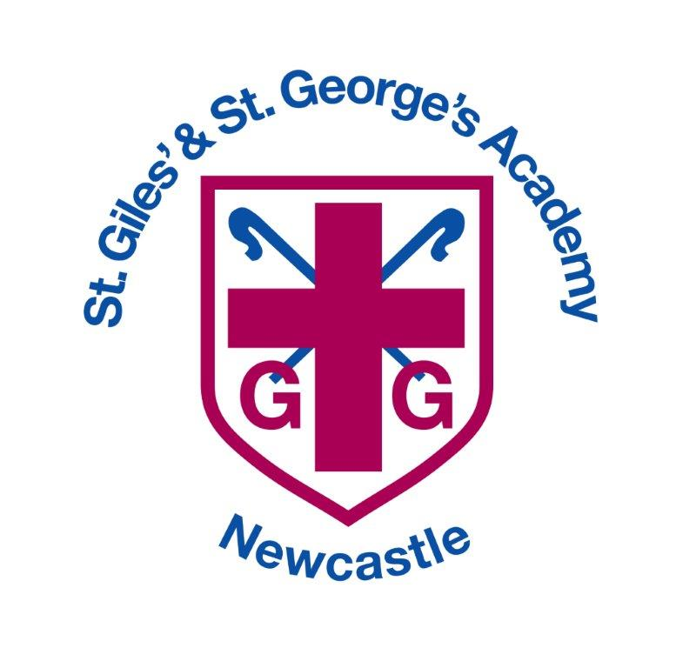

British Values Policy

**Date policy reviewed: March 2024**

|  |  |
| --- | --- |
| **Signed by** | **Date** |
| **Headteacher:** |  |
| **Trust:** |  |

**British Values Policy**

At St Giles’ and St George’s C of E Academy, we develop and promote British Values throughout our school and

within our curriculum.

“*We want every school to promote the basic British Values of democracy, the rule of law, individual liberty, and mutual respect and tolerance for those of different faiths and beliefs.” Lord Nash*

A key part of our plan for education is to ensure children become valuable and fully rounded members of society who treat others with respect and leave school fully prepared for life in modern Britain.

British Values

* The Rule of Law
* Democracy
* Individual Liberty
* Mutual Respect
* Tolerance for those of different faiths and beliefs

To do this our children will develop;

* An understanding of how citizens can influence decision-making through the democratic process
* An understanding that the freedom to hold other faiths and beliefs is protected in law
* An acceptance that people having different faiths and beliefs to oneself (or having none) should be accepted and tolerated, and should not be the cause of discriminatory behaviour
* An understanding of the importance or identifying and combating discrimination

The mission statement and aims of the school clearly reflect these values, and the whole school strives to uphold them.

**Our School Aims**

Our aims stand upon three fundamental principles;

* To provide every child with the life skills to become successful learners who reach their full potential.
* To provide a safe, supportive, stimulating and inclusive environment where every child is recognised, cared for, encouraged and valued.
* St Giles’ and St George’s will actively ensure the involvement of the whole community, particularly families, who have a vital role in supporting their children’s education. This partnership will encourage healthy and positive attitudes motivating children to become life-long learners.

As a school, we value and celebrate the diverse heritages of everybody Alongside this, we value and celebrate being part of Britain. In general terms, this means that we celebrate traditions and customs in the course of the year; for example, Harvest Festival during the Autumn term and trips to the pantomime in at Christmas. We also value and celebrate national focusses, recent examples being; Macmillan Coffee Morning, Roald Dahl Day, Chinese New Year and Safer Internet Day, with many more opportunities planned in throughout the year to collaborate with the wider community and world e.g. Children in Need

Further to this, children learn about being part of Britain from different perspectives. Two specific examples of when we teach about being part of Britain are:

Geographically: Our rivers, coasts and seaside holiday topics ensure that children have a better understanding of what Britain is, learning more about:

* + its coasts, rivers and mountains
  + where Britain is in relation to the rest of Europe and other countries in the world
  + Historically: Key moments in British history are studied in the topics such as World War 2 and significant historical figures.

The table below shows how our Gospel values link with school British values.

|  |  |  |
| --- | --- | --- |
| **Term** | **Gospel Value** | **British Value** |
| Autumn 1 | Intentional and Prophetic | Individual Liberty |
| Autumn 2 | Compassionate and Loving | Mutual respect |
| Autumn 3 | Faith filled and Hopeful | Tolerance for those of different faiths and beliefs |
| Spring 1 | Learned and Wise | The Rule of Law |
| Spring 2 | Curious and Active | Democracy |
| Summer 1 | Attentive and Discerning | Tolerance for those of different faiths and beliefs |
| Summer 2 | Grateful and Generous | Mutual Respect |