
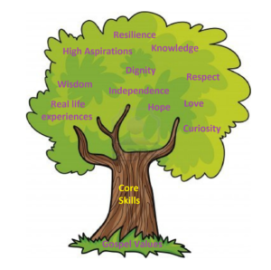

Unit: Knowledge and Understanding

Key questions/ experiments:
How are our homes different to other animal /people’s homes?

Art/Design Technology
Text: On the way home, Emma Jane’s aeroplane, When I was a child.
Skills:
- Ascribes meaning to marks that they draw, write and paint
- Hears and says initial sounds in words
- Links sounds to letters
- Writes some identifiable letters
- Orally segment and blend CVC words
- Begin to build CVC words.
- Recognise and make marks for their name
- Makes small motor vertical, horizontal and circle patterns

Final Outcome/s: 3D

Create a 3D home/vehicle for either themselves or a character from our books.
Unit: Programming -All about instructions
Overview:
Follow instructions
Give simple instructions
Dressing up instructions
Debugging instructions
Predictions
E-Safety: Smartie the Penguin.
Unit: Celebrating Difference
Overview:
- Make comparisons similarities and differences.
- Understand bullying and knowing how to deal with it.
- Making new friends
- How to celebrate differences
Unit: Incarnation
Religion: Christianity

Key Question: Why do Christians perform nativity plays at Christmas?
Religious Education
Unit: White Rose – Circles and triangles, 1, 2, 3, 4, 5
Objectives include:
- Subitising to 5
- Composition to 5
- Developing spatial awareness.
- Representing, comparing and composition
- Exploring shapes with 3 and 4 sides.
- Properties of 3 and 4 sided shapes
- Shapes and non-shapes
- One more and one less.

Ball Skills
Children will develop fundamental ball skills such as rolling and receiving a ball, throwing to a target, bouncing and catching, dribbling with feet and kicking a ball.

Develop fine pincer grasp
Physical Education
Reception Curriculum Overview – Aut 2 Adventures through time

In story time, we will be reading: Various books by Oliver Jeffers

English
Science
Unit: Kapow History: Adventures through time

Key Question:
How has transport changed over time?
How have we changed over time?
Pictures from the past

Unit: Exploring Sound
Key Skills:
Vocal Sounds
Body Sounds
Instrumental Sounds
Environmental Sounds
Nature Sounds
Mathematics
Computing
Humanities
PSHCE
Music

