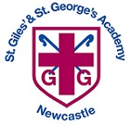
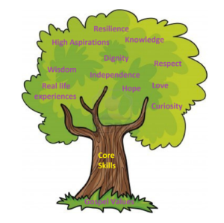

Unit: Knowledge and Understanding

Key questions:
How have I changed over time?
Comparing themselves as they have grown.
How can we organise ourselves?

Art/Design Technology
Text: Funny Bones, Super Duper You, Argh there’s a skeleton inside you, The pigeon has to go to school.
Skills:
- Gross motor movements
- Beginning to sit and listen to stories.
- Draw a clear picture. Talk about pictures in detail.
- Ascribe meaning to marks.
- Hear the initial sound in words.
- Form some recognisable letters.
- Hold pencil correctly.
- Building CVC words

Final Outcome/s: Drawing and Colour.
Create a self-portrait in your own style after looking at different artist’s styles.
Printing with body parts.
Colour mixing
Making marks and patterns with chalk, felt pens, wax crayons.
Unit: Technology in provision
Overview:
- Explore a range of technology
- Name technology used in the classroom
- Name technology used at home
- Understand what ‘technology’ is.
E-Safety: Smartie the Penguin.
Unit: Getting to know you
Key Question:
How have I changed since I was a baby?
What things have happened in my past that I can remember?
How have my toys changed?
How have household objects changed?

Unit: Being Me in my World.
Overview:
- Help other to feel welcome.
- Make our community a better place.
- Work well with others.
- Care about people’s feelings.
Unit: Special People
Religion: Christianity/Judaism

Key Question: What makes people special?
Religious Education
EYFS Curriculum Overview – Aut 1 Getting to know you

Units: White Rose – Just Like Me and It’s me 1, 2, 3!
Objectives include:
- Joining in with number nursery rhymes.
- Recite number names in order to at least 5.
- Use mathematical language in play.
- Matching and sorting amounts
- Comparing size mass, amounts and capacity
- Exploring pattern
- Representing 1, 2 and 3
- Comparing 1, 2 and 3
- Exploring circles and triangles

In story time, we will be reading: Starting school, The colour monster goes to school, That’s not my name!
Introduction to PE
I can demonstrate balance and make independent choices. I can negotiate space safely with consideration for myself and others. I follow instructions involving several ideas or actions. I play co-operatively and take turns with others. I use movement skills with developing balance and co-ordination.
Physical Education
English
Science
Unit: Music in Continuous Provision
Key Skills:
Listen to and respond to music in provision
Notice changes in volume
Say what they like/dislike about music
Begin to explore what different sounds objects make
Mathematics
Computing
Humanities
PSHCE
Music

