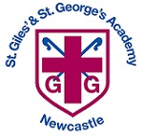
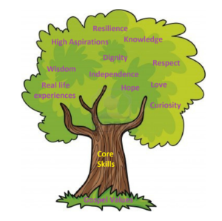

Unit: Animal needs for survival and Humans
Key questions/ experiments:
How can we group animals based on their needs for survival?
How are the needs of humans similar or different from those of other animals?
Do the oldest children have the most teeth?

Art/Design Technology
Text: The Queen’s Hat
Skills:
- Continue to write simple sentences with capital letters, finger spaces and full stops.
- Begin to generate their own more complex sentences.
- Full stops, questions marks, exclamation marks and commas
- Sentence types (All the W’s and BOYS)
- Conjunctions (but, or, yet, so, if, because)
- Time adverbials

DT Unit: Structures
Children design and build a throne for a monarch.

Unit: What is a computer?

- What does a computer need?
- What everyday items use technology and how?

Unit: Geography – Climates

Key Question:
Would you prefer to live in a hot or cold country?
Unit: Being Me in My World
Overview:
- Hope and fears
- Rights and responsibilities
- Rewards and consequences

Unit: What Did Jesus Teach?
Religion: Christianity
Key Question: Is it possible to be kind to people all the time?

Religious Education
Myths and Legends

Children will explore structure, notations and texture and create their own graphic scores

Year 1 Curriculum Overview – Autumn 1

Units: White Rose – Place Value
Objectives include:
- Sort, count and represent objects
- Count forwards and backwards
- Find one more and one less
- Compare numbers and begin to use <>=
- Order numbers
- Tens and ones, using a part whole model and addition.
- Count in 2s, 5s, 10s and 3s.
Mathematics
Authors/books of the Half Term: Tom Percival, Captain Finn Series and Agent Moose.

Fundamentals
Focus on running, jumping, hopping and
skipping

Ball skills
Focus on sending and receiving a ball

Physical Education
English
Science
Computing
Humanities
PSHCE
Music

