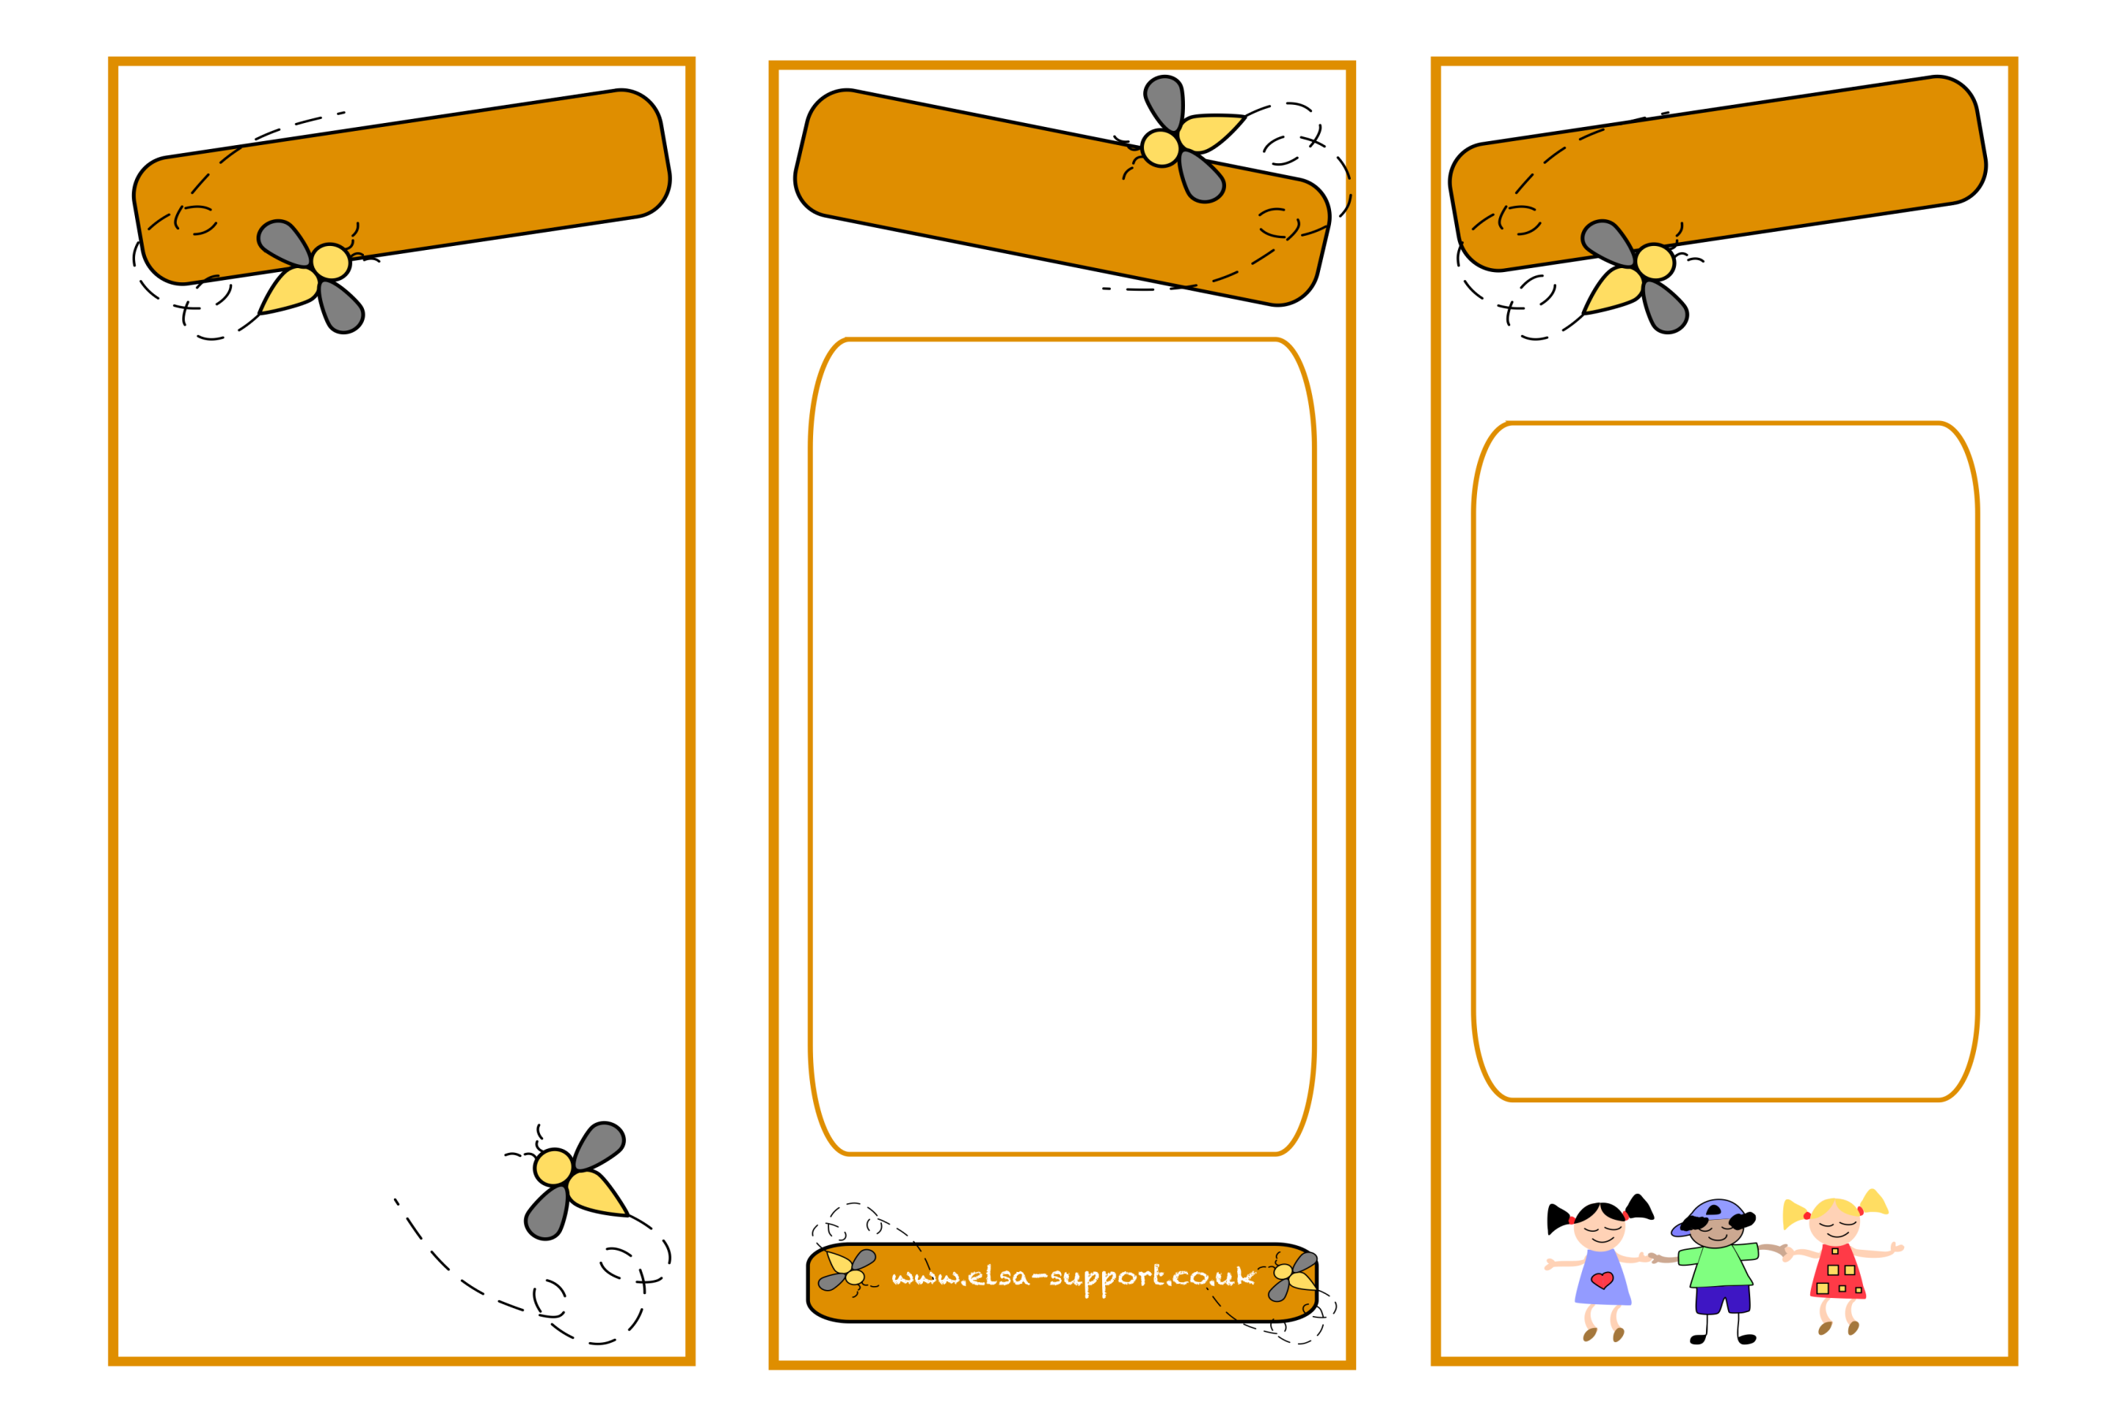
An ELSA is a specialist teaching assistant with a wealth of experience of working with children. ELSAs are trained and regularly supervised by the Educational Psychologists in your Local education authority. An ELSA is a warm and caring person who wants to help your child feel happy in school and to reach their potential educationally. Their aim is to remove the barriers to learning and to have happy children in school and at home.
Please do talk to the ELSA in your school if you have any problems with your child.

Loss and bereavement
Self-esteem
Social skills
Emotions
Friendship issues
Relationships
Anger management
Behaviour
Anxiety
Bullying
Conflict
Relaxation techniques
Emotional
Literacy
Support
Assistant

Mrs Alcock
ELSA
ELSAs can help with
What is an ELSA

