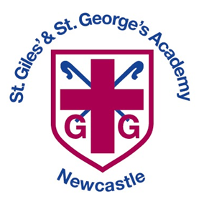
All About Me!
My name is _________________________________
I like to be called _____________________________
This is a picture of me:
Please help your child to complete this booklet for their new teacher. Talk about the questions and help your child to add their ideas, drawings and photographs.
Return to your class teacher by

This is my family:


This is my house:
These are a few of my favourite things

My favourite stories:
My favourite toys:
My favourite game:
My favourite animal:
My favourite colour:
My favourite food:
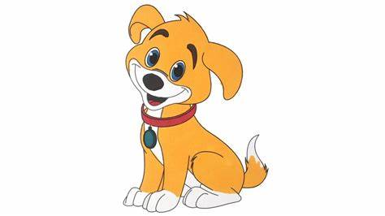
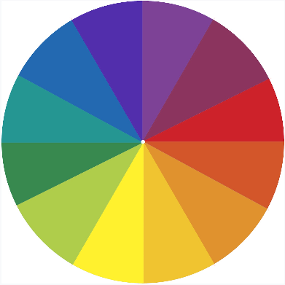
Here are some skills I have already achieved:
(E.g. using scissors, zipping up coat, buttons)

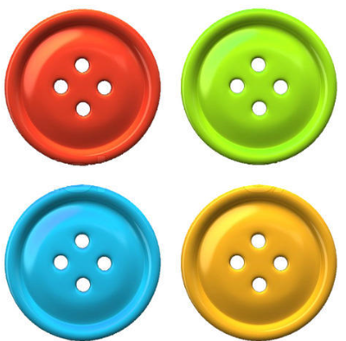
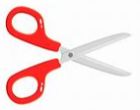
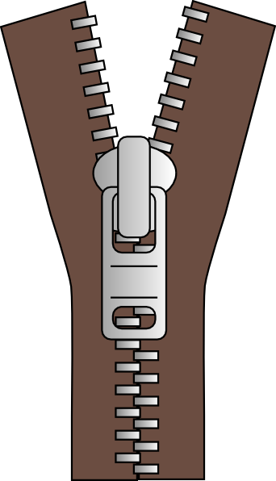

Do you like to learn inside or outside?
These are my friends. I like to work and play with them.

A special picture for my teacher.
A special message for my teacher.

What are you most looking forward to in Reception? What are you excited about?
Is there anything you are worried about?
Box for parents/carers
(Please add anything that you think would be useful for us to know)

Box for parents/carers

Is there anything else you would like to tell us about your child?

