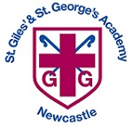
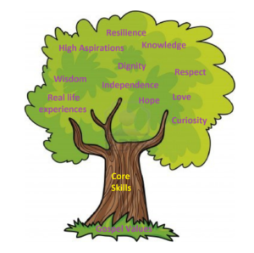

Units: White Rose – Electricity and Sustainable Energy.
Key questions/ experiments:
What common appliances use electricity? Can you draw and build a circuit? What has gone wrong with the circuit? What are conductors and insulators? What is the difference between a conductor and an insulator? How can we reduce our energy usage?
Art/Design Technology
Text: The Flower
Writing to Entertain: Setting description (before)
Writing to Entertain: Setting description (after)
Skills: speech, fronted adverbials with commas, conjunctions, different sentence types, descriptive language, paragraphs.
Art – Fabric of Nature
Describe objects, images, and sounds with relevant subject vocabulary. Create drawings that replicate a selected image.
Select imagery and colours to create a mood board with a defined theme and colour palette. Complete four drawings, created with confident use of materials and tools to add colour.
Understand the work of William Morris, using subject vocabulary to describe his work and style.

Unit: Website Design
Overview: Create a Sway with a title, image and a completed first header section. Create a clear plan for their web page and beginning to create it. Create a professional-looking web page with useful information and a clear style, which is easy for the user to read and find information from. Create a clear plan by referring back to their checklist to include a range of features. Create a web page with clear sections and with a range of features in. E-Safety: What is a bot?
Unit: Geography
Key Question: Why are rainforests important to us? Describe a biome and give an example. State the location and some key features of the Amazon rainforest. Name and describe the four layers of tropical rainforests. Understand that trees and plants adapt to living in the rainforest and give an example. Define the word indigenous and give an example of how indigenous peoples use the Amazon’s resources.
Unit: Healthy Me
Overview: Can identify the feelings that they have about their friends and different friendship groups. Recognise negative feelings in peer pressure situations. Can identify the feelings of anxiety and fear associated with peer pressure Can tap into their inner strength and know-how to be assertive

Unit: Easter
Religion: Christianity
Key Question: Is forgiveness always possible for Christians?
Religious Education
Unit: Body and tuned percussion (rainforest) Key Skills: Identify the structure of a piece of music, know when there is more than one layer in a piece of music. Play a sequence in the correct order, in time with their partner. Have two contrasting rhythms and melodies being played together. Create a complete piece of music with four different layers and an appropriate structure.
Year 3 Curriculum Overview – Spring 2

Units: White Rose – Length, Perimeter and Fractions
Objectives include:
Metres, centimetres and millimetres, comparing lengths, calculating perimeter, comparing and ordering fractions, understanding denominators, fractions on a number line, fractions in a bar model.
Football: To develop dribbling, to change direction when dribbling, to develop passing, to apply attacking and defending skills to gain possession, to compete in a tournament.
Yoga: to talk about the benefits of yoga, to link poses together to create a flow, to move from pose to pose in time with breath, to demonstrate clear shapes, to increase control and balance.

Physical Education
English
Science
Mathematics
Computing
Humanities
PSHE
Music

