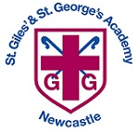
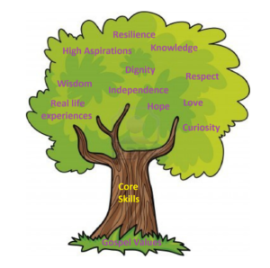
Physical Education

Unit: My Environment
Key questions/ experiments:
Watch changes that take place from egg to chick.
Which materials will protect the egg the best?
How can we organise different farm animals?
What do things need to grow?

Art/Design Technology
Text: Egg Drop, Hattie Peck, The enormous Turnip, Jack and the beanstalk, Superworm, A squash and a squeeze, The growing story.
Skills:
- Hear and write all phonemes in CVC words.
- Form all letters recognisably once taught.
- Practise reading and writing basics 2 and 3 tricky words.
- Use a finger space between two or more words.
- Orally retell a story using ‘first, then, next’.

Final Outcome/s: Fruit Kebabs/Smoothies
- Fantastic fruits and vegetables
- Healthy foods
- Designing
- Fine motor skills
- Making
- Designing packaging

Unit: Computer systems and networks (exploring hardware)
Overview:
- Explore hardware
- Real world tinkering
- Pictures of play
- Picture walk
- Class photo album
Unit: Healthy Me
Overview:
- Make a healthy choice.
- Eat a healthy diet
- Be physically active
- Keep safe.
- Be a good friend.
Unit: Salvation
Religion: Christianity
Key Question: Why do Christians put a cross in the Easter garden?
Religious Education
Unit: Musical Stories
Key Skills:
- Moving to music
- Using instruments to represent characters
- Story telling with actions
- Using instruments to represent actions
- Musical Story composition
- Performance

Number: Growing 6, 7, 8 continued / Building 9 and 10
Objectives include:
- Composition of 9 and 10
- Ordering numbers to 10
- Number bonds to 10
- 3D shape
- Consolidating patterns

Gymnastics
In this unit, children will develop their basic gymnastic skills through the topic of 'animals and their habitats'. Children explore basic movements, creating shapes, balances, and jumps and begin to develop rocking and rolling. Show an awareness of space and how to use it safely and perform basic skills on the floor and apparatus. Copy, create, remember and repeat short sequences. Begin to understand using levels and directions when traveling and balancing.
In story time, we will be reading: Various books by Tom Fletcher

EYFS Curriculum Overview –
Sp 2 – Life on the Farm

English
Science

Unit: Life on the farm

Key Question:
How does our environment compare to the farm?

Mathematics
Computing
Humanities
PSHCE
Music

